Job title: Classroom Teacher (Primary) | Service area: Learning Skills and Culture - Schools
Post number: | Division: Schools
Grade: MPS (1-6) | Section/team: The Trentside Federation
Overall purpose of job:
- You are required to carry out the professional duties of a schoolteacher as set out in the School Teachers Pay and Conditions document.
- The post holder will be expected to work in accordance with the policies of the school and the Local Authority.

Post holders will be expected to be flexible in undertaking the duties and responsibilities attached to their post and may be asked to perform other duties, which reasonably correspond to the general character of the post and are commensurate with its level of responsibility.
Main responsibilities:

- To teach a class full time, to the high standard expected by the Headteacher, Governors and the community served by the school.
- To act as curriculum co-ordinator for an area yet to be decided (unless completing ECT years).
- To be responsible to the Headteacher or her representatives.
- To manage and lead a curriculum area (unless completing ECT years) following school policy.
- To maintain good order and discipline among pupils whilst safeguarding their health and safety during activities which take place within and outside school.
- To supervise and manage other adults, for example teaching assistants and / or special needs support assistants.
- To attend staff meetings, parents’ evenings and school training day meetings as appropriate.
- To participate in procedures for implementing the school’s Performance Management policy.
To perform delegated duties in accordance with any directives reasonably given by the Headteacher or her representatives.
TEACHING AND PASTORAL CARE
- As a classroom teacher plan, prepare and teach to meet the educational needs of all children assigned in accordance with the National Curriculum and policies of the school.
- To be aware of individual needs within the classroom, both educational and pastoral.
- To identify and support accordingly, pupils with special needs, including more able children, in liaison with other school staff and professional from external agencies.
- Provide guidance on the social and personal development of children and undertake pastoral care of pupils.
- To have high expectations and to create a learning environment of high quality and organisation.
- To work within the stated curricular organisational and philosophical aims of the school and assist in achieving their effectiveness.
- To co-operate with other members of staff, work as part of a team with professionalism, to achieve the overall aims and objectives of the school.
- To take part in the assessment of pupils within the school in accordance with statutory guidelines and school policies.
- To liaise with parents and keep them informed about their child’s education and progress in line with school policy.
PROFESSIONAL DEVELOPMENT
  - To review personal teaching methods and programmes of work.
  - To undertake, as necessary or required, training to ensure continued professional development.
Position in organisation:

Indicate how many staff the post is directly accountable for: 0

Are posts in more than one location? No
Is this at the same site? Are the posts managed highly mobile? N/A
Is the supervision/management shared with another post in the structure? No

Please indicate which post(s) _______________________________________________

You must provide an organisation chart that shows where the job sits within the structure. This should be a simple diagram but with enough detail to put the job into context, i.e. the post holder may manage different groups of staff undertaking different tasks. The chart must show the job in question, the job to which it reports, those jobs which report alongside it and subordinate posts.

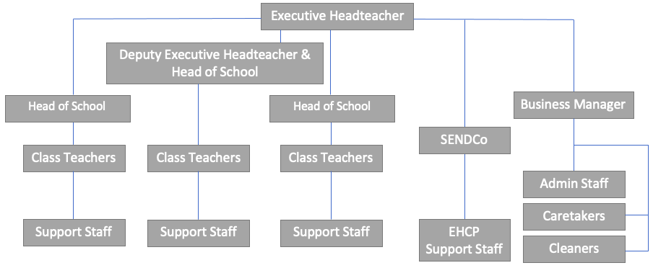

Note

Post holders will be expected to be flexible in undertaking the duties and responsibilities attached to their post and may be asked to perform other duties, which reasonably correspond to the general character of the post and are commensurate with its level of responsibility. This job description is provided for guidance only and does not form part of the contract of employment.

Date of Job Description: 20 October 2023

Date copy sent to Post holder:

POST NUMBER |  |  |  |  | JOB TITLE |  |  |  | HOURS PER WEEK
 | FACTORS |  |  | ESSENTIAL |  |  | DESIRABLE |  |  |  | HOW IDENTIFIED
 | Education, Training and Qualifications |  |  | - Qualified Teacher Status  - Evidence of keeping up to date with educational thinking and knowledge  - Knowledge of positive behaviour management  - Be prepared to attend appropriate courses |  |  | - Good honours degree  - Post-graduate study (PGCE)  - Other relevant qualifications  - Evidence of attendance of educational courses |  |  |  | - Application form  - Interview  - References  - Certificates
 | Experience |  |  | - Successful teaching experience within the primary sector  - Experience of NLS and NNS  - Recent FS/KS1/2 experience  - Experience of using ICT in the classroom  - Experience of teaching children with special educational needs and the more able  - Ability to work alongside colleagues as part of a team |  |  | - Experience of leading a curriculum area  - Experience of teaching in different primary Key Stages |  |  |  | - Application form  - Interview  - References
 | Knowledge and Skills |  |  | - Excellent classroom teacher  - Ability to get on with people and establish relationships with governors, staff, parents and pupils.  - High standard of communication skills  - Ability to establish and maintain good discipline  - Sound understanding of Primary Strategy / Curriculum initiatives  - Good ICT skills |  |  | - Expertise of one or more curriculum areas  - Experience of developing school policy documentation, subject improvement, schemes of work and assessment  - Ability to organise extra-curricular activities |  |  |  | - Application form  - Interview  - References
 | Personal Qualities |  |  | - Reliable, honest, efficient, well-organised  - Openness and willingness to learn  - Good communication skills – able to relate to people at all levels  - Able to set targets and meet deadlines  - Caring and understanding approach with commitment to justice, equity and equal opportunities  - Sense of humour  - Enthusiastic, energetic, imaginative, forward looking, hard working  - Professionalism, sensitivity and discretion |  |  | - Whole ‘rounded’ personality  - Be able to work on own initiative within the school framework  - Be a positive and enthusiastic forward looking teacher  - Commitment to parental/community involvement |  |  |  | - Application form  - Interview  - References
 | Working Arrangements |  |  | - Available for some out of hours working, including Parents Evening, and other in-service commitments |  |  | - Interests other than education  - Willingness to participate in school extra-curricular activities  - Residence within reasonable travelling distance from school |  |  |  | - Application form  - Interview  - References
 | Employee:  (signed) |  |  |  |  |  | (print) |  |  | Date:
 | Manager: (signed) |  |  |  |  |  | (print) |  |  | Date:

