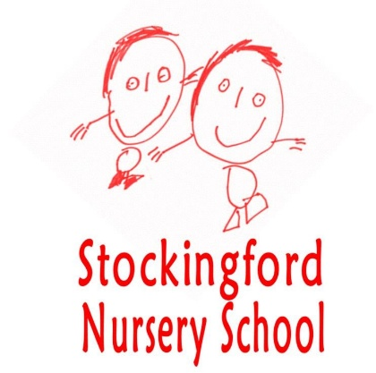

Stockingford Maintained Nursery School

Recruitment Information Pack

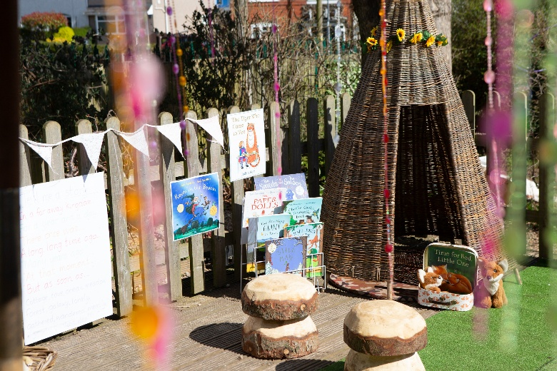
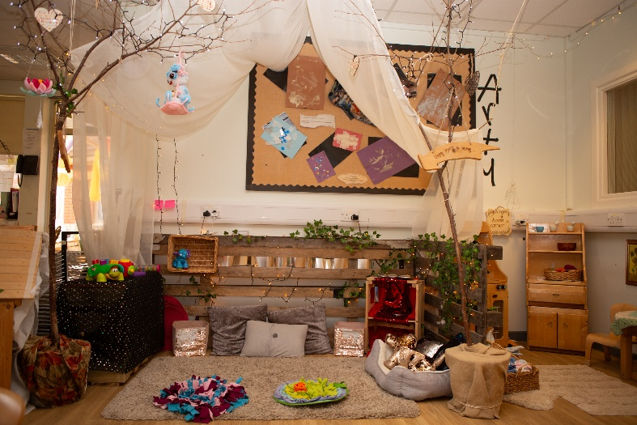






Thankyou for your interest in joining our amazing team at Stockingford Maintained Nursery School.

This pack contains information about our Nursery School and how to apply for the advertised vacancy.

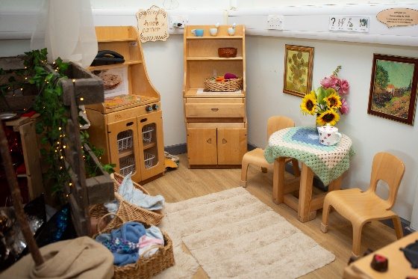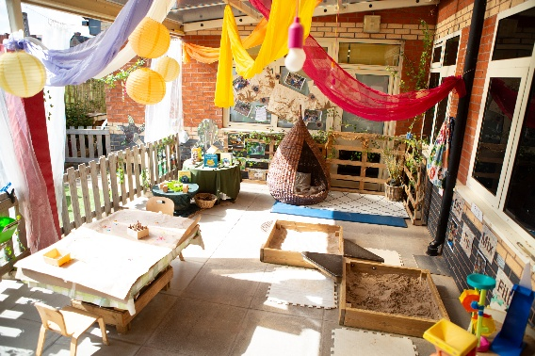

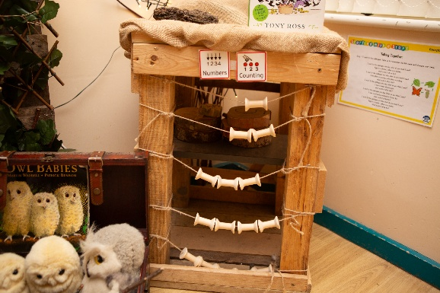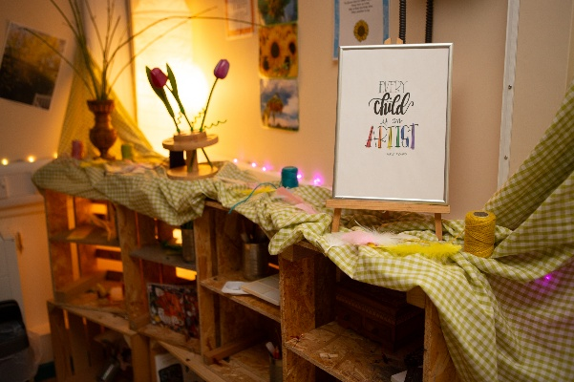

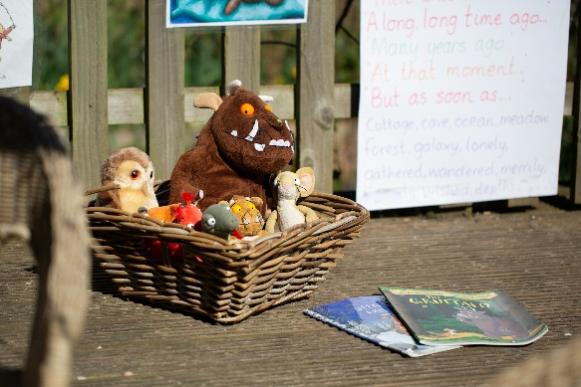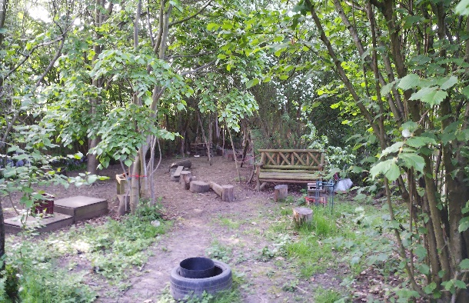

Nurture, Inspire, Grow

Letter from the Head Teacher

A very warm welcome to Stockingford Nursery School. We are a maintained nursery located in the heart of Stockingford in Nuneaton. There has been a Nursery onsite in Stockingford since 1942, and we are proud to have been a part of the local community and many of our parents (and grandparents!) have fond memories of their own time here.

As a maintained school, we have a Head Teacher, with qualified teachers and highly experienced practitioners supporting and extending learning.

We pride ourselves on offering a welcoming, safe and stimulating environment, with high quality teaching and learning experiences for children aged 2-4 years old. We recognise that children's foundations for learning are embedded in their early years experiences and we work in close partnership with home to support learning and development together.

We look forward to meeting you!

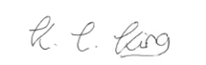
Katherine King - Headteacher

Process of application:
- Download an application pack from West Midlands Jobs Portal or on the DfE vacancy portal
- Visits are warmly and strongly recommended. Please contact the Head Teacher on head1041@welearn365.com or telephone 02476 383708 to book in.
- The closing date, and interview dates will be clearly marked on the advertised vacancy.

Safeguarding Statement
Our commitment to Safeguarding Children:
This school is committed to safeguarding and promoting the welfare of children and young people as required under the Education Act 2002 and expects all staff and volunteers to share this commitment:
- To ensure awareness of school policies and procedures re: Child Protection and Safeguarding.
- To be aware of the signs and symptoms of abuse by attending relevant courses, staff meetings and INSET.
- To follow school policy and report all causes for concern to the DSL.
- To ensure the safety of all pupils in the school learning environment both indoor and outdoor.
- To know that Safeguarding is the responsibility of all staff.

Visions and Values
Nurture, Inspire, Grow
- Celebrating, respecting and valuing everyone as unique individuals
- Exploring, investigating and discovering through play
- Creating a safe, stimulating learning environment that promotes curiosity, awe and wonder
- Working together to encourage children and families to achieve their full potential
- Developing independence and resilience through positive relationships
- Laughing, loving, and living in the moment, to create lasting memories and dispositions for lifelong learning

For more information, please visit our school website:
www.stockingfordnurseryschool.co.uk
What does OFSTED say about our Nursery School?

In June 2022, we had our Nursery School Inspection and achieved ‘Outstanding’ status.

‘A place of possibilities’ is how leaders describe their school. They are absolutely right. Highly skilled adults nurture, inspire and enable children to grow. Leaders and staff are highly ambitious for what children can achieve. They want the very best for them. No limit is put on what children can accomplish.

Children make exceptionally strong progress. The enticing learning environment and carefully planned activities spark children’s interests. They settle quickly and love to explore. There is a real buzz of learning across the nursery. For example, at lunchtime in the bistro children develop excellent social skills as they eat by candlelight to the sound of soothing music. Staff ensure that every moment is a learning moment.

Staff get to know and understand each child really well. They gently and patiently show children how to do things. They sensitively help children understand and manage their emotions and feelings. Relationships with adults and between children are exceptionally strong. Children behave very well and look after each other. Bullying is not an issue.

A strong partnership with parents and carers is in place. Parents say that their children flourish. They value the way leaders look after whole families, as well as their children.

To read our full report, please go to https://reports.ofsted.gov.uk/provider/20/125491

What do our families say about our Nursery School?

This Nursery is wonderful and one of the best. The staff are so helpful and friendly. My twins enjoy the nursery and are always happy. Thankyou for your support and hard work you do with the children.

As a family, we have used the Nursery for the past 10 years, and what a wonderful place it is. Our older children have thrived during their time here, and now our two youngest are getting the same chance to develop here. Lovely staff with such wonderful areas for the children to develop lots of skills.

Owl Babies – Brilliant activities for the children & adults!! Lots of fun and learning for them. Great to see all the children enjoying themselves. Lots to do, well organised. Thank you

My son had the best time in Forest School! Stockingford should be proud of middle nursery teachers for all the hard work they do, and for the lovely session.

100% recommend Stockingford Maintained Nursery School.
All the staff are lovely and make you feel so welcome... it really is like a little family. The care and support the staff have given my two boys has been absolutely amazing. I don’t want my oldest to leave, they are that good! but we look forward to the year ahead when my youngest returns this coming September

Absolutely amazing nursery and very supportive teachers. I highly recommend this nursery. I give it a five star rating. When my son started nursery, he was very shy and having language barrier. But all staff supported him well. He became very comfortable there. He loves this place and he made so many friends there. I am so thankful to all staff. They all are very lovely and awesome.

