Overview of ICT systems, facilities and platforms
(November 2022)

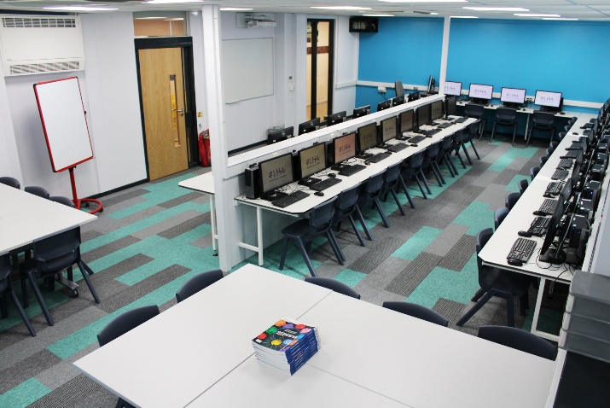
This is a fantastic time to be joining our ICT Support Team as we embed our strategic ICT plan which places digital technology at the heart of our curriculum. The aim is to develop skills for a seamless transition towards further education and the workplace for our students and so we are looking for a passionate Senior Technician to lead on the technical aspects of ICT across the school.

The vision at LHA is not to replace high-quality teaching with devices but rather, enhance what we know about effective learning and teaching with technology. We have asked ourselves: will developing the use of student devices at LHA help students know more, remember more and do more?
The answer is a resounding YES!

As a school we embraced Remote Learning during the pandemic and there is a strong appetite for continued technological developments. We would like the successful Technician to work alongside the Curriculum Leader for Digital in continuing to bring about planned change.

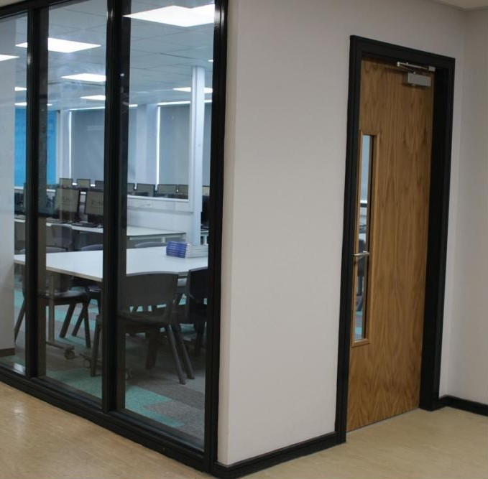
We currently have 5 ICT suites used for Computing, Business, Technology Art/Graphics and Media Studies. We have introduced devices into the classrooms throughout the curriculum through a 1:1 device scheme. This has been rolled out to Key Stage 3 (Years 7, 8 and 9) initially and future new Year 7 intakes will continue to join us with a school specified device until each year group have access to the technology in every classroom. Where some students keep their devices in School, pickup is between 08:30 and 09:00am, with drop off’s after our Period 5 (3pm).
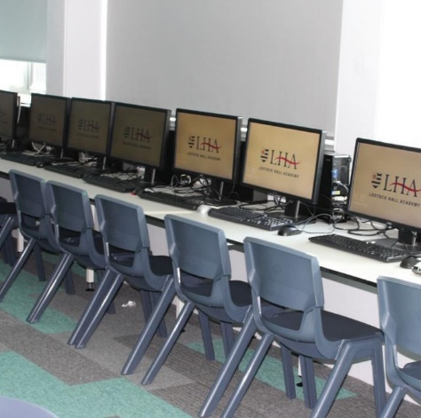
Recently, we have spent considerable investment in upgrading and redefining our ICT spaces in School.

We currently run approximately 13 servers (most physical but some are virtualised) in a Microsoft environment with Windows 10 to each desktop.
For Mobile Device Management of our 1:1 device strategy, we employ Microsoft InTune which has proved to be a stable platform for the large number of devices enrolled.

Desktop devices round school are predominantly Dell and redirected Desktops and Start Menu’s provide users with a standardised experience.
Remote Access is available using Microsoft Terminal Services.

CCTV is managed by SmartPSS.

The management of software and patch rollouts is delivered by a PDQ platform (Deploy and Inventory).

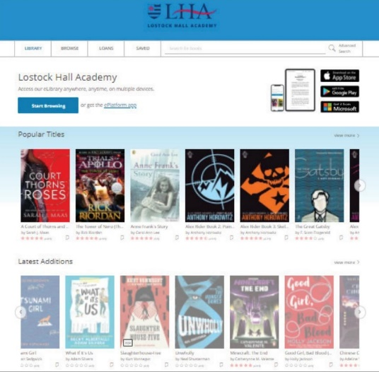
We run an IT Helpdesk system through one of our Learning Platforms (School Synergy) which staff also make use of as a web enabled MIS (Management Information System) and this is fed and maintained by our central MIS which is SIMS by ESS (formerly Capita).
On a similar note, there are a number of web platforms which enhance teaching and learning across the School. Reading is a particular focus for us currently and so we utilise Reading Plus at Key Stage 3, Century Tech at Key Stage 4 and ePlatform by Wheelers Books as our Online Library Centre.
Our Main School external website is managed by Schudio.

Our Catering function is outsourced to Aspens and the EPOS system runs on Trust-E with online payments for parents managed through School Gateway/ParentPay. Students are issued with MiFare cards which can then also be used in our PaperCut “Follow Me” print solution. Sharp MFD’s are stationed round school with print jobs released by the MiFare cards. These devices are also configured for Scan-To-Email in a bid to try and reduce the amount copied/printed. Staff are assigned into various PaperCut groups to allow us to better understand the make-up of our printing requirements by department round school.
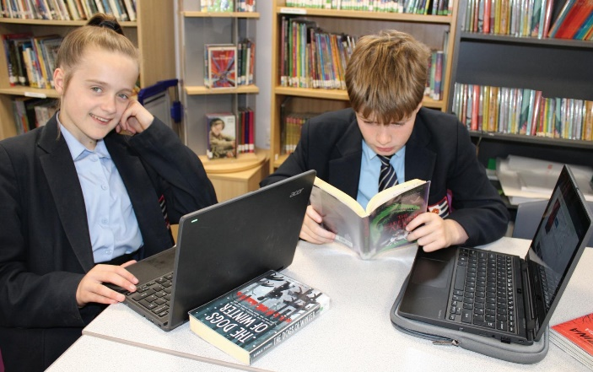
Our Wireless solution runs on a UniFi Controller and access is provided to staff on a BYOD scheme authenticating via their AD credentials. The 1:1 student devices connect with the UniFi wireless and we also run a Guest network which is allocated to a separate VLAN to maintain boundaries of separation from the core network.

Site Security for a number of doors and gates is provided by a Paxton Net2 system and again, MiFare cards are integrated into this to provide a seamless experience for users with the one token.

Visitor Management along with staff sign in/out is provided by EntrySign and MiFare cards can be scanned to enable staff to sign in/out quickly.

Anti Virus is predominantly delivered round the site by Microsoft Defender, although we do still have some areas running Sophos.

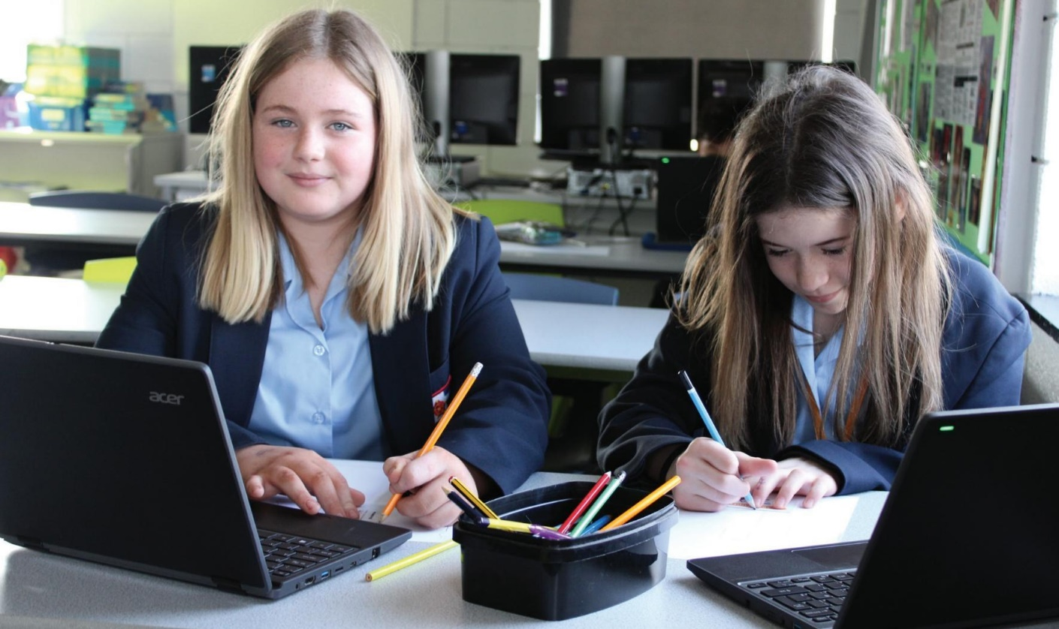
Our Disaster Recovery and Backup solution runs on Veeam.

