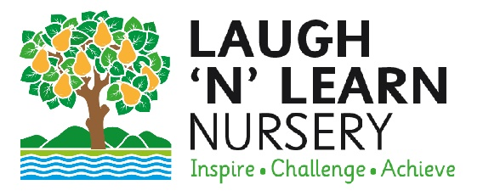

Person Specification – Nursery Manager

Factor | Essential Criteria | Desirable Criteria
Education and qualifications | Minimum Level 2 approved qualification in Early Years Education and Childcare or equivalent.  Level 2 maths qualification or ability to achieve one upon commencement. | Food Hygiene Certificate.  Paediatric First Aid (or willingness to complete before commencement).  Level 3 or higher qualification in Early Years Education and Childcare or equivalent or a desire to achieve this.  Specific experience and training for under twos.
Experience and Knowledge | Experience of Early Years education.  Experience of providing care and education to children with a wide  range of needs and abilities.  Strong understanding of early childhood development and learning.  Good knowledge of the EYFS curriculum.  •Knowledge and commitment to child protection, health and safety, equal opportunities and SEN/inclusion.  Knowledge of health and safety practices and procedures. | Minimum of 2 years’ experience within a childcare setting.  Experience of working with children under 2 years of age.  Excellent knowledge of how to provide for the needs of babies and young children.
Skille and Attributes | Empathy and understanding of children under five.  Excellent verbal and communication skills with children and parents.  Excellent organisational skills.  Able to carry out light physical duties to include lifting children and setting up resources.  Reflective approach and  commitment to personal  development.  Administrative and basic IT skills.  Calm and caring nature.  Ability to work as part of a team.  Able to work on own initiative. | Adaptable and flexible and the ability to cope with changing needs.  Ability to write reports and keep clear and accurate  records.  Ability to observe and assess children’s development.
Personal Qualities | Reliable, enthusiastic, and flexible.  A commitment to quality in all areas, with a high level of motivation and enthusiasm.  Able to perform under pressure.  A creative thinker and problem solver.  A good sense of humour.

