Job Description
Science Technician

Post Title: | Science Technician
Base: | Woldgate School & Sixth Form College
Salary: | SCP6
Line Management: | Head of Science
Contract: | 37hrs per week – term time plus 5 days

Core Purpose:
To support the effective day-to-day operation of the Science Department by ensuring that laboratories, equipment and resources are well organised, safe and fully prepared for teaching and learning. Working under the direction of the Head of Science and teaching staff, the postholder will provide technical support to facilitate practical science activities and enhance students’ learning experiences.

Duties & Responsibilities:
Support the practical and technical aspects of the science curriculum by preparing, providing, maintaining, organising and managing the resources required for healthy, safe and secure, exciting practical activities to be carried out by staff and students:
- Prepare, maintain and organise laboratory equipment, materials and teaching spaces.
- Organise and assign jobs within the technician team.
- Provide technical assistance to staff and students during practical lessons.
- Research new demonstrations/practicals for use within the science department.
- Collect, assemble, prepare, issue, clear away, clean, maintain and store apparatus and other items required for practical science classes or demonstrations.
- Clear bench tops and fittings, e.g. drawers, cupboards, fume cupboards in laboratories and ancillary room.
- Overall responsibility for maintaining stock levels of necessary materials and any stock records required.
- Liaise with Head of Science and teaching staff regarding processes for ordering equipment and resources.
- Prepare stock solutions and replenish re-agent bottles.
- Maintain and supervise aquaria, vivaria, animal and plant experiments and livestock.
- Annually check and take stock of equipment and materials, updating the Inventory where necessary.
- Oversee the safe storage and disposal of chemicals and biological materials.
- Working knowledge of how all equipment is required to be set up and be able to provide direction to other technicians in the team.
- Construct models and apparatus for use in the Science area.
- Carry out first-line maintenance repairs to damaged apparatus. Responsible for the pro-active replacement of broken equipment.
- Undertake, in any department of the school, any Science work appropriate to the grading and skills of the technician.
- Ensure that all laboratory activities are carried out safely, efficiently and in accordance with relevant health and safety requirements.
- As a responsible adult in a potentially dangerous environment, report all cases of unacceptable conduct to the teacher in charge. Where there is a risk to the safety of students, all reasonable steps should be taken to remove the risk.
Other duties and responsibilities ;

- Any other duties commensurate with the general level of responsibility of the post that the Headteacher may from time to time ask the post-holder to perform.

PERSON SPECIFICATION

Criteria | Essential | Desirable | Evidence
Qualifications and Experience
Relevant qualification: A Level in science subjects or equivalent qualification | X |  | A/C
Experience of working as a Science Technician |  | x | A/I
Experience of working in a school |  | x | A/i
Training on safety with chemicals for technicians |  | x
Professional knowledge and understanding, skills and attributes
Familiarity with laboratory apparatus and chemicals. | X |  | A/I
Computer literacy and knowledge of Microsoft Office applications, particularly Word and Excel. | X |  | A/I
Ability to manage workload effectively and prioritise work tasks | X |  | A/I
Attention to detail | X |  | A/I
Personal skills/attributes
Suitable to work with children | X |  | A/I/R
Knows professional boundaries, establishes professional relationships with children | X |  | A/I/R
Self-motivated but able to work in a team | X |  | A/I/R
Able to act on advice | X |  | A/I
Able to contribute positively to the school, its aims and ethos | X |  | A/I/R

A= Application; C = Certificate; R = Reference; I = Interview

As this is a new role it will be regularly reviewed and amended as required, in consultation with the postholder.

Note - This person specification is not necessarily a comprehensive definition of the post. It will be during the first year and will be subject to modification and amendment after consultation with the post-holder.

The school is committed to safeguarding and promoting the welfare of young people and expects all members of staff to share this commitment. An enhanced DBS disclosure is required for all posts.

How to apply
If you would like to apply for this vacancy, please download an application form from the Wonder Learning Parntership website.
Applications should be returned to Ceri King, People & Culture Lead, Woldgate School & Sixth Form College cking@woldgate.net
The school is committed to safeguarding and promoting the welfare of young people and expects all members of staff to share this commitment. An enhanced DBS disclosure is required for all posts.
CLOSING DATE: 14th October 2026 9am

How to Find Us
Woldgate School and Sixth Form College, 92 Kilnwick Road, Pocklington, York. YO42 2LZ Tel: 01759 302395

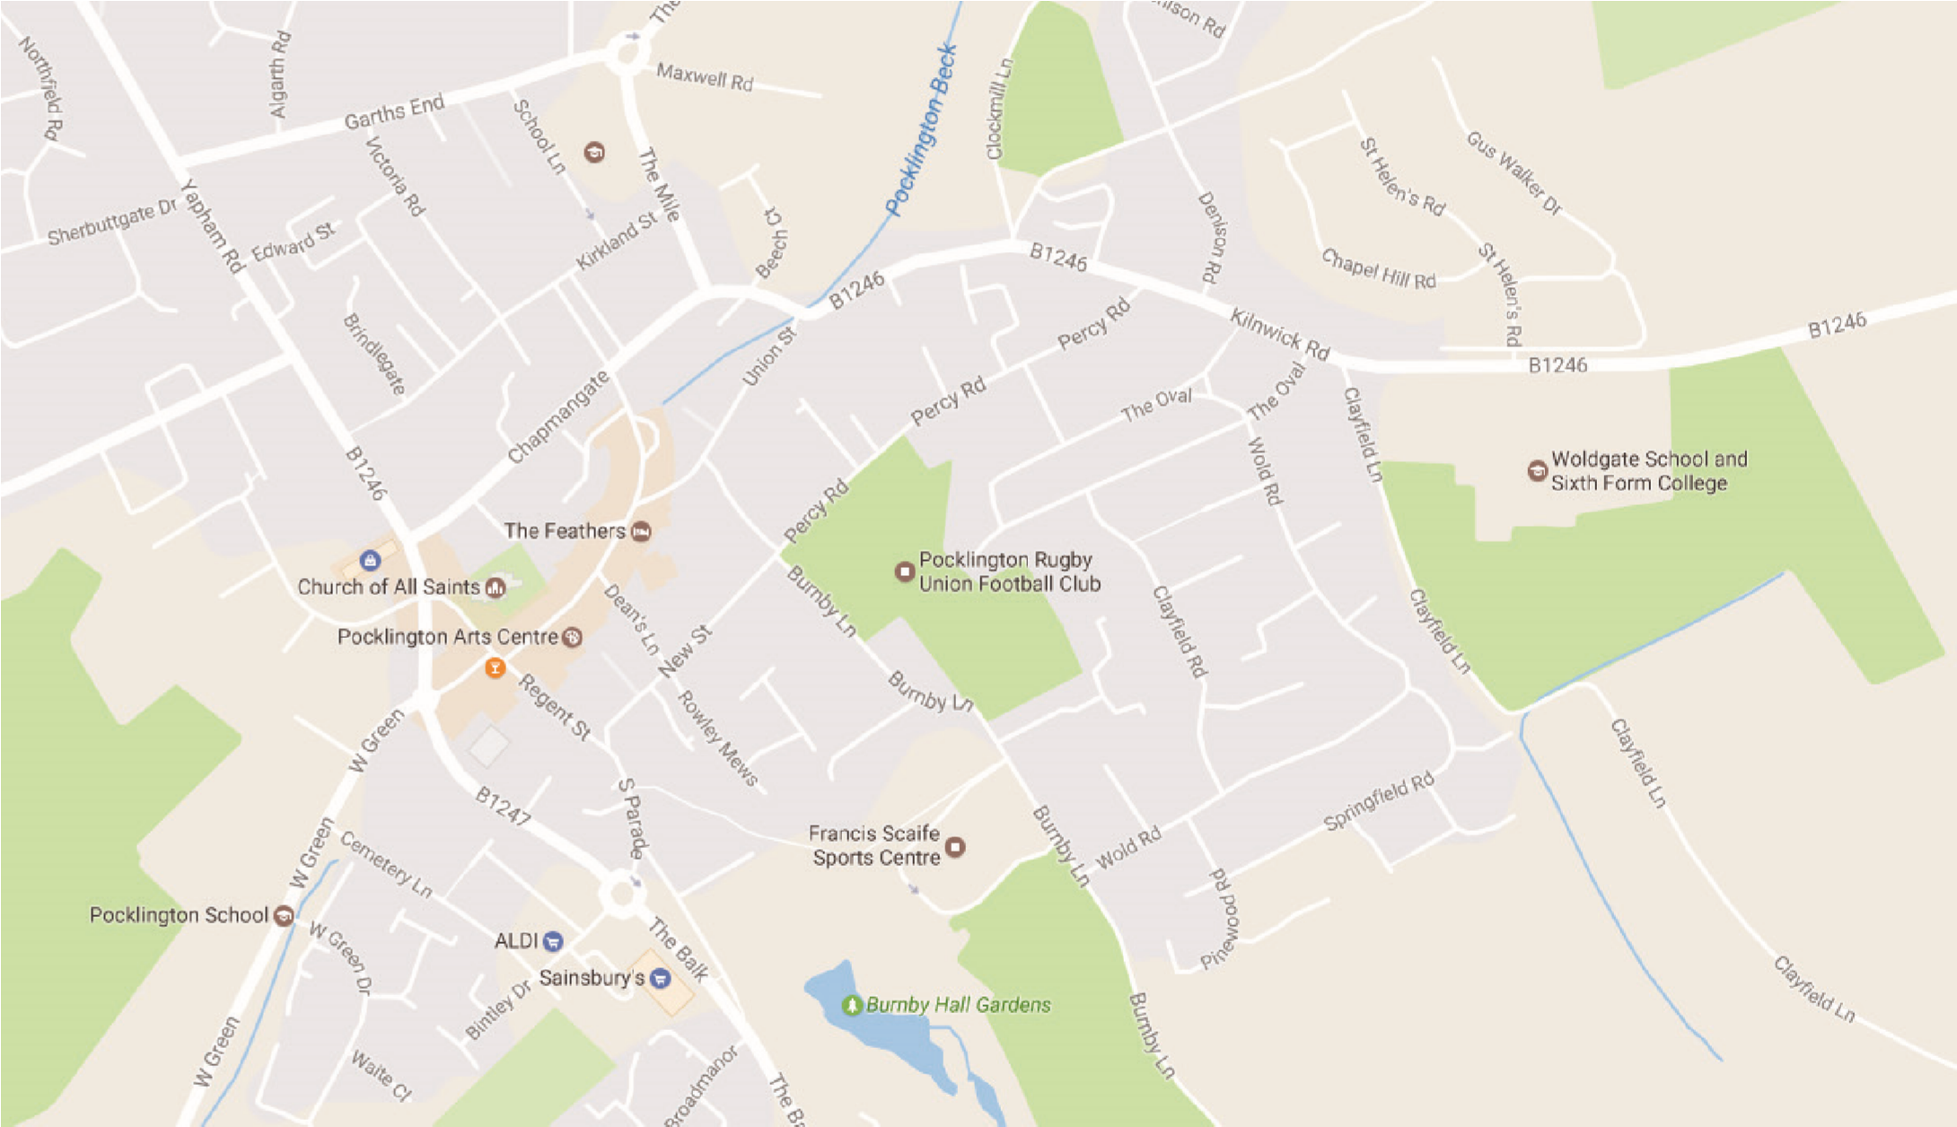

A. From Hull - Take the A1079 including the by-passes of Beverley and Market Weighton
- Take the right-hand fork from Pocklington at the Yorkway Hotel
- Take the 3rd exit from the roundabout, past the Rugby field on your right.
- Turn right at the B1246 signposted Warter, Driffield, Bridlington
- Woldgate School is the last building on the right as you leave the town.

B. From Humber Bridge - Take the Westward route towards Leeds along the A63
- Leave the A63 at the slip road and bridge over signposted for Market Weighton, Bridlington
- Pass through villages of South Cave and Sancton
- Turn west at Market Weighton bypass, A1079 towards York
- Follow instructions A3, A4, A5

C. From Leeds - Take A64, York by-pass towards Scarborough
- Leave A64 at Grimston Bar roundabout signposted York, Bridlington, Hull
- Exit from roundabout onto A1079 towards Hull
- Twelve miles approximately along A1079 after Pocklington Industrial Estate, turn left for Pocklington, just after Bonds International.
- Pass Pocklington School on left, at roundabout take 3rd exit past bus station, fire station.
- Take the first exit from the roundabout.
- Follow instructions A4, A5

D. From North-East England - Take A19 southwards until Northern by-pass of York
- Follow signs for Hull, Bridlington
- At A64 turn West for Leeds
- Follow instructions C2, C3, C4, C5, C6

E. From Scarborough, Bridlington - Follow sign from Driffield
- Bypass Driffield along North and West side
- Leave bypass where signposted for M62, Market Weighton
- At Bainton roundabout take second exit along B1246 towards North Dalton, Warter, Pocklington.
- Woldgate is the first building on the left as you reach Pocklington.

