Senior Teacher – Behaviour & Transition – Barnfield Campus
L11 Fixed Term contract for Autumn Term 2022/23 (1/9/22 to 31/12/22)

QE School

Candidate Information Pack

Letter from the Headteacher

Welcome to Queen Elizabeth’s School or QE, as it is often affectionately known. Thank you for taking the time to find out more about the role of Senior Teacher – Behaviour & Transition – Barnfield Campus. I hope the information in this pack is helpful and I look forward to receiving your application.

This is an exciting opportunity for an inspirational leader to join QE at a crucial time in the school’s history. The role of Senior Teacher – Behaviour & Transition – Barnfield Campus is pivotal, and one where you will have every opportunity to provide excellent leadership to a unique school community. I look forward to receiving applications from ambitious, selfless and collaborative leaders ready to transform lives, strengthen our community and make the world a better place.

QE is a place where all people are empowered. Our curriculum challenges students, inspiring their curiosity and creativity. We develop knowledge and understanding of the world and promote the values of respect, reflection and resilience. Our vision is to be a place where all people in our community progress and are engaged and fulfilled.

At QE we are empowered by the following values:

- Respect: We are considerate and we help each other. Treating everyone equally and understanding our differences makes our world stronger.
- Reflection: We progress by giving careful consideration to what we do. Thinking about our actions in a positive way guides us as we move forward.
- Resilience: We overcome difficulties and work on things to get better at them. Embracing challenges helps us to learn.

You will need to embody our ethos, vision and values in everything you do. In particular you will embed our values into our approach to behaviour management on the Barnfield Campus. We are an inclusive school that is absolutely committed to providing the best possible comprehensive education to our community. We ensure a broad range of subjects are available to all students, for examination at both age 16 and post 16 and we are determined to see improved outcomes for all our young people, especially Disadvantaged Students (DS) and those with SEND.

You will be determined and will play a vital role in leading QE. You will join a newly formed team of committed and highly professional leaders. I believe that the best way to operate is to support colleagues, through continuous professional development, coaching and encouraging all staff to be reflective practitioners who are intent on continuous improvement. As an integral member of the School’s Leadership Team, it will be your job to work with all colleagues to enhance that culture and apply it equally to our dealings with students.

You will need to provide the leadership that will uphold the very highest standards of Behaviour and Attitudes, and you will be accountable for this area of the Education Inspection Framework (EIF). The school operates over two campuses 15 minutes apart. Year 7 and 8 are based on the Barnfield Campus and Year 9 – 13 on the Western Road Campus. You will lead on, and be accountable for the highest standards of behaviour of all students on the Barnfield Campus. You will also take responsibility for transition from primary school to our Barnfield Campus, and transition from Year 8 into Year nine on our Western Road Campus. You will work closely all staff and in particular work with the Headteacher, Deputy Headteacher Inclusion and SENDCO, the Pastoral Team Leader, as well as Heads of Year and Head of 6th Form.
I believe in an approach to learning that equips students with a growth mind-set, intrinsic motivation and the skills of how to learn, who will therefore be empowered and fulfilled. It will be your job to help secure that approach to life in our young people. As an outstanding teacher yourself, you will be well placed to lead and develop teachers to continuously improve their practice and maintain a relentless focus on student engagement, fulfilment and progress. Of course, in particular, you will have the presence and assured professionalism to be an exceptional role model in relation to managing students’ behaviour.

As you will have gathered by now, this is a hugely challenging role, but one that is as rewarding as it is important. Our students are excellent, exceptionally friendly and respond well to good teaching. The overwhelming feeling is one of kindness and respect. As you will see below, you will be working with a strong school leadership team who are well supported by a range of other leadership teams and staff from the Ted Wragg Trust, especially colleagues in a similar roles in nearby Exeter schools. Our staff are fantastic and determined to deliver our core purpose - Educating to Empower.

I look forward to hearing from you, our website gives a lot on information about the school and if you would like to arrange a visit or have any questions you are very welcome. Please do get in touch via hr@tedwraggtrust.co.uk
Closing date 12pm 22nd August 2022 with interviews scheduled for the afternoon of 25th August 2022
Yours sincerely

Rupert Poole
Queen Elizabeth’s School Principles of Teaching
Principle of Better Practice | So that..
1. High expectations for behaviour and routines
a) Teachers demonstrate effective classroom management  b) Teachers consistently apply the Ready to Learn policy  c) Teachers ensure that there is a high student participation rate  d) Teachers reinforce effort and provide recognition  e) Teachers ask questions that promote student participation | a) Minimal lesson time is wasted dealing with low-level disruption or disorderly transitions  b) Students can think hard about their learning free from distractions  c) All students are engaged  d) Students understand the connection between effort and achievement  e) A high number of students are asked and answer questions
2. Quality of instruction
a) Teachers give highly effective explanations  b) Teachers provide clearly defined outcomes  c) Teachers present new knowledge in small steps  d) Teachers model excellence and how to achieve it  e) Teachers ask a high quantity of process and factual questions | a) Students quickly grasp ideas  b) Students have total clarity about what they are learning and what success looks like  c) Each step can be mastered before students move on  d) Students know what excellence looks like as well as how to achieve it  e) Students are given opportunities to practise new material
3. Literacy: vocabulary, reading, oracy, writing
a) Teachers explicitly instruct Tier 2 and Tier 3 vocabulary  b) Teachers provide challenging subject based reading  c) Teachers plan, prompt and model structured talk activities  d) Teachers break down, scaffold and model complex writing tasks in their subject | a) Students use academic vocabulary fluently in speech and writing  b) Students can comprehend challenging academic texts  c) Students can eloquently verbalise their knowledge and understanding  d) Students can independently plan, draft and edit extended writing
4. Making it stick
a) Teachers regularly use low stakes testing  b) Teachers guide students as they begin to practise new material  c) Teachers give students opportunities to practise independently  d) Teachers use visuals and other resources to support explanations  e) Teachers ask questions which make links with prior learning | a) Students can embed learning into their long term memory  b) Students can develop fluency and accuracy in new areas of learning  c) Skills and knowledge become automatic for students  d) Students can successfully understand and remember key aspects of learning  e) Students are encouraged to draw on prior knowledge
5. Inclusive classroom
a) Teachers have a clear understanding of all learners’ requirements  b) Teachers develop and apply personalised strategies in the classroom  c) Teachers do not rely solely on resources or interventions  d) Teachers reflect critically on the impact of teaching on all learners and adapt strategies in response to feedback | a) All students can access learning within lessons  b) All students encounter the appropriate level of challenge within lessons and can make progress  c) Inclusion is embedded in every aspect of the classroom  d) Students’ needs are responded to flexibly and strategies are reviewed regularly for impact
6. Effective feedback
a) Teachers give students high quality feedback  b) Teachers accurately gather information on student learning  c) Teacher provide students with opportunities to act upon feedback  d) Teachers plan and ask questions that provide a picture of student learning | a) Student actions are refocused/directed to achieve a goal (ReACT)  b) Teachers know which topics to re-teach that were not grasped first time  c) Students can swiftly develop further knowledge and skills  d) Teachers can identify gaps in student learning

Role Description – Senior Teacher – Behaviour - Western Road Campus

CONDITIONS
As defined in the school Teachers Conditions of Service Document and school policy documents.
The post holder will be an integral member of the school’s Leadership Team (LT) and Behaviour and Inclusion Leadership Team. They will lead and line manage the Western Road Campus Heads of Year. They will be supported and line managed by the Deputy Headteacher - Inclusion and SENDCO.

KEY PURPOSE
- Implement an effective behaviour management system/policy that is endorsed by staff, students and parents / carers and results in outstanding student behaviour across the campus
- Head of Year for one the year groups based on the Barfield Campus (Year 7 or 8 as agreed at interview)
- Ensure effective transition from Year 6 into Year 7 and from year 8 into Year 9
- Actively promote the school and lead on all transition and recruitment activities to ensure QE is the number one choice of all residents in Crediton and the surrounding villages
- Work the Business and Operations Team Leader and the Communications Officer to promote and market the school, with particular reference to Year 6 recruitment
- Implement policies that embody the QE Values and manage student behaviour in a way that focuses on building strong, mutually respectful relationships between all staff and students
- As an integral member of the LT, to provide strategic leadership of the school, with particular reference to the Education Inspection Framework (EIF) areas of: Behaviour and Attitudes, Personal Development and Safeguarding
- To work in close association with the Headteacher and Deputy Headteacher Inclusion, on the Behaviour and Inclusion Leadership Team to ensure excellent practice in respect of behaviour management, safeguarding and inclusion throughout the school.
- Head of Barnfield Campus – ensuring high standards of student behaviour and coordinating all events specific to the Barnfield Campus
- Deputy Designated Safeguarding Lead for the Barnfield Campus – reporting to the Headteacher who is the Designated Safeguarding Lead. Ensure all aspects of Keeping Children Safe in Education are upheld and the highest possible standards of safeguarding, including contributing to staff training
- Ensuring high student attendance
- Robustly line manage staff as required
- Proactive and tenacious liaison with external agencies, such as alternative provision providers and other Trust schools to ensure students’ needs are met
- Champion the needs of Disadvantaged Students (DS)
- Being a positive role model in all aspects of leadership, management, teaching and learning to students and staff

ESSENTIAL OUTCOMES
- empowering our students – with particular reference to DS. Empowered students = excellent outcomes
- ensure all aspects of the EIF for Behaviour and Attitudes and safeguarding are met - at least to the ‘good’ criteria and always with intent to secure the ‘outstanding’ criteria
- supporting the highest possible standards of safeguarding, including contributing to regular high quality and impactful staff training and awareness
- ensure accurate record keeping and data tracking systems are in place in respect of whole school Behaviour and Attitudes and safeguarding
- student attendance – ensuring robust systems, recording and approaches to maximise student attendance
- encourage students’ engagement with learning by creating a promoting the QE Values and a strong ethos of behaviour for learning - with particular reference to DS
- ensuring QE students are engaged, make progress and are fulfilled, developing systems to monitor this and ensure Heads of Year are working effectively to ensure all students in their year group are engaged, make progress and are fulfilled - with particular reference to DS
- actively promote the QE values and ensure they are integral to all systems and approaches, and are both taught and observable/measurable in the school’s Personal Development programme
- keep up-to-date with national developments in the areas responsible for – in particular behaviour management, safeguarding and personal development
- ensure systems for analysis of behaviour and attendance data are in place and proactively action plan accordingly
- working with other members of the Leadership Team, identify teachers’ professional development needs in relation to behaviour management and lead professional learning as required
- ensure the highest professional standards are maintained within the Heads of Year and the Pastoral Team
- ensure excellent communication with parents and all outside agencies, such as Police, social workers and alternative provision providers
- lead actions to follow up concerns about the behaviour of students, both inside and outside of school
- involvement of parents / carers at an early stage as part of the management of behaviour difficulties

SPECIFIC AREAS OF RESPONSIBILITY
- Acting as a positive role model for the all staff so that staff have a clear understanding of good professional conduct, with particular reference to behaviour management
- ensuring all school policies in relation to behaviour management are understood and followed by members of the staff
- responsible for the day-to-day management of the school by being a visible and effective presence and contributing to the duty rota
- checking that all staff are fulfilling their professional responsibilities and carrying out their duties effectively
- organising and provisioning of resources - overseeing and evaluating budget allocations to ensure spending is in line with learning priorities and best value principle
- effective communication within the school and to key stakeholders with regards to students’ conduct both inside and outside of school, to ensure confidence in the school in the wider community
- encouraging parents and carers to be supportive and involved with their child’s education at QE
- ensuring high standards of health and safety
- championing and demonstrating an understanding and a commitment to safeguarding students –ensuring this is high profile throughout the school
- promoting equality of opportunity and aspiration in staff and students alike
- plan and implement the developments required in the context of the overall School Improvement Plan
- ensure efficient communication with all Associate staff and the Catering team as required
- undertake staff appraisals, line management and performance management, as required
- participate in the recruitment of personnel and ensure effective induction of new staff
- working with the Heads of Year, create an assembly rota and lead on assemblies, as required
- attendance, and the chairing of meetings, at the direction of the Headteacher
- Other general professional duties under the reasonable direction of the Headteacher
- A classroom teaching load will be an essential part of the role and will be determined at interview with the successful candidate

Strategic Leadership Team
Meets weekly – strategic leadership

Headteacher
Responsibility for the Overall Effectiveness strand of the EIF and strategic leadership. Designated Safeguarding Lead. Chairs the weekly Behaviour and Inclusion Leadership Team meetings.
Deputy Headteacher – Quality of Education
Responsibility for the Quality of Education strand of the EIF. Coaching and all aspects of high quality teaching and learning and the QE Principles of Teaching.
Deputy Headteacher – Inclusion and SENDCo
Responsibility for SEND provision, SEND outcomes and inclusion throughout the school. Head of Barnfield Campus
Head of Business and Operations
Responsible for all aspects of the school’s Business and Operations function

Leadership Team
Meets twice a half term – ensuring progress against school improvement priorities

Headteacher
Deputy Headteacher Quality of Education
Deputy Headteacher Inclusion
Head of Business and Operations
Director of Maths and Visual Arts
Director of English and Performing Arts
Director of Science and Technology
Director of French and EBACC
Director of PE and Professional Learning
Senior Teacher – Behaviour - Western Road Campus
Senior Teacher – Behaviour and Transition - Barnfield Campus

Behaviour and Inclusion Leadership Team
Meets weekly – either campus based or as whole school team. Focus on individual student engagement, fulfilment and progress, attendance and safeguarding

Headteacher
Deputy Headteacher Inclusion
Senior Teacher – Behaviour - Western Road Campus
Senior Teacher – Behaviour and Transition - Barnfield Campus
Assistant SENDCo Barnfield Campus (Associate Staff)
Assistant SENDCo Western Road Campus (Associate Staff)
Head of Year 7
Head of Year 8
Head of Year 9
Head of Year 10
Head of Year 11
Pastoral Team Leader (Associate Staff)
Safeguarding Officer (Associate Staff)

Person Specification
Please ensure you provide evidence that you meet as many of the following descriptors as possible in your application form. We are looking for the potential in a person, not necessarily their experience so if you are short on experience make sure you demonstrate your potential.

 | Descriptor
Expertise | - Knowledge of how to, and ability to, motivate young people and adults  - Leading others to enhance their performance  - Managing student behaviour  - Supporting students’ progress  - Analysis and interpretation of data  - Using self-evaluation to plan and effectively deliver improvements within a school setting  - Ability to deliver consistently outstanding teaching and to model that teaching for others  - Interpersonal skills that promote school improvement  - Effective communication skills that improve relationships with key stakeholders; staff, parents and carers, students, governors and the wider community
Qualifications | - Good honours degree  - Teaching qualification  - Qualified Teacher Status  - Recent and relevant professional development  - Safeguarding level 3
Experience | - Teaching  - Working with young people  - Teamwork  - Communication  - Leadership in a school setting  - Safeguarding and ensuring Keeping Children Safe in Education is championed and upheld to the highest standards  - Experience of supporting colleagues to improve their practice
Personal qualities and beliefs | - Passionate belief in the potential of all young people  - Highest possible standards of practice in relation to the safeguarding of young people  - Total respect for all members of our community and ability to model this respect  - Highly effective team worker  - A solution focused thinker  - Inspirational  - Reflective practitioner  - Belief in ‘growth mindset’ (as defined by C. Dweck)  - Belief that the concept of continuous improvement is a real and powerful process  - Commitment to learning as a lifelong endeavor and able to model this to the wider community  - Energy and enthusiasm  - Creative and not risk averse  - Belief that education empowers people  - Belief that education is a moral enterprise and not an exercise in gaming the latest government’s league table  - Belief that comprehensive education is a powerful force for good in society
About the area
The historic market town of Crediton has a population of approximately 8,000 and lies only seven miles from the thriving university city of Exeter. Crediton has regular trains from Exeter and Barnstaple and the A377 provides good access to Exeter. It is also easy to access the A30.

Crediton lies in the heart of an area of outstanding natural beauty and the Barnfield Campus in particular enjoys spectacular views over the rolling Devon countryside and Dartmoor. Crediton is convenient for the many recreational opportunities provided by both Dartmoor and Exmoor and the south and north Devon coasts.

Queen Elizabeth’s School has a long and proud history of serving Crediton and the surrounding villages, that stretches back over four hundred and sixty years. We have a large rural catchment area and we are the only secondary school in the town. We have excellent relationships with all our partner primary schools through our work with the Crediton Learning Community.

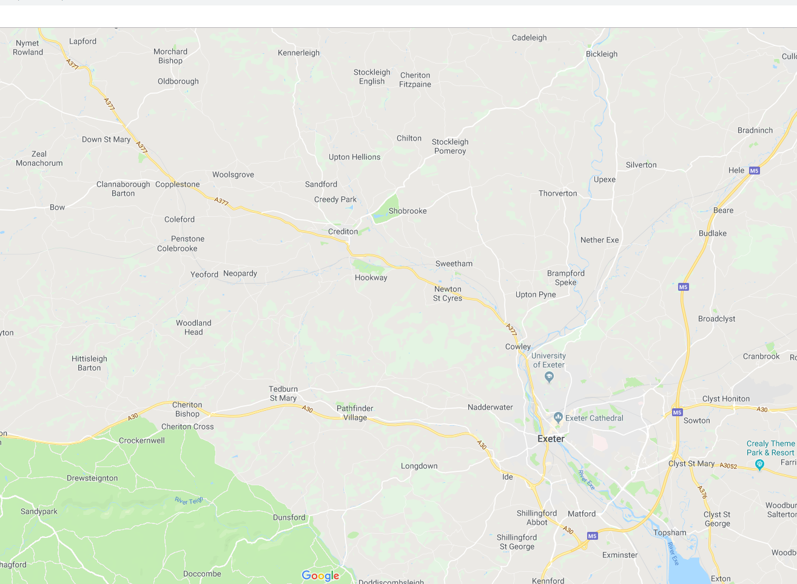

Queen Elizabeth’s School and the Ted Wragg Multi Academy Trust is committed to safeguarding and promoting the welfare of children and young people and expects all staff and volunteers to share this commitment and operate in accordance with the Safeguarding and Child Protection Policy. All applicants will be subject to a full Disclosure and Barring Service check before an appointment is confirmed. This role requires the ability to fulfil all spoken aspects of the role with confidence and fluency in English.

