



**Senior Teacher**

**Recruitment Information Pack**



## Contents

About the School 3

Application Process 5

Job Description and Person Specification 6



**Masham CE School**

Masham is a small, inclusive, rural school in the heart of this thriving market town. It has a close-knit, family orientated community, where people matter. This is reflected in how we live our lives at Masham school.

We are a distinctive school, where we aim to be ambitious for our children. Founded in 1819, Masham school has a rich history and tradition of serving its local community with pride, care and compassion.

Through a broad, rich, child-centred curriculum, at Masham our learning is a journey of relevant and local experiences leading to the development of skills, knowledge and understanding. Children are encouraged to take inspiration from each other, their teachers and the world around them. From this holistic approach emerge thriving children whose academic success is underpinned by confidence and wellbeing.

**Vision & Values**

*‘One Body, Many Parts (1 Corinthians 12)*

Each of us has a special talent and role we can use for God, like the different parts of a body working together.

At Masham, we work together under God’s guidance to grow minds, spirits and bodies to learn, care and share together.

We want everyone to flourish. We cherish our values as we promote the flourishing of all.

* **Kindness**
* **Courage**
* **Respect**
* **Excellence**
* **Perseverance**

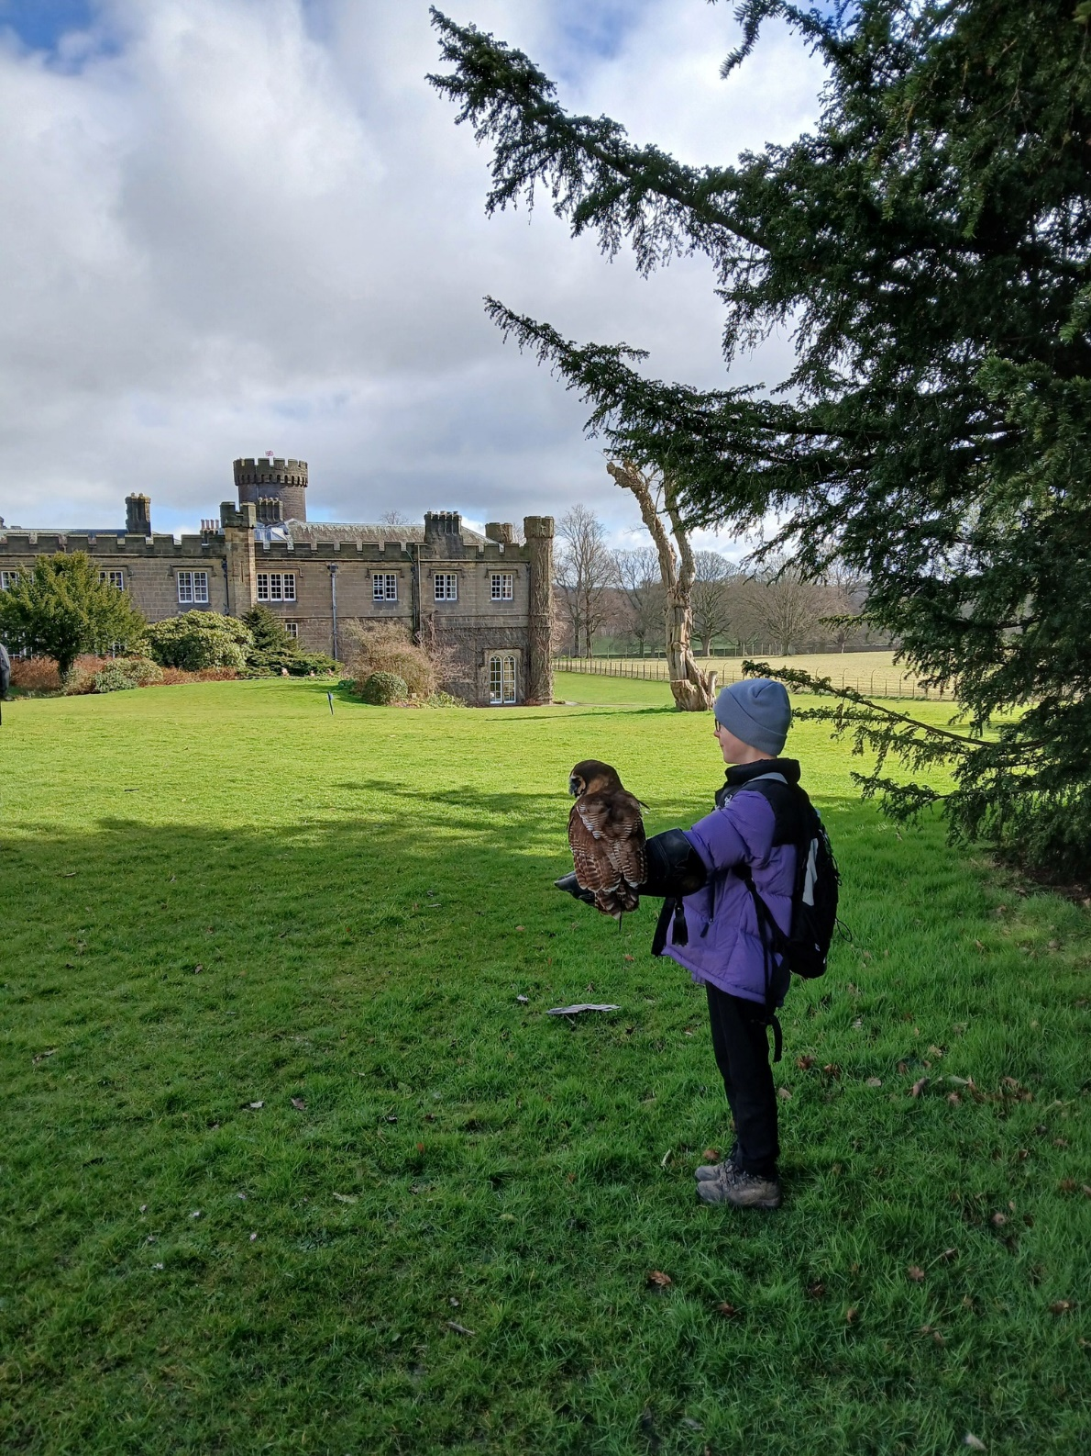

**Our Y5/6 Class demonstrating our values of courage and perseverance**



## Application Process

The closing date for all applications is **11:59pm Sunday 29th June**

Interviews are anticipated to be held **Thursday 3rd / Friday 4th July – TBC**

**The Governing Body would like to inform applicants that Transition Day will take place on 8th July. We would be delighted if the successful candidate were able to attend, to meet the new pupils.**

**Application Process**

Please apply online via NYC Jobs. An email will be sent to candidates with the outcome of the shortlisting process. Unfortunately we do not accept CV’s.

**Queries / Visits**

Please contactChloe Bullen at [Chloe.Bullen@northyorks.gov.uk](mailto:Chloe.Bullen@northyorks.gov.uk) or on 01609 536 964

**Visit Slots**

• Thursday 26th: 10am – 1pm

• Friday 27th: 10am – 1pm

Visits are by appointment only, please contact Chloe to book. Please note these may be open visits with other candidates also present.

**When applying please take into account the following:**

**Employment History**

In line with KCSIE requirements, please complete your **full** employment history to ensure any gaps in your education and career history are accounted for.

**Suitable References**

When completing your application, please provide two employment referees. Generally, this should be your current and most recent Headteacher or line manager. Please note if your former Headteacher or line manager has since left, please use an alternative current senior staff member as they need to be in post at your former location to be able to confirm your details in full.

Unfortunately, we cannot accept personal references or personal email addresses.

Please get in touch for any queries if you are unsure.

**Supporting Information**

The supporting information section of your application should clearly evidence your ability to meet the requirements we have outlined in the job description & person specification. This will be used to shortlist applicants for this role and therefore it is imperative that you provide evidence as requested.

**Job Description**

**JOB TITLE:** Senior Teacher (Fixed Term – 1 year)

**GRADE:** MP3-6 + TLR2a

**RESPONSIBLE TO:** Head teacher and Governors

**RESPONSIBLE FOR:** Deployment of support staff allocated (where relevant) Operational management of the day-to-day running of the school in the absence of the Headteacher. This post-holder will be Deputy Designated Safeguarding Lead.

**JOB PURPOSE**: Promote effective learning, appropriate achievement and educational, social and personal progress of all pupils for whom the teacher is designated as being responsible, consistent with the aims of the school and the unique needs of each individual.

**KEY RESPONSIBILITIES:**

1. Develop and maintain an up-to-date knowledge and understanding of the areas of teaching and pupil support for which post-holder is responsible.
2. Act as Deputy Designated Safeguarding Lead (DDSL), supporting the Designated Safeguarding Lead in ensuring the effective implementation of safeguarding policies and procedures, responding to concerns, and promoting a culture of vigilance and care across the school.
3. Plan work to meet the learning needs of allocated pupils in a consistent and effective way.
4. Use appropriate teaching and classroom management strategies to motivate pupils and enable each to progress.
5. Monitor the progress of pupils for whom the postholder is responsible to set expectations and give constructive feedback.
6. Maintain appropriate records to demonstrate progress made by pupils.
7. Participate fully in professional development activities to develop practice further, sharing the learning from these as appropriate.
8. Make an active contribution to the policies and aspirations of the school.
9. To fulfil all of the requirements and duties set out in the current Pay and Conditions Documents relating to the conditions of employment of teachers.
10. To fulfil all of the responsibilities and duties required by the School’s policies on teaching and learning.
11. To achieve any performance criteria or targets arising from the School’s Performance Management arrangements.

This job description will be reviewed annually

**Person Specification**

|  |  |
| --- | --- |
| **Attributes** | **Desirable/ Essential** |
| Considerable experience of teaching in primary schools | Essential |
| Senior leadership experience or an aspiration to become a senior leader | Essential |
| Able to evidence excellent pupil progress | Essential |
| Experience of working positively and closely with staff, parents and guardians | Essential |
| Effective experience in creating a positive climate and environment to secure accelerated learning | Essential |
| Recent OFSTED experience | Desirable |
| **EDUCATION AND TRAINING** | |
| QTS | Essential |
| Thorough knowledge of teaching, learning and curriculum in primary schools | Essential |
| Commitment to continued professional development | Essential |
| Evidence of recent & relevant training | Essential |
| Safeguarding Awareness | Essential |
| An excellent classroom practitioner | Essential |
| Have experience as deputy designated safeguarding lead (or a desire to access training) | Essential |
| **PROFESSIONAL KNOWLEDGE AND SKILLS** | |
| Effective use of assessment data to plan sequence of learning that secures accelerated progress | Essential |
| Work effectively as part of a team, relating well to colleagues, pupils and parents | Essential |
| Excellent use of ICT to support learning | Essential |
| High expectations of all pupils | Essential |
| Detailed knowledge of the National Curriculum and its planning and delivery | Essential |
| Implications of the Code of Practice for Special Educational Needs for teaching and learning | Desirable |
| Evidence of ability to maintain high standards of behaviour and develop attitudes of care, control and cooperation | Essential |

**APPLYING FOR A JOB WITH NORTH YORKSHIRE COUNCIL**

**IMPORTANT ADVICE ON COMPLETING THIS APPLICATION**

Your application form plays an important part in your selection. Please ensure you address all the essential requirements listed in the specifications. The following advice should help you to complete the application form as effectively as possible.

**Data Protection**

The information that you state on this application form will be used by the school and the Council to consider you for a job vacancy. To find out about how we use your personal data for the purposes of recruitment please see our Privacy Notice at [www.northyorks.gov.uk/working-us](http://www.northyorks.gov.uk/working-us).

**Rehabilitation of Offenders**

The post you are applying for requires you to have an enhanced Disclosure and Barring Service criminal records check for work with children, with a barred list check if you work in regulated activity. This check for disclosure of criminal history will include spent convictions, pending prosecutions / current court proceeding and police enquiries.

Should you be shortlisted, you will be asked to disclose full details of your criminal history prior to your interview. This includes any information deemed relevant as part of Keeping Children Safe in Education which may arise in an online search undertaken on shortlisted candidates. This information may be discussed with you at your interview in order to assess job related risks, but we emphasise that your application will be considered on merit and ability and you will not be discriminated against unfairly. Failure to disclose this information will result in any offer of employment being withdrawn.

Please also see the policy statement on the Recruitment of Ex-offenders below.

**Information in Support of your Application**

Every post advertised is supported by a full person specification. The specification lists all the essential skills, experience and qualifications which are necessary for the job and the criteria against which you will be assessed, both through your application form and at interview.

As part of the application process, you may have been asked to demonstrate within this application form how you meet some or all of the criteria or key competencies outlined in the person specification. Rather than simply repeating your career history, look at the skills and experience required by the job and provide evidence that you possess them by giving **specific and detailed examples** which include a focus on outcomes and on your own contribution to the scenario. Try to use different and varied examples wherever possible.

When completing these sections, do not forget the skills and experience you have gained outside full-time work. Outlining your previous work experience or other responsibilities may help you to uncover skills which you have taken for granted and which are clear signs of your ability to do the job.

**Canvassing**

You must not try to influence an elected Council Member, any council employee or a member of the school governing body, to act in your favour, as this will disqualify you. If you are related to a Councillor, a Council employee or a governor you must indicate this in the relevant section of the application form.

**Policy Statement on the Recruitment of Ex-offenders (Source** [**www.gov.uk**](https://www.gov.uk/government/publications/dbs-sample-policy-on-the-recruitment-of-ex-offenders/sample-policy-on-the-recruitment-of-ex-offenders)**)**

1. As an organisation assessing applicants’ suitability for positions which are included in the Rehabilitation of Offenders Act 1974 (Exceptions) Order using criminal record checks processed through the Disclosure and Barring Service (DBS), this school complies fully with the DBS [code of practice](https://www.gov.uk/government/publications/dbs-code-of-practice) and undertakes to treat all applicants for positions fairly.
2. This school undertakes not to discriminate unfairly against any subject of a criminal record check on the basis of a conviction or other information revealed.
3. This school can only ask an individual to provide details of convictions and cautions that it is legally entitled to know about. Where a DBS certificate can legally be requested (where the position is one that is included in the Rehabilitation of Offenders Act 1974 (Exceptions) order 1975 as amended, and where appropriate Policy Act Regulations as amended) this school can only ask an individual about convictions and cautions that are not protected.
4. This school is committed to the fair treatment of its staff and potential staff, regardless of race, gender, religion, sexual orientation, responsibilities for dependents, age, physical/mental disability or offending background.
5. This school has this written policy on the recruitment of ex-offenders, which is made available to all DBS applicants at the start of the recruitment process.
6. This school actively promotes equality of opportunity for all with the right mix of talent, skills and potential and welcome applications from a wide range of candidates, including those with criminal records. Candidates are selected for interview based on their skills, qualifications and experience and criminal record information is only requested from short-listed candidates.
7. A disclosure is only requested from the DBS after a thorough risk assessment has indicated that one is both proportionate and relevant to the position concerned. For those positions where a criminal record check is identified as necessary, all application forms, job adverts and recruitment briefs will contain a statement that a DBS certificate will be requested in the event of the individual being offered the position.
8. This school ensures that all those who are involved in the recruitment process have been suitably trained to identify and assess the relevance and circumstances of offences.
9. This school also ensures that they have received appropriate guidance and training in the relevant legislation relating to the employment of ex-offenders, e.g. the Rehabilitation of Offenders Act 1974.
10. At interview, or in a separate discussion, this school ensures that an open and measured discussion takes place on the subject of any offences or other matter that might be relevant to the position. Failure to reveal information that is directly relevant to the position sought could lead to withdrawal of an offer of employment.
11. This school makes every subject of a criminal record check submitted to DBS aware of the existence of the [code of practice](https://www.gov.uk/government/publications/dbs-code-of-practice) and makes a copy available on request.
12. This school undertakes to discuss any matter revealed on a DBS certificate with the individual seeking the position before withdrawing a conditional offer of employment.