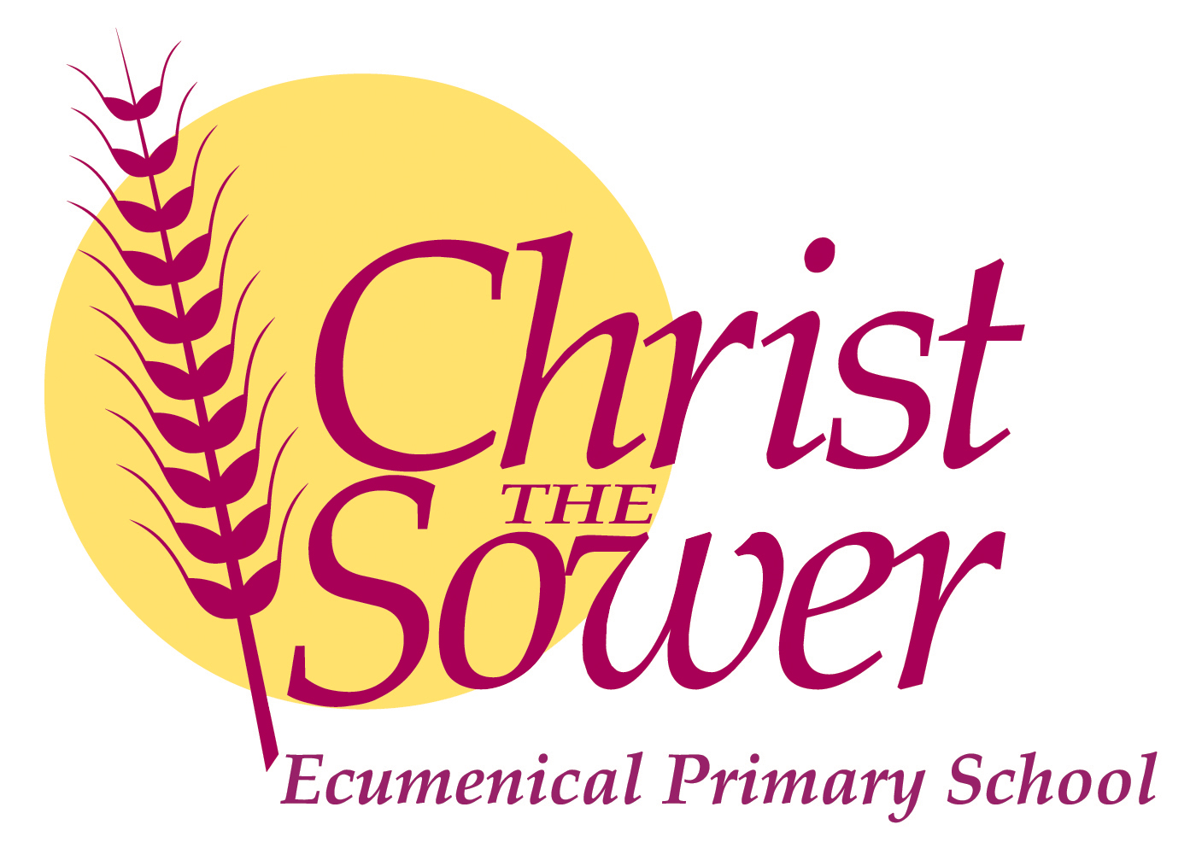

**We are looking for a Senior Teacher to lead our Key Stage 1**

**and Foundation Stage**

**At Christ the Sower Ecumenical Primary School**

To start September 2021

MPS plus TLR2 (£2873)

**Closing Date: Tuesday 4th May 12.00 noon**

**Interview date: Monday 10th May 12.00 noon**

This is a wonderful opportunity for an enthusiastic high quality teacher to join our hard working, friendly team. Starting in September 2021, we are interested in someone who has a real desire to impact children’s lives and who is serious about adapting and adding to their own learning and experience.

We are looking for someone with:

* commitment to place the child first in all that they do
* high ambition and aspirations for all the children in the school
* genuine love of, and ability to nurture, children from a wide variety of experiences and backgrounds
* commitment to supporting our Christian ethos
* personal drive and commitment to creating, engaging, fun and purposeful learning experiences
* ability to work well in a team

We can offer you:

* An exciting opportunity to work in a new MAT in Milton Keynes
* CPD opportunities and career development
* Amazing children who will bring a smile to your face every day
* A friendly, supportive and dedicated staff team
* Supportive parents and community
* Modern purpose built facilities

Applicants are invited from all faiths and none. Contact our Headteacher, Lorraine Quirk on 01908 867356 to learn more or to arrange a visit prior to application. Visits are very welcome.

For an application pack please contact Christine Smith, [csmith@ctsmk.org.uk](mailto:csmith@ctsmk.org.uk) or on 01908 867356 or visit our website [www.ctsmk.org.uk](http://www.ctsmk.org.uk).

*Our school is committed to the safeguarding and welfare of our children. All appointments will be subject to full DBS Disclosure.*