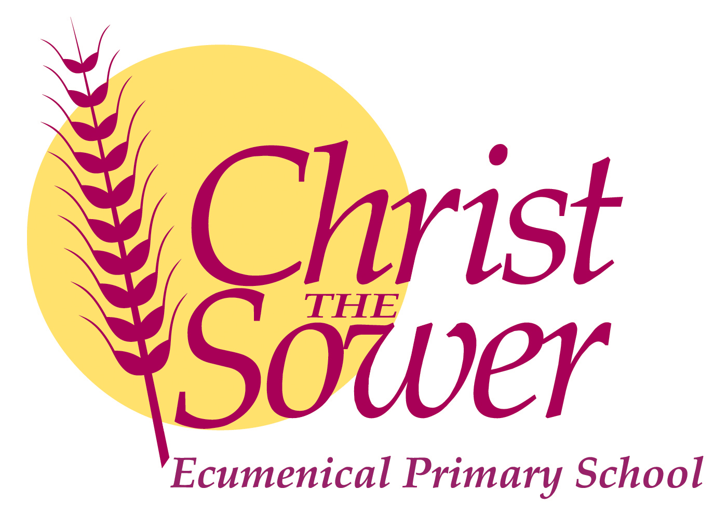

Dear Applicant,

Thank you for expressing an interest in working at Christ the Sower. At the end of this term we have one teacher retiring and another moving out of the area so we are looking to recruit 2 class teachers, one in KS2 and one to lead our KS1 and Foundation Stage.

We are a very special school here at CtS. In Autumn 2018, the school was placed in special measures. The school then joined the Oxford Diocese Bucks Schools Trust in September 2019 and has developed and improved since then. Although it is hard work in a special measures school, it is also exciting and extremely rewarding to be part of the school’s journey ‘To Good and Beyond’.

We are a mixed staff with early career stage teachers and some more experienced teachers. We work a lot in key stages but also together as a whole teaching team. Professional development is very important to us and there are plenty of opportunities to continue to grow and learn as a teacher.

The wellbeing of our children is a priority for us, now more than ever. However, the wellbeing of all our staff is also very important. We have a designated wellbeing lead and are all very supportive of each other – although a sense of humour is a priority.

Over the last two years CtS, like many other schools, has been affected by COVID and the national lockdowns. Yet despite all this, we have come a long way since Autumn 2018. We would no longer judge ourselves as Special Measures School and are confident that Ofsted would also recognise the improvements. We have amazing children, excellent behaviour, very supportive parents and friendly and welcoming staff.

So if you are looking for a hardworking, fun and great place to work and develop your teaching career we would love to hear from you. We are happy to show you around the school in a COVID secure way, so visits are more than welcome.

We look forward to meeting you soon.

Yours sincerely,

Lorraine Quirk