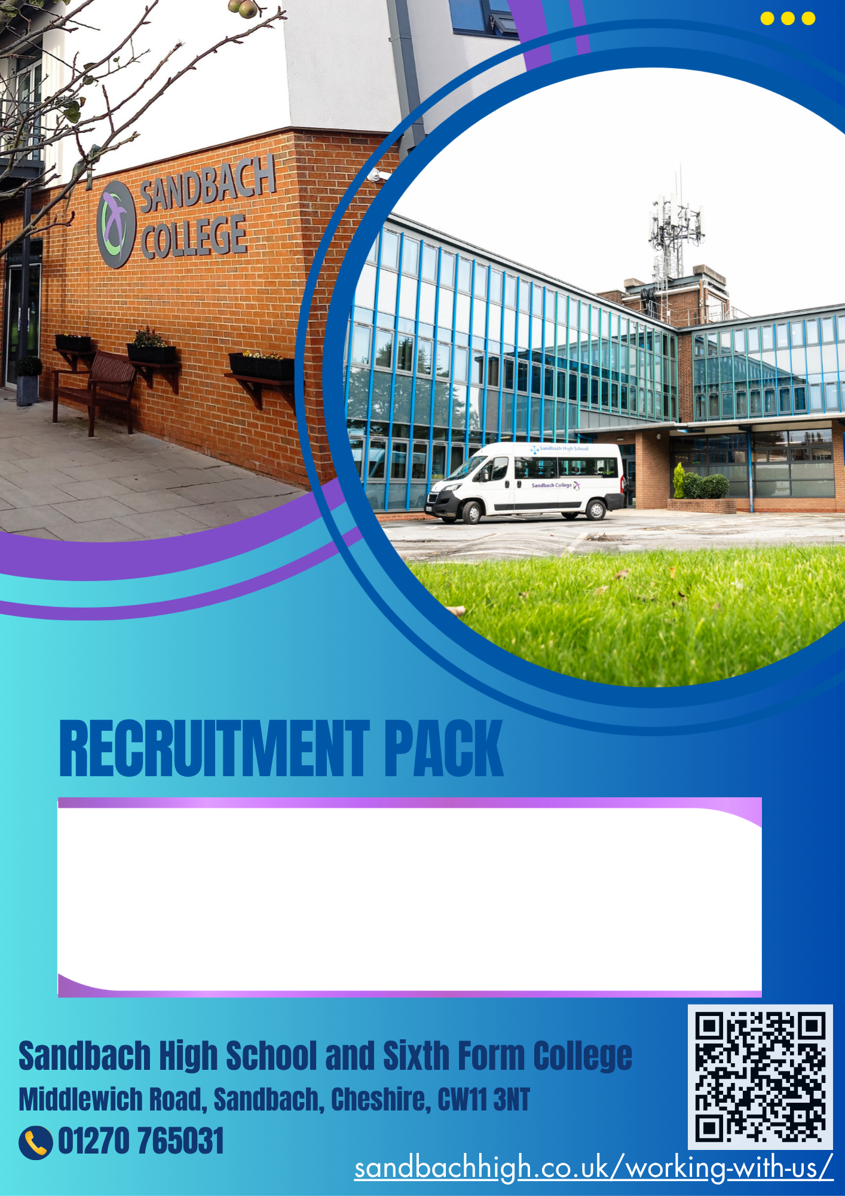

Role: Site Maintenance Officer
Starting date: As soon as possible
Closing date for applications: Friday 28th August 2026
Interviews to take place: W/B Monday 31st August 2026

Thank you for your interest in Sandbach High School and Sixth Form College. We hope that our website will help you to find out more information about what it is like to be a member of staff at our school.

We are a community in which our students and staff strive for excellence. Our values are at the core of our school; they are our promise to our families that within the school we will: Create Opportunities, Shape Futures, Learn with Passion, Nurture Ambition and Respect Difference. Our students want to make a difference in the world and our Curriculum is the springboard that enables them to achieve their ambitions.
We care about our students. We care about their wellbeing, their personal development and them as people. They are the heart of what we do as educators. We are teachers of children first, subjects second.

Standards of uniform, behaviour, attendance, punctuality and attitudes to learning are high here. We believe that the small things matter. Students are safe here in the knowledge about the clear expectations around these standards as they see visible consistency in the application of them.
Our parents/carers know that we ensure that the very best potential is realised for all of our
students because we have the highest standards. We are here to ensure that the very best life chances are achieved by our students. We have a track record of students attending the very best universities, securing sought after Apprenticeships and making a real difference in our community and further afield.

Sandbach High School and Sixth Form College has a rich culture of the Arts, STEM, Sport and our impressive extended Curriculum. We know that a well- rounded school experience should be diverse and offer a wealth of opportunity and that is offered here in abundance. You can be confident in the knowledge that students are attending a school with consistently high academic achievement within a warm community who are kind and compassionate to each other.
Our success as a school is a combined effort of dedicated staff, supportive families and our hardworking students.
If you would like to know more, we would welcome you to contact us.

Ellen Walton
Headteacher
Sandbach High School and Sixth Form College
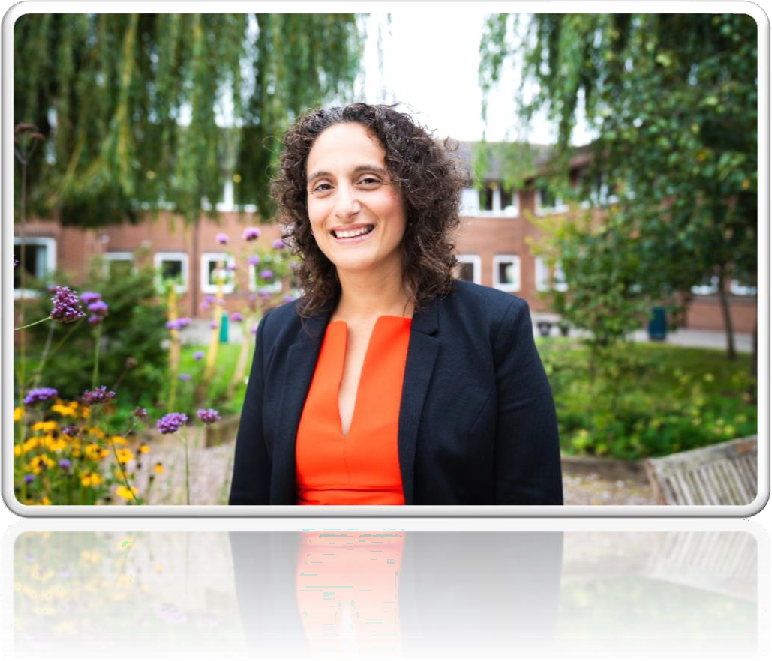

Site Maintenance Officer

Appointment Type | Permanent
Start Date | As soon as possible
Salary Scale | Sandbach High School and Sixth Form College pay scale  Grade 5 £25,801.04 - £28,598.72  (Pay Award Pending)
Closing Date | Friday 28th August 2026
Interview Date | W/B Monday 31st August 2026
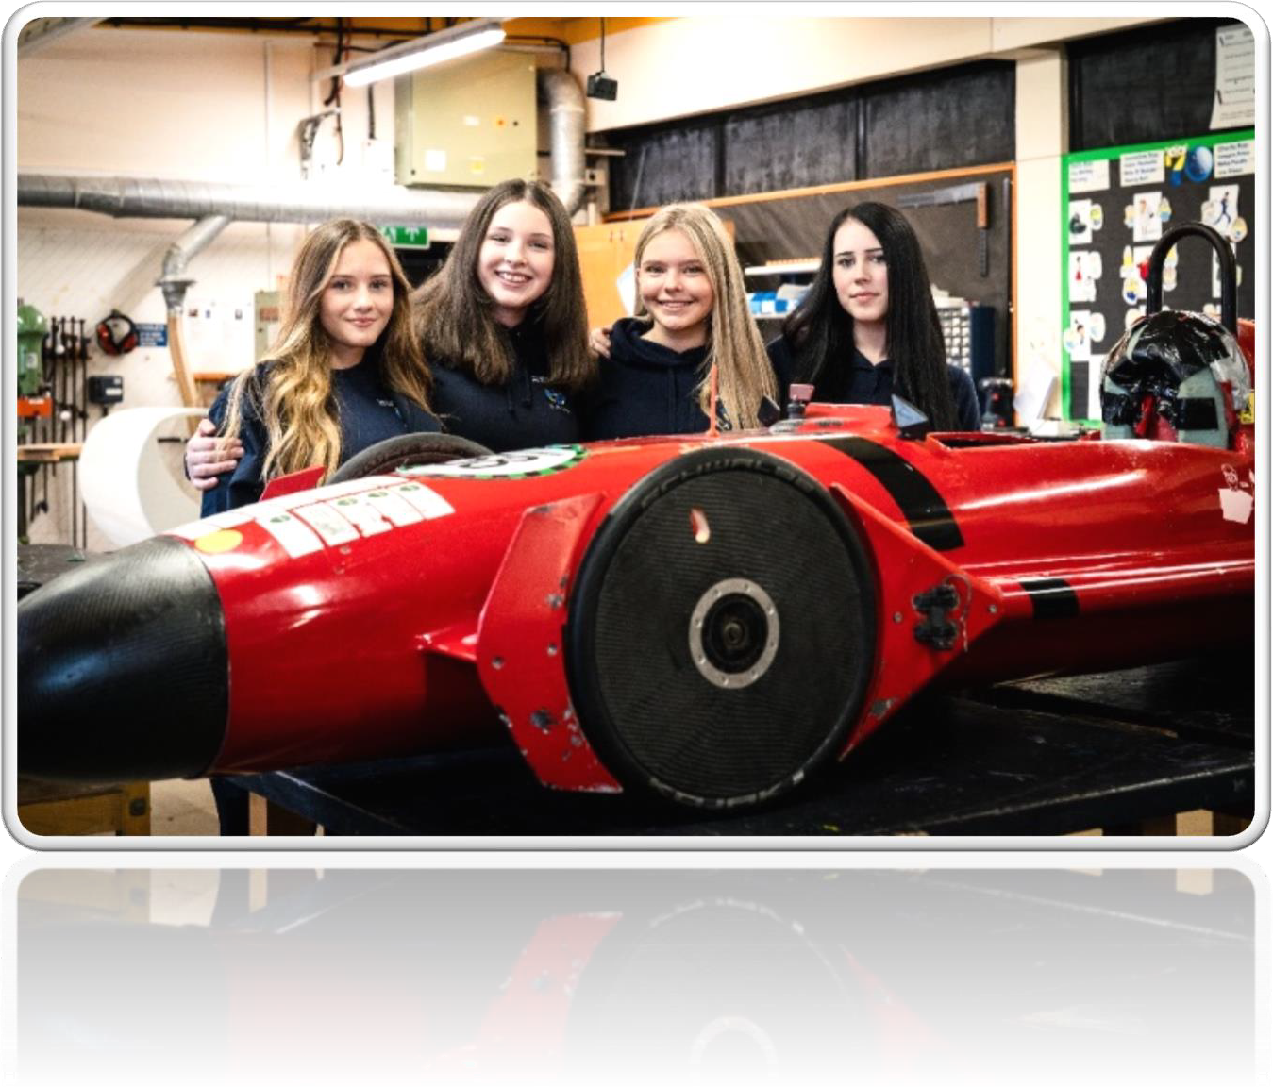

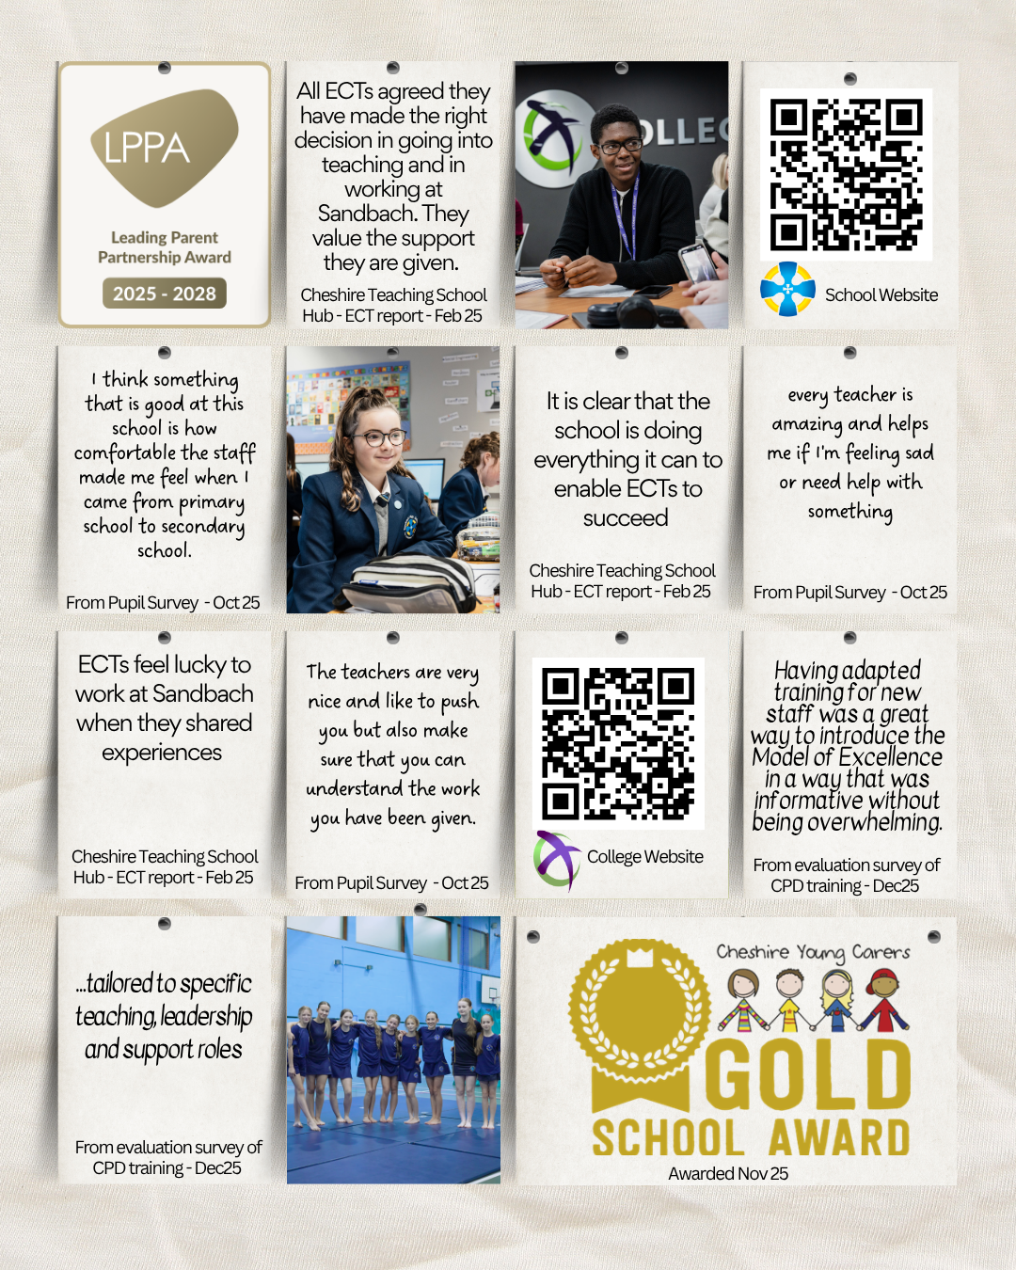

Who we are
Sandbach High School and Sixth Form College are proud to be registered with ‘Investors In People’ and continue to support the development of our teachers and support staff. We offer regular training programmes as well as staff well-being activities. Our school offers an exciting, rewarding and supportive environment for all our staff enabling them to grow and build on their skills.

We take pride in being a caring and well-ordered community where everyone is encouraged to develop self-awareness and personal responsibility and play a full part in the life of the school. Our Code of Conduct is based on respect, courtesy and consideration. We make sure that students who work hard, help others and show responsibility in their behaviour are properly recognised through our awards system. Commitment and success in sport or music are celebrated in the award of distinctive colours badges.

Our extensive curriculum is broad and balanced, giving all students the opportunity to develop their potential. A wide range of learning and teaching strategies is used to actively involve students in the learning process. Progress is carefully assessed and monitored.

Vision
An ambitious school with positive role models at every level across the school community. We strive for excellence in academic achievement and personal development. A school with visible consistency and kindness in its high standards of behaviour and attitudes. A school with research-led Quality First Teaching ensuring that all children from all backgrounds can achieve the very best life chances through creativity and a passion for learning.

Key Priorities
Key Priorities for 2026-2027

- To embed a culture of high expectations and our Model of Excellence across our whole school community.
- Securing assessment of knowledge for all including those who are disadvantaged or SEND
- To develop a positive culture amongst students and staff where we lead for legacy and in the service of others.

Values
  - Shaping Futures ♦ Learning with Passion ♦ Respecting Difference
    - Nurturing Ambition ♦ Creating Opportunity ♦THIS is our Community

Who are we looking to appoint?
The Board of Trustees are seeking an enthusiastic and inspiring Site Maintenance Officer
To work as part of the school team.
The successful candidate will be creative, imaginative and an excellent team player

We can offer you:
    - The opportunity to work in an Ofsted rated ‘Good’ school.
    - The opportunity to work with a supportive and forward-thinking Leadership Team
    - The opportunity to work alongside a collaborative, forward thinking Headteacher and Senior Leadership Team whose priority is to support and develop you.
    - Friendly and highly motivated students who are keen to learn and take pride in their achievements.
    - A comprehensive induction programme when joining the school
    - An Investors in People approved school where staff are supported and encouraged to take part in professional development programmes with the opportunity to share best practice within your own department and with staff from other specialisms.

    - A fantastic school to gain a wealth of experience to grow your career.

Job Description – Site Maintenance Officer

BASIC JOB PURPOSE
- To be responsible for the security of the premises and their contents, including being a registered key holder.
- To ensure that heating systems are in good working condition and conducting other routine checks i.e checking of oil levels.
- To undertake minor and major repairs i.e changing of light fittings, electrical sockets, plumbing tasks, carpentry, decorating and PAT testing.
- To assist general grounds maintenance duties in and around the school environment.
- Respond to radio calls.
- To maintain Health & Safety standards across the school.

MAIN RESPONSIBILITIES
1 | Maintain the school building, including effecting minor or major repairs and improvement works. Decorate interior and exterior to a high standard in order to fulfil the schools specific requirements, carry out site walk arounds to identify any Health & Safety issues and report/ action accordingly.
2 | Monitor and operate the engineering systems (i.e. boiler rooms and heating etc.) and advise Premises Manager of any faults in order to ensure the most economical use of fuel and water.
3 | Responsible for the day-to-day operation and maintenance of appropriate site security systems, including opening and closing the building at the beginning and end of the school day, lettings outside of school hours and responding to call outs as necessary in order to provide satisfactory security arrangements where required.
4 | Maintain and monitor Health & Safety standards in line with the schools’ policies. i.e complete annual Smartlog refresher training suited for the position. Ensuring that all working areas are kept clean and tidy.
5 | To be a First Aider (FAW) 3 day course.
6 | Assist the Site Maintenance Assistant as and when required.
7 | Manage and organise setups for school events i.e parents evening, exams desks, lettings and other setups as requested by the school.
8 | Monitor day to day stock levels and ensure any orders are placed in a timely manner. This also includes ordering relevant materials for planned maintenance works i.e school holidays.
9 | Effectively plan, prioritise and manage the day-to-day job requests via mailing inbox and site team diary.
10 | To manage and ensure that the weekly and monthly compliance checks are completed amongst the site team.
11 | Manage COSHH related items ensuring they are handled & stored correctly, and registers are kept up to date.
12 | Managing the day-to-day operation of the site in the absence of the Premises Manager and overseeing any contractor(s) works.
13 | Carry out gritting procedures and snow clearing during winter months to ensure that site is safe in line with the schools gritting policy.
14 | Monitor grit stock levels and arrange replenishment as required. Ensure that all grit bins are maintained and in a fully stocked condition during winter months.

Person Specification - Site Maintenance Officer
 |  | Essential |  | Desirable | How  identified
Qualifications and Training | • • | - Literacy and Numeracy skills at Level 2. |  |  | Application
Relevant Experience | •  • | - Operation of cleaning equipment, power and hand tools.  - Building maintenance i.e electrical, plumbing and carpentry. | • | Experience of working in similar environment undertaking general and major maintenance duties. | Application  References  Interview
Skills and Knowledge | •  - •  •  - • •  • | - Good knowledge and understanding of health and safety, electrical regulations and COSHH.  - Good IT skills e.g. use of email, use of word and Excel and other computer software. |  |  | Application  References  Interview
Personal  Qualities | •  • • •  • | - To be able to work as part of a team and build positive relationships.  - An ability to take initiative and seek advice where appropriate.  - Energy and enthusiasm.  - Good communication  - Flexibility for the schools needs.  - Commitment to safeguarding and promoting the welfare of children and young people.  - A commitment to continue own personal development. |  |  | References Interview

The Rehabilitation of Offenders Act

The Rehabilitation of Offenders Act allows for a person who has been convicted of a criminal
offence involving a sentence of not more than 2½ years imprisonment and who has since lived trouble free for a specified period of time (related to the severity of the offence) to be treated as if the offence, conviction or sentence had never occurred. This is known as a spent conviction.* This job is one of those to which the provisions of the above Act in relation to spent convictions*, do not apply. Applicants must therefore disclose whether they have any previous convictions*, whether or not they are spent.
Should an applicant have a criminal conviction*, this will be discussed in confidence at interview. However only convictions* that are relevant to the job in question will be taken into account.
Failure to disclose any conviction could lead to an application being rejected, or, if appointed, may lead later to dismissal.
Certain spent convictions* are ‘protected’ and are not subject to disclosure to employers, and cannot be taken into account by a recruitment manager. Guidance and criteria on the filtering of these convictions* can be found at the following link:
http://www.legislation.gov.uk/uksi/2013/1198/pdfs/uksi_20131198_en.pdf
*including cautions, reprimands or warnings.
People who have convictions will be treated fairly and given every opportunity to establish their suitability for the job, all applicants will be considered on merit and ability.
Any information that you give will be kept in strict confidence and will be used only in respect of your application for the job.

Disclosure & Barring Service (DBS)
Successful applicants will be asked to apply for an Enhanced Criminal Record Check (Disclosure) from the Disclosure and Barring service.
A copy of the Disclosure and Barring Service Code of Practice is available on request.
Further information about the Disclosure scheme can be found at
https://www.gov.uk/government/organisations/disclosure-and-barring-service

Safeguarding Children
Sandbach High School and Sixth Form College is committed to safeguarding and promoting the welfare of children and young people and expects all staff and volunteers to share this commitment.

All staff at Sandbach High School and Sixth Form College are expected:
- To adhere to the school’s corporate standards, policies, systems and procedures in relation to Safeguarding and Child Protection, and health and safety
- To set a personal example that contributes to the positive ethos of the school
- To be committed to the life of the school and to support its distinctive mission and ethos
- To behave at all times in accordance with the school’s values
- To agree annual performance targets with their Line Manager
- To promote the school favourably in the community
- To engage actively in the performance review process, addressing appraisal targets set in conjunction with the line manager each autumn term.
- To participate in training and other professional development learning activities as required.
- To promote equal opportunities and celebrate diversity in all aspects of the school.
- To play a full part in the life of the school community, to support its distinctive aim and ethos and to encourage staff and students to follow this example.
- To adhere to the school’s Staff Code of Conduct and the Dress Presentation Code.
- To comply with the school’s Health and Safety policy and undertake risk assessments as appropriate.
- To be familiar with and promote safeguarding requirements, demonstrating adherence to the DfE Guidance ‘Keeping Children Safe in Education’ and the school’s Safeguarding/Child Protection policies.
- To be aware of and comply with all school policies and procedures, in particular those relating to conduct, child protection (as above), health, safety and security, confidentiality and data protection, reporting all concerns to an appropriate person.

Safeguarding
Sandbach High School and Sixth Form College is committed to keeping children, young people and vulnerable adults safe. The post holder is responsible for promoting and safeguarding the welfare of the children, young people and vulnerable adults for whom she/he is responsible or comes into contact with.

Health & Safety
The post holder will be responsible for his/her own health and safety. All duties and responsibilities must be carried out in line with the specific requirements detailed in the school Health and Safety policies.

Policies & Procedures
The post holder will be accountable for ensuring that he/she is aware of relevant school policies and that all duties and responsibilities are carried out in line with the appropriate policies and procedures.

Equality Act 2010
The school will endeavour to make any necessary reasonable adjustments to the job and the working environment to enable access to employment opportunities for disabled job applicants or continued employment for any employee who develops a disabling condition (as defined in the Equality Act 2010).

Applications
We promote applications from all sections of the community, irrespective of background, belief, or identity, recognising the benefits that a diverse organisation can bring.
To apply for this post, please complete an application form with a supporting statement of no more than two sides of A4 on your suitability for the post and the school, with reference to your areas of expertise. Please send completed forms to recruitment@sandbachhigh.co.uk

