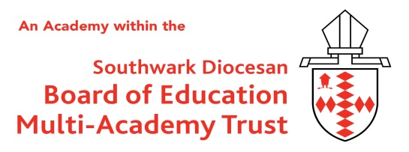

St Paul’s CofE Primary School,
Penrose Street, Walworth, London, SE17 3DT
Telephone: 020 7703 4896

office@stpauls.southwark.sch.uk
www.stpaulsprimary.school

Job Title: | Site Manager
Grade Range: | Southwark 6a, Points 15 to 19 (From £35,892 to £38,070)
Hours: | 36 hours per week (split shift)/ 52 weeks per annum
Start Date: | ASAP
About us:

St. Paul’s CofE Primary School is an academy which is part of the Southwark Diocese Multi Academy Trust. The school converted to the trust in February 2019 and with the support of the diocese, a team committed to whole school improvement and a wonderfully supportive group of Governors and parents is going from strength to strength.

Role of the Site Manager:

We wish to recruit a Premises Manager to be responsible for all aspects of our school environment. We require someone who is professional, knowledgeable, reliable and conscientious. This is a key appointment for the school; the successful candidate will be given delegated responsibility to ensure statutory compliance is met, the internal and external fabric of all school premises are safe and well maintained. Our aim is to create the best possible learning environment for our school community.

We can offer you:

- A dedicated and motivated team of colleagues and governors, committed and passionate about driving the school forward and improving outcomes for all pupils
- A happy and harmonious school community built on strong Christian foundations
- A great opportunity to make a difference to our children
- A culture of successful mentoring, peer support and professional development
- A school with excellent facilities and extensive grounds
- An easily-accessible school, close to Redhill town centre and railway station

Prospective candidates are encouraged to come and visit the school and discuss the post. We would love to show you our school. Please contact us on 020 7703 4896 or email office@stpauls.southwark.sch.uk

Closing date: | 12noon Monday 28th September 2026
Interview: | Friday 2nd October 2026
Applicants are expected to be sympathetic to the Christian ethos of the school.
St Pauls’s is committed to safeguarding and promoting the welfare of children and expects all staff and
volunteers to share this commitment.
All appointments are subject to a satisfactory enhanced DBS check and references.

