



INFORMATION FOR CANDIDATES 2023-2024

Nurturing Excellence
Growing Aspiration
Thriving Together

Dear Applicant,
We are delighted that you are considering applying for a role at Meadow Park School.
The school has been on an improvement journey and we are delighted that our most recent Ofsted inspection (January 2024) moved the predecessor school (Whitley Academy) out of ‘Special Measures’; giving a judgement of ‘Good’ in three areas, with an overall judgement of ‘Requires Improvement'.
‘Pupils, parents and staff all describe the significant improvements that have taken place at the school since the arrival of the new headteacher. There is now a clear and ambitious vision evident from all leaders to improve the quality of education for all pupils.’ (Ofsted January 2024)
We are a ‘caring and compassionate school’ where ‘Cultural diversity is celebrated’. (Ofsted January 2024)

We will offer you:
- A supportive, collaborative and friendly staff environment in a school where you will have the chance to make a real and positive impact on the lives of Meadow Park School students
- A comprehensive professional development programme with the school being part of the Finham Park MAT and The Lion Alliance, which offers a range of ITT, early careers, middle and senior leader development programmes through the National College, SSAT and the Chartered College of Teaching. We have a passion for teaching and learning and professional development; recent speakers have included Tom Sherrington, Dylan Wiliam, and Harry Fletcher-Wood amongst other leading educationalists
- A range of health and wellbeing services at the school and through the MAT and external services
- Free, on-site car parking
- Free tea, coffee, water, travel mug, water bottle, and fleece; with free food provided weekly
- The option to volunteer for paid lunch duties (additional pay, free lunch and coat)
- A commitment to staff well-being, including a Staff Forum and well-being committee
We are committed to Safer Recruitment practices and procedures and shortlisted applicants will be questioned about their commitment to the safeguarding of young people. The successful candidate will be subject to an enhanced DBS clearance.
Having read the candidate information, I hope that you feel excited by both the role itself and the chance to be part of Meadow Park School at a pivotal moment in its development. We welcome visits from prospective candidates and would be proud to show you round our wonderful school.

We look forward to hearing from you.



Mrs Bernadette Pettman
Headteacher (BA (Hons), NPQH, MCCT, FRSA
Our School
We are an 11-18 co-educational school (180 PAN in Years 7-11), with a growing Sixth Form.
“The school is welcoming to all pupils and is frequently described as caring and compassionate.”
“The school has high expectations of pupils’ attendance and behaviour.”
“The school has thoughtfully designed a curriculum that is ambitious and tailored to the interests of pupils. A broad range of subjects is offered at Key Stage 4, including several vocational subjects.”
“Teachers know their pupils well.”
Ofsted January 2024

We are a fairly typical city comprehensive school with students from a range of socio-economic backgrounds, including those in the most socio-economically deprived areas of Coventry. We are proud to be an inclusive school and multi-cultural community where ‘Cultural diversity is celebrated’; our students come from a range of nationalities and cultures.
Our brand-new Business and Innovation Sixth Form Centre was opened in September 2023, providing a range of A Level, vocational and technical qualifications. We specialise in providing courses, which enable students to go on to a range of universities, apprenticeships and employment, particularly careers linked to business and the NHS.
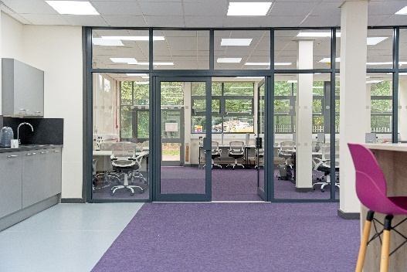
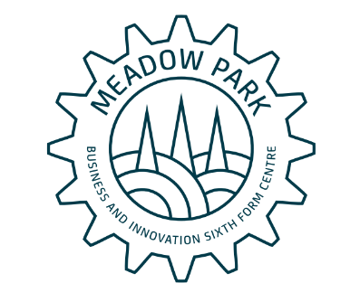


“Finham Park MAT has provided me with a huge range of opportunities throughout my career as a teacher. Staff are incredibly supportive and the opportunities for CPD are fantastic, including a new ‘Leadership Pathways’ programme. I would thoroughly recommend working in the MAT to anyone and hope to continue to develop my career over the coming years.”
FPMAT employee
The school’s last inspection highlighted many of the positive things that are taking place in the school and has given us a firm platform from which to achieve our aims.
Our school priorities for 2023-28 clearly focus on our culture for improvement and can be viewed on the next page.
We are very proud of all students at Meadow Park School where we develop students through our unwavering focus on Nurturing Excellence, Growing Aspiration, and Thriving Together.




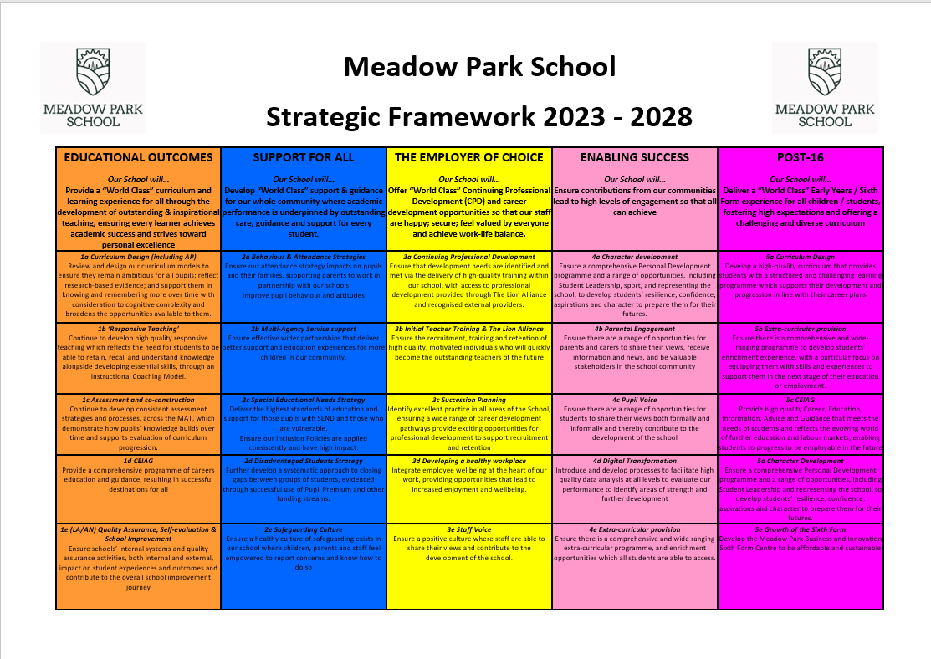
Strategic Framework 2023 - 2028

Opportunities
We are committed to developing our staff professionally and ‘growing our own’. Our most recent Ofsted report (January 2024) recognised ‘There is a coherent training plan in place to help teachers improve their teaching.’
All staff have access to a professional to provide personalised feedback and professional development through Instructional Coaching.
We have dedicated co-planning and co-construction time built into our directed time budget so that teaching staff can work collaboratively within the school and across the Finham Park MAT on teaching, learning and assessment. We also offer a range of in-house and nationally accredited courses through the Lion Alliance, these include:
Chartered Teaching Programme | TeachMeets | Lion Leadership Courses | ECT (Early Career Teacher) Programme
As part of the FPMAT you have access to a registered learning partner from the Chartered College of Teaching and we offer the CTP to colleagues within the alliance. | We host regular TeachMeet events that draw on our expert colleagues’ knowledge. This means we can be flexible and adapt to the changing needs of staff in schools. | We have 4 strands of leadership development courses. This includes Associate, Aspiring Middle, Middle and Senior Leaders courses. | The Head of the Lion Alliance is one of the regions ECT training facilitators; able to support newly qualified teachers as they begin their career.

We also have access to a range of key speakers who include world-renowned authors and teaching professionals; inviting them to speak about the latest developments in their specialist area at a range of Finham Park Multi Academy Trust and Lion Alliance events. Guests have included:

Tom Sherrington, Tom Bennett, Oliver Cavialioli, Mark Roberts, Adam Boxer, Matt Pinkett, Nina Jackson and many more…

We also recruit and mentor PGCE students through a school-led PGCE programme (in partnership with the University of Warwick), meaning we can offer further opportunities in:
PGCE Mentoring | Working with us as an alliance | Working with our partner universities
There are opportunities to mentor PGCE students in your subject. This involves mentor training being provided by our University partners, and is a great way to nurture the next generation of teachers. | We have regular opportunities to get involved and share your expertise with colleagues in our alliance schools. | We work with the University of Warwick, Coventry University and Birmingham City University, where there are opportunities to help support and contribute to the wider higher education community.

Find out more by visiting www.thelionalliance.co.uk
https://thelionalliance.co.uk/continuing-professional-development-cpd/
The area
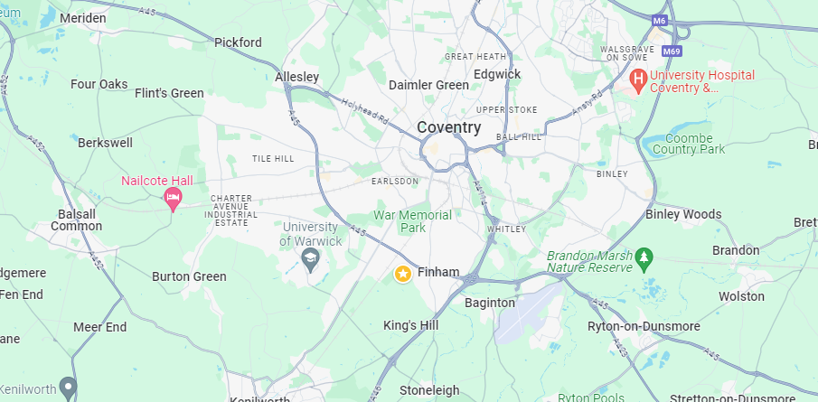


Coventry, a historically significant city with ancient Saxon and Roman origins and a vibrant heritage in industries like weaving, watchmaking and automotive engineering, emerged from the ashes of World War II as a symbol of hope and resilience.
The city's international partnerships, including twinning with 27 other towns, fostered its transformation into a centre for peace and reconciliation, while offering diverse activities, cultural attractions and excellent transportation links in a scenic Warwickshire setting.
Meadow Park School has incorporated these links into our school logo which features the city’s three spires, rolling hills and a cog. The School is located in an area that is close to the border between Coventry and Warwick. A vibrant, modern building and facilities in a beautiful location within easy reach of the M40/M6 corridor.

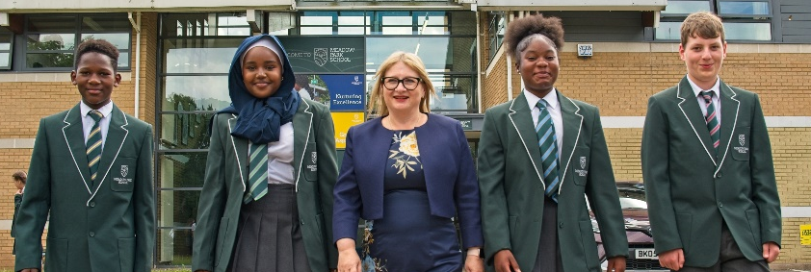
Contact us
Meadow Park School
Abbey Road
Coventry
CV3 4BD

Telephone 024 76302580
Email admin@meadowparkschool.com
Website www.meadowparkschool.com

Finham Park MAT
Torrington Avenue
Coventry
CV4 9WT

Telephone 024 77180000
Email hr@finhamparkmat.co.uk
Website www.finhamparkmultiacademytrust.co.uk





@MeadowParkCov @FinhamParkMAT

