

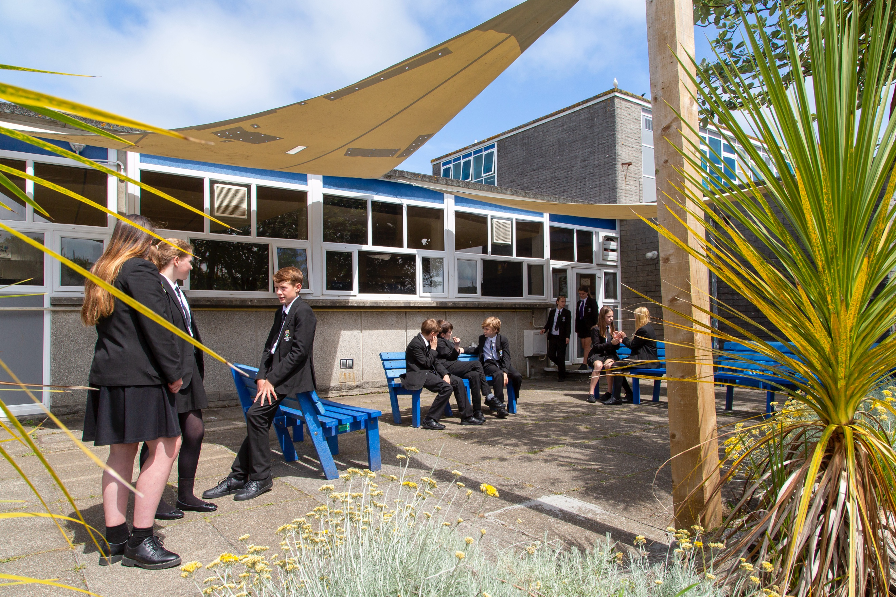

APPLICATION PACK

**Site Supervisor**

**Principal – Mr S Royle BA Hons PGCE NPQH**

Mounts Bay Academy

Boscathnoe Lane

Heamoor

Penzance

TR18 3JT

[www.mountsbay.org](http://www.mountsbay.org)

Salary scale: H3-H6 £28155.00-£30607.00 Pro rata

Contract Type: Part Time (3 days a week) 0.6 FTE 52 weeks a year.

Contract Term: Permanent

# Site Supervisor

An exciting opportunity has arisen, and we are now recruiting for an exceptional and experienced Site Supervisor.

Mounts Bay Academy is a caring and dynamic school which places students at the centre of everything we do. We are proud of the facilities and opportunities provided to students and focus on creating a culture for success, and a positive environment for learning.

The successful candidate will have previous supervisory experience and will provide strong and inspirational line management of the site team. They will be solutions focused, resolving issues quickly and effectively and will take full responsibility for the care, maintenance, and upkeep of the premises.

Application forms and information packs are available via our school website or upon request by telephoning

the Academy.

For further information, please contact Malvina Jenkin HR Manager at Mounts Bay Academy 01736 352399 or email: [mjenkin@mountsbayacademy.org](mailto:mjenkin@mountsbayacademy.org)

**Closing date for applications**: 17/06/2024

**Interviews: 20/06/2024 09.00 am**

**Start date: ASAP**

Please send your completed application form to Malvina Jenkin mjenkin@mountsbayacademy.org, Boscathnoe Lane, Heamoor, Penzance, TR18 3JT.

The successful candidate will be subject to reference checks with previous employers and an enhanced DBS disclosure check.

## 

## Welcome from the CEO of Leading Edge

## Welcome from the Principal

Dear Applicant

Thank you for expressing an interest in the post of Site Supervisor. I hope you find this information pack helpful and that, in due course, we shall receive an application from you.

Mounts Bay’s reputation for excellence has grown from over half a century of generating new ideas, encouraging divergent thinking, and nurturing a learning community of highly motivated staff and students.

We are passionate about developing talent and have created an environment where everyone is empowered to exceed their true potential. We pride ourselves in fostering a natural ability, ambition, and confidence in students to become forward thinking, highly employable entrepreneurs who drive creativity and inspire new levels of academic and professional success.

Secondary education is a key stage in the life and development of each young person and so we aim to work together with parents and carers to support the children; enabling them to develop and grow within our community and in building together a real sense of identity within Mounts Bay Academy

The Academy is committed to a leadership approach at all levels. We are all empowered to make a difference in terms of the school’s ability to address its core purpose. We encourage creative planning to challenge and inspire both students and staff alike.

Mounts Bay Academy is an exciting place in which to work. We always seek to appoint new colleagues who enjoy challenge and believe that they can contribute to helping us improve what we offer our students.

I look forward to hearing from you.

Yours sincerely,

Simeon Royle

Principal

## Application

## Application

If you wish to apply, please email your application to Malvina Jenkin HR Manager at [mjenkin@mountsbayacademy.org](mailto:mjenkin@mountsbayacademy.org) (copies of all the details are available online on our website under the ‘Vacancies’ section) or post your completed application form to the address below, together with a covering letter, clearly demonstrating your suitability for the role. Where possible, please also provide email addresses for your referees.

In line with our safeguarding practices, we are unable to accept CVs.

## Closing Date

Please ensure your application arrives before the closing date/time and that the post for which you are applying has been stated clearly on the application form. Applications received after the closing date will not be accepted.

## Interview

Interviews for the post will take place shortly after the closing date. All applicants will be informed if their application has been successful, within 2 weeks of the closing date.

Mounts Bay Academy is committed to safeguarding and promoting the welfare of children and young people and we expect all staff and volunteers to share this commitment.

We follow safer recruitment practices and appointments are subject to an enhanced DBS check prior to employment. Details of our Safeguarding and child protection policy can be found on our website [www.mountsbay.org.](http://www.mountsbay.org/)

Mounts Bay Academy

Boscathnoe Lane

Heamoor

Penzance

Cornwall

TR18 3JT

Phone: 01736 363240

Web: [www.mountsbay.org](http://www.mountsbay.org/)

## Job Description

|  |  |
| --- | --- |
| **Post Title:** | **Site Supervisor** |
|  |  |
| **Purpose:** | To be responsible for all aspects of the Academy’s site management to ensure the cleanliness, safety and security of the Academy buildings and grounds.  To line manage the site team.  To contribute to Academy decisions regarding premises management and development. |
|  |  |
| **Reporting to:** | Chief Operating Officer |
|  |  |
| **Direct supervisory:** | Site Team and grounds man. |
|  | Contract maintenance staff. |
|  |  |
| **Liaising with:** | Internal: Working closely with the Health and Safety and Compliance Manager and carry out daily checks in their absence and escalate back to them as needed.  Principal, Senior Management Team, Staff, Pupils, Volunteers and Governors  External: Parents, Cornwall County Council Technical Advisers, maintenance contractors, suppliers of goods and services and members of the public. |
|  |  |
| **Working time:** | 52 weeks a year 3 days a week |
|  |  |
| **Salary/Grade:** | H3-H6 £28155.00-£30607.00 Pro rata |
|  |  |
| **Disclosure level:** | Enhanced |
|  |  |

### MAIN (CORE) DUTIES

|  |
| --- |
| **Main Duties and Responsibilities** |
| * To be responsible for the overall security arrangements of the premises including ensuring that staff are aware of the procedures on security and the use of alarm systems, that there is an appropriate system of keyholding management, that periodic reviews off site security are conducted and that appropriate progress action is followed through. * Manage all forms of access and egress with pedestrian and public paths and gates, ensuring that all are compliant, serviced and safe. * Manage the processes around seasonal conditions and safe access and communications with staff are regular and up to date. * Monitor the building temperature using the BMS system to ensure a balanced working and learning temperature. * To organise, supervise and assist in major cleaning activities. * To draw up maintenance schedules and set routine programmes of work for cleaning staff, caretakers, premises and grounds maintenance staff to ensure consistently high standards of hygiene, cleanliness, upkeep and safety of all Academy buildings and premises. * To be responsible for the upkeep of playing fields, gardens, all weather surfaces (tennis courts, swimming pool where applicable) and land drainage. To ensure the maintenance of boundaries, footpaths, roads and rights of way within the Academy premises. |

|  |
| --- |
| **Leadership and Management** |
| * To work with the Health and Safety and Compliance Manager to ensure the Academy meets all Health and Safety regulations as far as reasonably practicable. * To be responsible for the line management of caretakers. * To ensure appropriate staffing levels and deployment of staff in all premises-related departments. To review the staffing establishment with the principal and undertake the recruitment and selection of additional staff in accordance with the agreed staffing strategy for the departments. |
| **Health and Safety** |
| * To work closely with the Health and Safety Compliance Manager to ensure that the Academy site is safe and compliant for all pupils, staff, volunteers and visitors. * Ensure Health and Safety processes and procedures are implemented to adhere to Health and Safety Regulations across the Academy. * To monitor the safe storage and control of any potentially harmful materials and chemicals used within the Academy and ensure that such materials are appropriately marked and signposted. |

|  |
| --- |
| **Security** |
| * Ensure that all Academy buildings and grounds are secure and manned guards and any systems/procedures and other appropriate personnel open and lock up areas, gates and doors. * To advise on the security of buildings during periods of lettings and to ensure appropriate heating arrangements are made to meet lettings demands. |
| **Contract Management** |
| * To, alongside the Health and Safety and Compliance Manager, be the client-side link with contracting staff, contribute to specifications, monitoring and review of all major contracts and services and to undertake appropriate administrative processes for specifying and letting minor contracts in accordance with established guidelines. * To liaise with client nominated officers as directed. * Where external contractors/inspectors are employed, to monitor work and certify that work has been done satisfactorily. * To work with the Health and Safety and Compliance Manager to ensure that any capital development projects are delivered on time and work in partnership with the elected project team. |
| **Building and Project Works** |
| * To support the Health and Safety and Compliance Manager to manage any ongoing building and project works and to ensure that the impact to business as usual is minimised. |
| **Sustainability** |
| * Engage and develop with new sustainable initiatives around energy solar gain and consumable reduction and new lighting and good practices around the Academy, * Engage with students on external grounds and curriculum projects, ensuring green initiatives are foremost. * Ensure all confidential and sensitive waste is collected and destroyed on site and evidence is supported and stored whilst meeting GDPR Regulations. * Manage all commercial and industrial waste, ensuring compliance and duty of care certificates are produced and stored locally. |
| **Compliance and Supporting Personnel Management** |
| • To be aware of and adhere to applicable rules, regulations, legislation and procedures eg County Council (Equal Opportunities Policy/Code of Conduct), national legislation (Health and Safety, COSHH, Data Protection). |
| * To maintain confidentiality of information acquired in the course of undertaking duties for the department and comply with GDPR Regulations. * Ensure the facilities staff job descriptions are up to date and reviewed. * Report all major incidents or accidents to the HSE on any such matters under RIDDOR. |
| **Other Specific Duties** |
| * To remain and adhere to the Trust’s Safeguarding Policy and child protection procedures. * To play a full part in the life of the Academy community, to support its distinctive mission and ethos and to encourage staff and students to follow this example. * To actively promote the Academy’s corporate policies. * Be responsible for your own continuing self-development, undertaking training as appropriate. * To be aware and adhere to applicable rules, regulations, legislation and procedures eg the Trust Equality and Diversity Policy, Staff Code of Conduct, national legislation and GDPR Data Protection Regulations. * To comply with the Academy’s Health and Safety Policy and undertake Risk Assessments as appropriate.     **As a restorative organisation we:**   * Apply the principles of mutual respect and responsibility in all our internal and external relationships. * Actively work to prevent, address and repair harm. * Engage in continuous learning to further develop our communication and problem-solving skills. |

Whilst every effort has been made to explain the main duties and responsibilities of the post, each individual task undertaken may not be identified.

Person Specification

|  |  |  |  |
| --- | --- | --- | --- |
| **Attributes** | **Essential** | **Desirable** | **Demonstrated By** |
| **Relevant Experience** |  | 5 years’ experience of building and grounds maintenance work in a  school/college or similar environment | Application Form / Interview |
| **Qualifications** |  | GCSE’S Maths and English as a minimum | Application Form |
| **Education and Training** |  | Relevant, transferable trade experience (electrical, plumbing, carpentry etc.)  Health and Safety and COSHH training  Lifting and manual handling training | Application Form |
| **Knowledge** |  | Knowledge of statutory compliance for the physical environment  Knowledge of Health and  Safety legislation as it applies to the Academy  Knowledge of building construction and maintenance  Technical knowledge and understanding of heating, lighting, security systems and building management systems  Understanding of systems for the ordering of supplies, commissioning contractors, facilities management  Good comprehension of surveillance systems and premises security  Good comprehension of technical systems and related legislation  Knowledge of Physical | Application Form / Interview |

|  |  |  |  |
| --- | --- | --- | --- |
|  |  | Resources and Information systems  Experience of managing and maintaining BMS systems  Experience of supporting and training teams related procedures and Health and Safety  Evidence of supporting and training teams on Health and  Safety related topics |  |
| **Skills and**  **Competencies** |  | Management and  organisational skills  Analytical and problem solving skills  Strong interpersonal and communication skills  Ability to empathise, communicate and collaborate confidently and effectively at all levels from students, suppliers, staff, governors and senior leadership  Able to provide advice and make recommendations to the senior leadership team and trust on longer-term  maintenance of the Academy site  IT skills.  Physical skills – manual dexterity in operating equipment and minor repair work; occasional short periods of physical effort such as bending and stretching and using tools and equipment.  Good personal organisation and time management  Ability to deliver staff training and present effectively | Application Form / Interview |
| **Behaviours** | Risk averse – ability to balance risk versus benefit Flexibility in working hours  Enjoys working as part of a team |  | Application Form / Interview |
|  | Able to work under own initiative and independently  Able to reflect and learn from experience  Resilient and able to function well under pressure  Propensity for attention to detail |  |  |