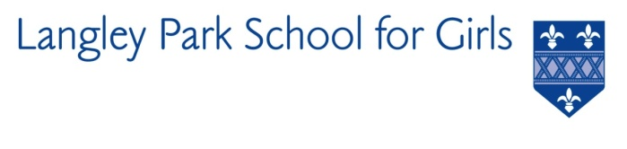

Langley Park School for Girls

Hawksbrook Lane

Beckenham

Kent BR3 3BE

Acting Headteacher: Mr David Webb

SIXTH FORM ACADEMIC SUPPORT TEACHER

REQUIRED ASAP

Salary: Unqualified teacher scale/MPS

Langley Park School for Girls is seeking to appoint an enthusiastic Academic Support Teacher to join the Sixth Form and Student Support team. This post will be supporting specific named or groups of students and those with medical needs and would be ideal for someone who has an interest in working within SEND or someone who is considering a future career in teaching.

Working with class teachers across the curriculum and the SEND team, the successful candidate will support students with their Key Stage 5 learning. This includes subject specific support as well as support for the wider skills for learning including transition points; from liaison with Year 11 teams to support with UCAS applications.

Although experience and qualifications will be an advantage, first and foremost we wish to appoint the right people to complement our team. The successful applicant will have access to on-site training and support which is specifically linked to the needs of identified students.

LPGS is an exciting place to work; a school in which students are motivated to achieve their best and work hard to make exceptional progress. We want our students to leave LPGS empowered to shape their own lives, and those of others, as the leaders of tomorrow.

LPGS is an inclusive and academically successful school in South East London with results in terms of progress and attainment that put it in the top 5% of schools nationally. It is now an all-ability school of 1700 students with a large co-educational Sixth Form. Currently there are 100 teaching staff , 58 associate staff (full and part time) and an annual budget of over £10 million. The school is part of the Impact Multi Academy Trust which is made up of 4 secondary schools and 3 primary schools across the Bromley borough. Public transport links are good and staff travel from across London and the South Coast. In October 2021, Ofsted found that if they undertook a Section 5 inspection they would judge us to be outstanding. In addition to this, 100% of staff asked told Ofsted that they would recommend the school.

LPGS is a calm, friendly and collaborative environment which offers strong staff support. Staff enjoy working here because our students love learning and work hard. Our CPD programme gives all teachers time to pursue their own priorities. This results in a two week October half term. Please see application details on our website www.lpgs.bromley.sch.uk. Completed application forms should be emailed to Helen Partridge, hpa@lpgs.bromley.sch.uk. If you are interested in this position and would like to arrange an informal chat with the SENCO before applying, please let us know and we will make the necessary arrangements.

Please note that whilst you are also welcome to submit a CV, shortlisting will be based solely on our application form and covering letter. All applicants must complete the LPGS Application Form.

We are a diverse school and an equal opportunities employer. We encourage applications from under-represented groups.

The closing date for applications is 12 noon on Wednesday 11th January 2023 with interviews on Tuesday 17th January 2023. You are encouraged to submit your application as soon as possible. Please note the school reserves the right to appoint prior to 11th January.

This school is committed to safeguarding and promoting the welfare of children and young people and expects all staff and volunteers to share this commitment. The successful applicant will be subject to an Enhanced Disclosure & Barring Service check.

