
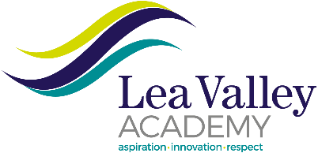

Sixth Form Student Manager
Full Time/Permanent
Term time plus one week
Required from September 2026

We are expanding our student support services therefore we looking to appoint a Sixth Form Student Manager to work in our increasingly popular school, which has a reputation for providing outstanding support for staff and students. Our associate staff are highly valued and play a vital role in the school’s aim to be a centre for educating our community for success.

This important role would suit anyone who wishes to work with children and make a real difference in their lives; you will be the main point of contact for students in your year group. If you are planning to enter the teaching profession, this is also an ideal opportunity to gain experience in managing groups of students and learning how to make an impact upon their progress in school.

As a Sixth Form Student Manager, you would be part of a successful team that provide professional leadership and management for a group of pupils to secure high levels of behaviour, promote high levels of ambition and promote independent learning. You would be supporting the Sixth Form Progress Leader responsible for a particular year group on a daily basis and working closely with students supporting their progress and helping them aspire to achieve their best.

If you are seeking a rewarding position where you can enrich the lives of students who attend Lea Valley Academy, then we want to hear from you.

Actual Salary Range: £32,344– £34,324 p.a. inc. (Scale 6 - Pt 18-22)
Hours: 36 hours per week x 40 weeks per annum (plus 1-hour contractual overtime per week)

For full details of the post or for an application pack please visit the school website https://www.edact.org.uk/careers or email us at lvarecruitment@edact.org.uk

Download an application pack from the school website https://leavalley.org.uk/ or email us at lvarecruitment@edact.org.uk When applying please ensure you meet the criteria set out in the job description and person specification.

Applications are to be received no later than 9am Monday 8th June 2026 with interviews to be held week commencing Monday 15th June 2026.
CVs will not be accepted as formal application and previous applicants need not re-apply.

We will be processing applications as received and reserve the right to close the vacancy early should we appoint earlier than the closing date.

We will be processing applications as received and reserve the right to close the vacancy early should we appoint earlier than the closing date.

Lea Valley Academy is part of the EdAct Trust and is committed to safeguarding and promoting the welfare of children and young people. Therefore, all employees working at this school are expected to share this commitment. An equal opportunity employer.

