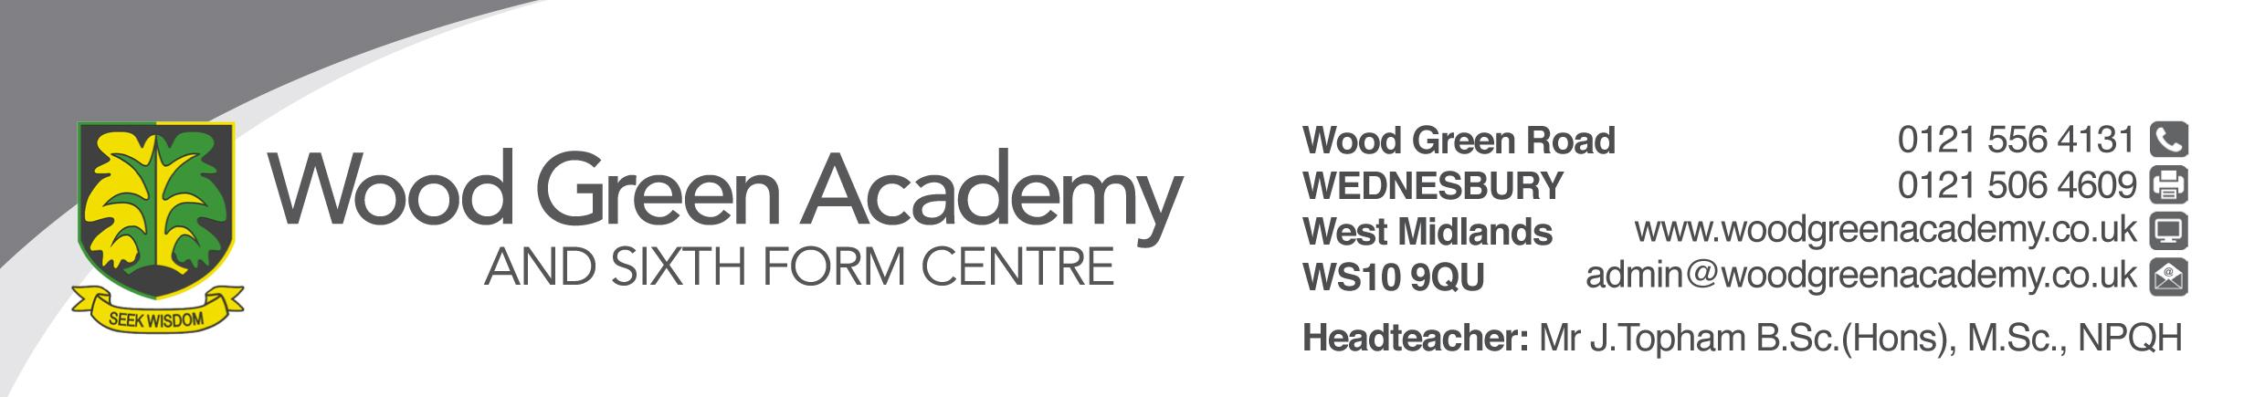
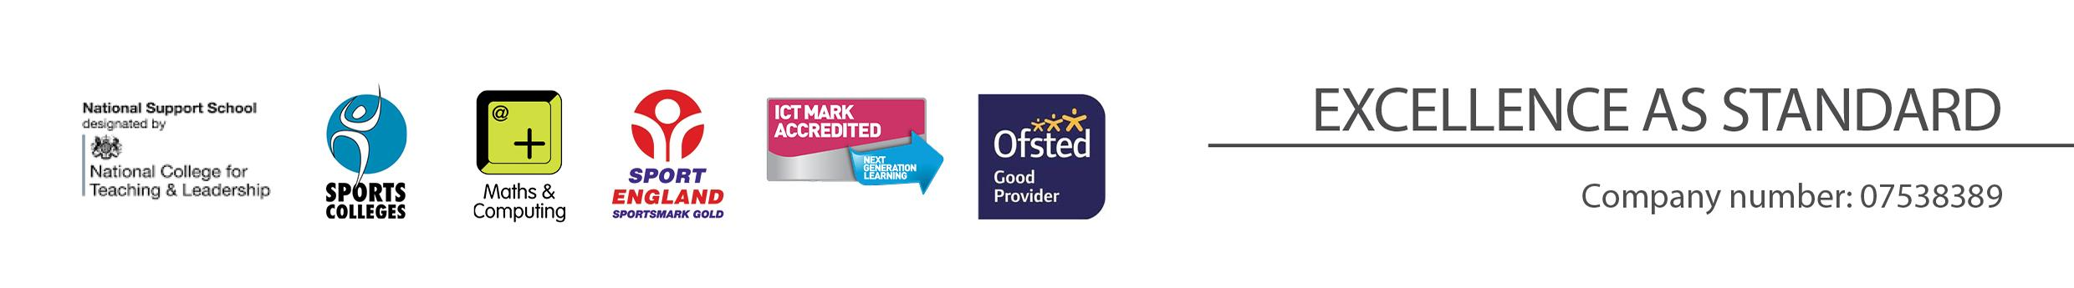
Post 16 Academic Coach and Learning Hub Manager
Person Specification

REQUIREMENT | ESSENTIAL | DESIRABLE
LEGAL REQUIREMENTS | Enhanced DBS Clearance
QUALIFICATIONS  Principally assessed through letter and application form | GCSE A* - C in English and Maths.  A Levels | Degree  A Level B or above in subject to be supported
EXPERIENCE and PROFESSIONAL COMPETENCE  Principally assessed through letter, application form and lesson observation | Experience of working with Secondary children  Knowledge and understanding of Equal Opportunities  Knowledge of Health and Safety issues
KNOWLEDGE  Principally assessed through letter and interview process | An understanding of child development and appropriate levels of childcare
COMMUNICATIONS  Principally assessed through letter and interview process | Have excellent written and verbal communication skills  Ability to use IT technology
PERSONAL ATTRIBUTES  Principally assessed through references, letter and interview process | To be committed to safeguarding and promoting the welfare of children and young people  Ability to motivate individuals to perform effectively  Ability to innovate and contribute to new initiatives  Commitment to working in partnership with parents  Awareness of and respect for, the needs of the individual child and their families, including multi-cultural and inclusive practices.  Flexibility and willingness to be involved in the school  Work effectively as a member of a team  Be an effective role model through presentation and personal conduct  Enthusiasm, energy, vigour, reliability and integrity

