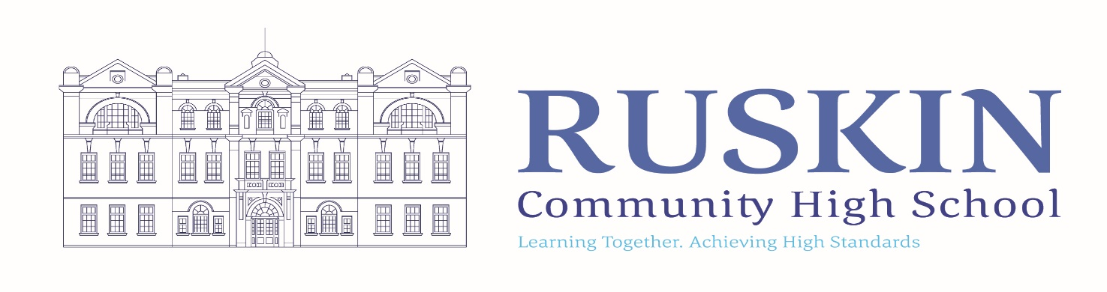
SENDCO

FULLTIME/PERMANENT: M6/UPR + SEND allowance

CLOSING DATE: Friday 15th October, 2021 – 12 noon
TO COMMENCE: 1st January 2022

Ruskin Community High School is seeking to appoint an inspirational and dynamic SENDCO who will lead the SEND Team within the school. We are seeking an individual who will inspire, support and motivate both staff and SEND students and encourage all SEND students to make good progress. This is a fantastic opportunity for an ambitious colleague to join us at a key point in our development.

The SEND Department consists of an Inclusion Hub Manager and five Teaching Assistants. Our Inclusion Hub supports a number of our SEND students, consisting on an intervention room, a work room, a classroom, a sensory/animal room housing two guinea pigs and a quiet room. Our five Teaching Assistants work with SEND students in all years and in all subjects.

The position is suitable for a current SENDCO and also aspiring SENDCOs, with Ruskin Community High School funding and supporting the NASENCO Award training if required. If you have a passion for SEND, supporting SEND students and are ready for a new challenge, we would welcome an application.

Job Purpose
- To ensure that school’s practice is compliant with the SEND Code of Practice (2014) and other relevant statutory requirements.
- To work with Ruskin Leadership team ensuring an ethos of Inclusion within the school and a culture of high aspirations for students with SEND.
- To ensure that the provision of SEND support is in accordance with the aims of the school.
- To be responsible for the accurate identification of SEND need across the school, ensuring a rigorous and thorough assessment process.
- To be a role model with regard to Quality First Teaching and differentiation within your own teaching practice.
- To be responsible for the embedding of Quality First Teaching across the school.
- To be responsible for the SEND Team, ensuring high quality targeted interventions enabling students with SEND to make better progress.
- To provide a programme of professional development with regard to SEND, that ensures all staff have the knowledge, skills, confidence and understanding to plan teaching and learning effectively and enable students with SEND to make expected progress.
- To be responsible for tracking the progress of students with SEND.
- To write a termly report to the Governing body on progress and developments.

If you would like a tour or wider discussion around the role, please contact the school. You can also visit our website.

cont…
For an application pack and further details of this position visit the School Website at www.ruskinhighschool.co.uk or email recruitment@ruskin.cheshire.sch.uk
Application forms must be returned for the attention of Miss H Goodwin, School Business Manager. It is acceptable to send applications via email to recruitment@ruskin.cheshire.sch.uk or by post to Ruskin Community High School, Ruskin Road, Crewe, CW2 7JT.

Please note – CVs will not be accepted.

Ruskin Community High School is an equal opportunities employer. Our school is committed to safeguarding and promoting the welfare of children and expects all staff to share this commitment. All posts are subject to enhanced DBS check, medical and references.

Telephone enquiries about the post will be welcomed if applicants require any further information at any time on 01270 560514.

The vacancy will close sooner if we receive a large number of applications.

Please be advised that this post will also be advertised on CEC Website, Ruskin Website and internally.

