Acting Head Teacher:  MRS SARAH SMITH  Telephone:  01372 377922  Email:  admin@woodlands.surrey.sch.uk | 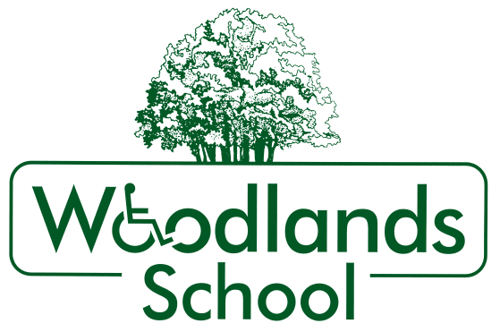 | FORTYFOOT ROAD  LEATHERHEAD  SURREY  KT22 8RY  Website:  www.woodlands.surrey.sch.uk

15th November 2021

Dear Applicant
MATERNITY COVER - CLASS TEACHER
Thank you for your interest in the above post. Woodlands is a successful school for pupils aged 2-19 who have severe or profound learning difficulties or an autistic spectrum disorder. The school has a large, varied staff team who work hard to support each other in building a happy working environment. We have high aspirations for all of our pupils and we are dedicated to safeguarding and promoting high levels of wellbeing and self-esteem. The successful candidate will share in this commitment.
We are looking for a teacher with knowledge, experience or an interest in special education. Applications are welcome from teachers with primary or secondary experience, who are able to teach a wide range of subjects to pupils at the earliest levels of learning. We have a holistic approach to developing the whole child and to this end staff work collaboratively with parents and other professionals.

It is likely that the successful candidate will have recent, relevant experience of working with young people with severe learning difficulties or physical or sensory impairment. However, this role would suit a candidate at any stage in their career. We would welcome applications from:

- Experienced SEN teachers;
- Teachers currently working in mainstream schools who are keen to pursue a career in special education.

If any of these descriptions sound like you then we would be delighted to receive your application.

Please return the application form by 9.00am on Monday 6th December 2021.

The successful applicant is expected to start in January 2022. References for short-listed candidates will be sought and any issues arising will be discussed at interview.

If you have any questions, please contact Nicola Sutehall in the Upper School office on 01372 377922 or email admin@woodlands.surrey.sch.uk.

We look forward to hearing from you.

Yours sincerely

Sarah Smith
Acting Head Teacher

