Job Description Specialist Learning Support
Pay Range -C Range Linked to Role profile LSA Grade C- 2131
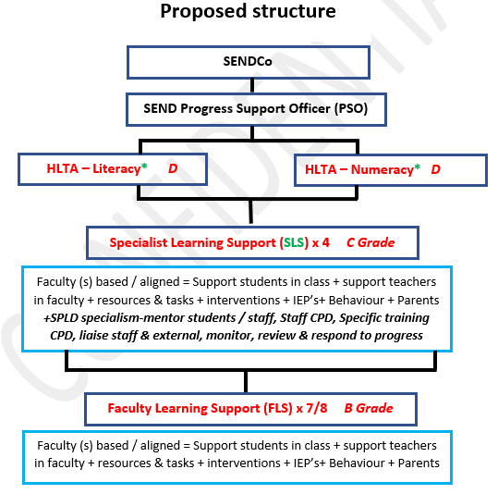

Role Purpose: | - To support SEND students in the classroom and faculty allocated to access learning and make expected progress.  - To complement and support the professional work of the Teacher to support task and learning activities.  - To support the progress of SEND students within the faculty and providing best practice resources and sharing ideas.  - To liaise with teacher within the allocated faculty with regards to curriculum and be prepared to support tasks and activities. This could include some pre-learning, responsive support in the classroom and additional interventions.  - To support SEND students in readiness and during formal assessments.  - Actively Support and manage behaviour in conjunction with the teacher.  - Carry specialist responsibility and support/mentor other staff in developing skills and knowledge.  - Carry specialist responsibility and support/mentor Students with their engagement, attendance and progress in school.  - Regularly liaise, monitor, meet and communicate with students in their care under the banner of their specialist field.  - Liaise with external agencies to invest and support specialist area as well as build CPD knowledge.  - Take ownership for liaising and disseminating key CPD and strategies to support students and teaching staff.  - Take ownership for implementation of specific SEND strategies and monitor impact and review. ( with support from PSO)  - The role includes dealing with individual pupils and/or groups with complex and demanding learning needs. The post holder’s working hours predominantly respond to students needs and will include provision outside of school hours.
Areas of Specialist Learning support – Based on the 4 areas of need from CoP- Communication/Interaction, Cognition/Learning, SEMH, Sensory/Physical
Specialist Responsibility to be agreed on successful application.
Specialist Responsibility whilst specified in the first instance, are changeable in light on the needs of the students, within the school's cohort.
Accountabilities | - Support for Students  Working with students, in the class, break times, out of lesson time, interventions, managing behaviour. | 85%  25 lessons
 | - Support / Liaison with / for Teachers & students  Planning, resource prep, liaison with others (students/ staff/parents).  Sharing/ disseminating best practice in area of specialism. Create and maintain clear resources / CPD bank for all staff to access.  Working without the close presence of the teacher to independently develop resources and strategies.  Liaise and work collaboratively with external agencies (with support and direction from SENDCo / PSO).  Liaising with students to assess provisions and progress and their families. | 15%  4 lessons  +time pre  /post school
 | - Support for Curriculum  Review progress, produce resources, assist with assessment | 5%  1 lesson  +time pre  /post school
Liaison  TS  1.8  Parents and agency specialist support | - Guide and provide CPD for all school staff in the area in which they hold a specialist qualification and / or area of trained expertise.  - Regularly disseminate best practice ideas and resources to stakeholders  - Liaise with outside agencies and take forward the ownership for strategic implementation.  - Liaise with parents with regards to the needs of SEND students, their progress and additional support needed (in consultation with SENDCo and PSO)  - Liaise with parents to report on/ review pupil progress following interventions.  and IEP’s.  - Regularly (daily / weekly) Liaise with faculty teachers (including strategic groups e.g. RAG) and middle leaders to ascertain and create links with curriculum delivery. E.g., E/M interventions require liaison with regard to the E/M teachers / HoF
Support for student progress development and inclusion.  TS  1.3  Subject Know  1.4  Lesson time  1.5  Differentiate & adapt resources  1.6  Assess /  feedback  1.7  Behaviour  1.8  Parents / staff | Student Progress  - Where needed, take responsibility for whole class learning under the overall direction of a teacher.  - Assess needs of pupils where appropriate and in discussion with SENDCo, identify specific needs and intervention.  - Co-ordinate and deliver specialist learning activities for SEND students (select  and prepare resources)  - In the presence of and in collaboration with the teacher, facilitate learning tasks in a strategic manner to support accessibility and progress. To work with identified students individually and collectively by contributing to decisions about the most appropriate learning goals and strategies, utilising information and training shared within the SEND faculty.  - Support with Access arrangement provision.  - Oversee and deliver out of school learning activities to support SEND students, that consolidate class work.  - Supervise and assist individual/small groups of pupils in activities set by teachers with teacher guidance.  - Build and maintain successful relationships with pupils treat them consistently, with respect and consideration  - Help reinforce and promote independent learning and social skills by supporting pupils in groups  - Help pupils record work in an appropriate way and to develop study and organisational skills  - Support pupils to be on task and to build motivation by modelling good practice  - Build the pupils’ confidence and enhance self-esteem and actively seek to promote the academic, social and emotional welfare of pupils  - Implement behaviour management policies in accordance with guidance provided by the teacher  - Attend formal and informal meetings with teachers (within working hours) to contribute to planning lessons/ activities  - Prepare materials and resources within faculty area assigned to best support all SEND students within faculty to make expected progress.  - Help prepare pupils beforehand for a task to ensure they can access learning content.  - Take every opportunity to develop pupils’ language, reading, mathematics and related skills as directed by subject specific teachers  - Assist the teacher in setting appropriate learning and behaviour expectations of pupils and supporting pupils appropriately to achieve these  - Supervise practical tasks  - Be pro-active in keeping records and evaluating identified pupils’ progress  - Support the use of ICT in the classroom and develop pupils’ competence and independence in its use  - Effectively implement planned learning activities/ teaching programmes as agreed with the teacher, adjusting activities according to pupils’ responses as appropriate  - Interact with, and support pupils, according to individual needs and skills.  - Produce case studies (alongside the SENDCo) for students who they support who have high Needs. To participate in planning and evaluation of learning activities with the teacher, providing feedback to the teacher on pupil progress and behaviour  - In line with the designated specialist are of ‘responsibility’ and after adequate training, to assist in meeting particular pupils’ needs, e.g. physical development, speech /language development, and medical needs identified in an approved care plan agreed by parents.  - In the presence of the teacher, present agreed learning tasks in a clear and stimulating manner to help maintain pupils interest and motivation; to work with pupils individually and collectively by contributing to decisions about the most appropriate learning goals and strategies  - To supervise pupils for limited and specified periods including break-times  - To assist with escorting pupils on educational visits where deployed.  - Promote the inclusion and acceptance of children with Special Educational Needs within the classroom ensuring access to lessons and their contents through appropriate clarification, explanation and resources  Interventions  - Under supervision of the SENDCO / PSO develop and co-ordinate Individual Education Plans (IEP’s)  - Under supervision of the SENDCO / PSO help Co-ordinate and deliver interventions to boost and develop progress areas of identified students.  - Provide accurate feedback and reports on SEND student attainment  - Analyse impact of interventions delivered and liaise and suggest refinements.  - Undertake a commitment to developing own CPD to support effective delivery of interventions.  Data  - Be aware of relevant SEND data and in relation to the progress of students and possible actions to develop.  - Review transition data and be aware of student needs  - Provide regular data and assessments in relation to interventions.  Specialism  - Lead, advise and support others in area of expertise of SEND  - Regularly liaise and meet with Students in their specialist care / support to enable effective support and progress in school.  - Respond to the needs of students in their specialist care / support by planning and seeking solutions and liaising with staff and family.  - Liaise with the SENDCo and PSO regarding additional resources which need funding / purchasing and follow the schools' required processes.  Professional  - Consistently model professional practices to support the development of all students  - Attend relevant school meetings as required  - To respect confidentiality at all times  - Share and support the school’s commitment to safeguarding and promoting the welfare of all young people  - Participate in the performance and development review process, taking personal responsibility for identification of learning, development and training opportunities in discussion with line manager  - Carry out other roles and tasks as requested by the Headteacher which are commensurate with salary grade
Skills needed | - Experience of teaching/learning/ child support working environment.  - Ability to work independently and with initiative.  - Able to work at an advanced level with staff to support planning and delivery of activities.  - Confidence and professional approach to liaise with all staff in the school to support practice / pedagogy  - Passion for working with young people and SEND students.  - Knowledge of the SEND code of practice. (Training provided)  - Good standard of literacy of Numeracy.  - Approachable and professional manner to work alongside staff and vulnerable students.  - Current knowledge of education research and thirst for learning. (Training provided)  - Excellent organisational and time management skills  - Excellent presentation skills including to a range of audiences.  - Excellent knowledge of office 365 and a willingness to develop skills, including data and monitoring.  - Ability to meet tight deadlines  - Successful Leadership experience at a range of levels.  - Ability to listen.  - Ability to work as part of a team and motivate others.  - High levels of motivation and to be work proactively.  - Some Experience at implementing and monitoring the Assess-Plan-Do-Review cycle. (training provided)  - Willingness and ability to collaborate and coach others.  - Problem solving skills and ability to work under pressure.  - Willingness and ability to promote the work and development of BHCS in a professional and collaborative manner.  - Excellent communication skills- written and verbal.
Undertake other reasonable tasks directed by the Headteacher and/or DHT.

