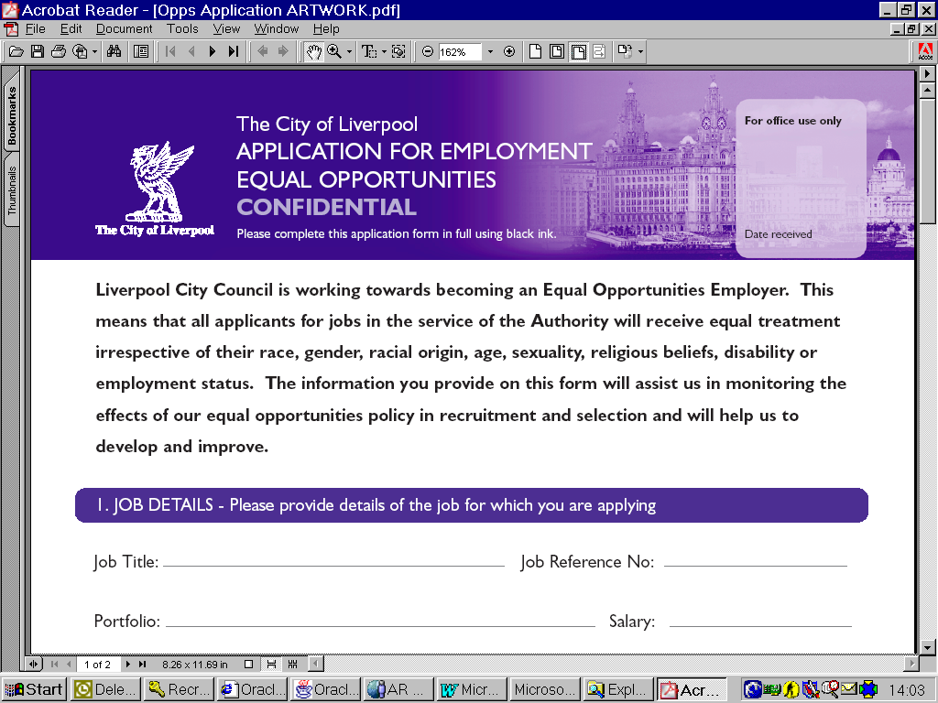
Liverpool City Council is an Equal Opportunities Employer. This means that all applicants for jobs in the
service of the Authority will receive equal treatment irrespective of their race, gender, marital status, age,
disability, religious beliefs, sexual orientation or employment status. The information you provide on this
form will assist us in monitoring the effects of our equal opportunities policy in recruitment and selection
and will help us to develop and improve.

1. JOB DETAILS – Please provide details of the job for which you are applying
Job title: |  | Job reference number:

2. PERSONAL DETAILS
Title: |  | First name(s): |  | Last name:
Date of birth: |  |  | Age group :

3. GENDER IDENTITY
Gender:
Is your gender identity the same as the gender you were assigned at birth? |  |  | Do you live and work full time in the gender role opposite to that assigned at birth?

The following categories are consistent with the Government’s 2001 Census and have been approved by the Commission for Race Equality.

4. RACIAL ORIGIN – Please confirm appropriate category
Asian or Asian British |  |  | Black or Black British
Chinese or other ethnic group |  |  | Mixed
White |  | If other, please specify: |  |  |  | Prefer not to say

5. DISABILITY
Do you consider yourself to be a disabled person:
6. RELIGION/BELIEF
Please select appropriate category: |  | If ‘other’ please specify:

7. SEXUAL ORIENTATION
Please select appropriate category:

8. SUPPLEMENTARY INFORMATION - Please identify if you would like any support or adjustments to be made to enable you to take part in the selection process for reasons such as religion, disability, medical or maternity.
Please state:
(if applicable)

Thank you for your application.
Please refer to the guidance notes for full details of the return postal and email addresses.

