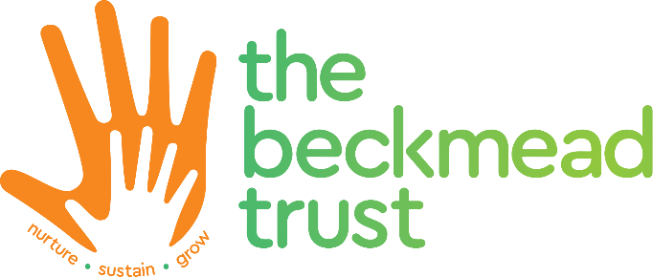
Speech and Language Therapist - Chaffinch Brook School
Band 6 Equivalent
NJC Scale Grade 10 Point 30 – 32 (£32,234- £34,012 Actual Term time salary)
Term Time only plus 5 staff training days.
Full time 36 hours per week
Tenable: ASAP
Closing Date: 8th April 2022
Interviews Date: 28th April 2022

Chaffinch Brook School is recruiting a Speech & Language Therapist to join our Staff Team to work with our wonderful children.
We recognise the power of excellent SALT in overcoming the barriers to communicating and to empower life-long access to opportunities.
The post holder will provide assessment, interventions and advice to pupils and staff at Chaffinch Brook School, an Outstanding special school for children aged 5-16 with autism and related challenging behaviour. All of our students have social and communication difficulties which have seriously impacted on their ability to learn and function in schools; they also lack confidence and motivation and many have delays in basic skills.
The ethos of the school is one of nurture and positivity; every child is valued and encouraged to achieve, and it has a whole school communication-friendly approach.The post holder will be responsible for the provision of specialist interventions and assessments using evidence based / client centered practice and developmental principles to assess, plan, implement and evaluate interventions and treatment programmes.
The school curriculum is underpinned by the principle of establishing meaningful communication for pupils of different abilities and the speech and language therapist will have an integral part to play in developing this ethos. The post holder will be an active member of the multidisciplinary team working alongside the class teams.
We are seeking someone who is qualified:
- BSc (Hons) Speech & Language Therapy / Diploma in Speech & Language Therapy
- Registered with the Royal College of Speech & Language Therapists and HPC

Applications should be submitted on the completed Beckmead Trust Support Staff application form with a Personal statement, Disclosure form and Equal opportunities form. Please send applications to recruitment1@beckmeadtrust.org by the closing date.
We do not accept CV’s.

The Beckmead Trust is committed to safeguarding and promoting the welfare of our children and young people so expect all staff and volunteers, as well as those who work on the premises, to share this commitment. As part of our safeguarding commitment, appointment to any post is subject to receipt of satisfactory references, medical clearance to include the ability to participate in Behavioural and Physical Intervention and a satisfactory Enhanced Disclosure and Barring Service (DBS) Check as well as evidence of the right to live and work in the United Kingdom.

In accordance with current GDPR compliance, we will not keep any details/application forms on file once the position is filled.
Please email Georgia Smith gsmith136@beckmeadtrust.org to contact Andy Millard Head Teacher to arrange a visit prior to application.

