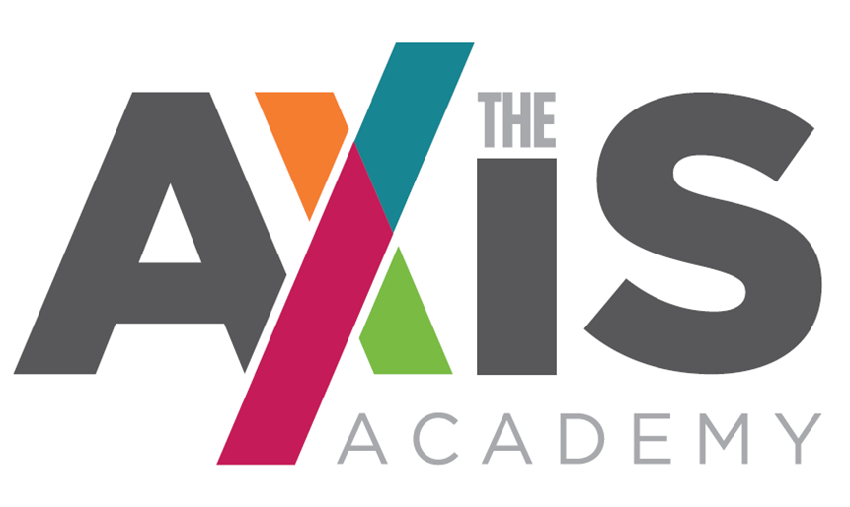

A specialist provision for students with Social, Emotional and Mental Health needs, with specific focus on mental health difficulties.

SPEECH AND LANGUAGE THERAPIST RECRUITMENT PACK

Pay Scale: £30,600 - £35,700
(pro rata 39 weeks per year
Part-time contract 3 days a week)

The Axis Academy
Lodgefields Drive
Crewe
Cheshire
CW2 8TU
CONTENTS

- Letter from Head teacher
- Application + Selection process and schedule
- The Axis Academy story and vision
- Speech and Language Therapist Role and Job Description
- Speech and Language Therapist Person Specification and assessment criteria
- Safer Recruitment and Selection Policy Statement
- School holidays

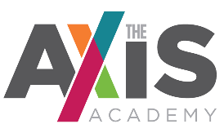
Dear Applicant

Thank you for your interest in our Speech and Language Therapist vacancy.

The Axis Academy is fast becoming a beacon of outstanding practice in SEMH specialist provision. You will have the opportunity to grow with the school and truly make a difference to the most vulnerable young people in society.

We pride ourselves on being a versatile, empathetic, and intuitive team which develops bespoke, personalised programmes of study to meet the needs of all of our students to provide them with the opportunity to maximise their potential, whatever that potential may be. As a specialist school this is a rare opportunity that will give you the chance to help develop an education system that truly focuses on the individual.

The Speech and Language Therapist will be a pivotal member of our team, and will be responsible for the assessment and direct work with young people with speech and language needs. They will also lead on the development and delivery of therapeutic one to one and group interventions to support effective communication, personal, social, emotional and academic development.

We are looking for a qualified therapist who is registered with a governing body such as HCPC. You will have experience in a therapeutic capacity, specifically in relation children and young people. The person will also be responsible for effectively engaging with various stakeholders. The successful candidate will be required to demonstrate a clear understanding of risk management and safeguarding.

We are looking for individuals who can inspire a love of learning, foster curiosity and creativity both within and outside of lessons.

If you feel that The Axis Academy may be the right place for you, I hope you will consider applying for the post.

I will be more than happy to have an informal conversation if you have any further questions please do not hesitate to get in touch.

I look forward to hearing from you.

Yours sincerely

Helen Phillips
Head teacher (Director of Education)

The Axis Academy Speech and Language Therapist Recruitment and Selection Process

- You are asked to complete The Axis Academy Application Form which is attached.

- You are asked to include as part of, or separate from the Application Form, a Letter of Application that addresses the items listed under desirable criteria on the attached Mental Health Counsellor Person Specification & Assessment Criteria. Please keep this letter as brief and to the point as possible (no more than 2 sides).

- You are asked to return your Application Form & Letter of Application by email to:

admin@theaxisacademy.org

The deadline for applications is: Midday on 8th October 2021

Interviews will be held: Friday 15th October 2021

Start date: As soon as possible

If you would like further information please contact admin@theaxisacademy.org or alternatively telephone: 01270 304 074

The Axis Academy Educational Vision

Our Mission and Vision.

It is our mission to provide children with a wealth of education which doesn’t just focus on academic achievements. It is our drive to implement a holistic approach to supporting children in order for them to feel safe, develop self-worth, be happy and have true informed perspective, through quality education.
We will offer a wide and varied curriculum which will inspire and excite them so that children feel ambitious and empowered to succeed. Ultimately we want to unlock every child’s potential, reaching out to every possibility within them, making sure we have the most impact for their future.
Through a diverse and carefully tailored curriculum, and positive, understanding and empathetic staff students’ anxieties will reduce and their emotional well-being will improve and students will become confident and functioning members of society.
We want to motivate children, to inspire their minds and encourage them to think outside of the box. We want children to believe in their dreams, to believe that it is possible for them to accomplish anything they want and make it a reality, giving children a purpose in life and the confidence to believe in themselves. This is not just an aim but a devout commitment.

To deliver the vision the Speech and Language Therapist will work in collaboration with the Head teacher focusing on three key themes:

Re-connecting, raising aspiration and motivating
  - A whole education, recognising that essential pre-cursors to academic success are personal and emotional development, independent living and decision-making skills and discovering meaningful interests and goals
  - A personalised speech and language plan including specific engagement activities based on the interests of each individual learner
  - Positive and trusted adult role models in the form of Learning Mentors, qualified teachers, pastoral, therapeutic and metal health specialist staff recruited for their enthusiasm for working with vulnerable young people and their ability to understand and adapt, in order to meet the needs of the students
  - Opportunities to support social and emotional needs through individualised programmes and a varied curriculum

Unlocking every child’s potential
- The curriculum will determine the knowledge and skills students will learn at each stage. It will be planned efficiently to deliver exceptional lessons where students make outstanding progress, and are able to relate their learning to the wider world
- Individualised interventions, based on the interests and skills of the students, and which will draw upon the diverse range of pastoral, vocational, engagement and personal and social development activities
- Small groups of students (max 1:8) with capability to offer 1 to 1 student support
- Practical application of English and Maths to develop skills that prepare for accreditation and work towards independence and social integration

Recognising and celebrating achievement
- Positive learning environments with praise for success and recognition of achievement
- Regular liaison with parents and carers to involve them fully in the education of their children including weekly progress telephone calls
- Celebration of success through weekly celebrations with students and staff, rewards for targeted elements and high profile annual celebration events
- Relevant vocational learning that broadens the curriculum offer to students providing the opportunity to support their classroom learning by gaining practical skills in the workplace, and ultimately allowing them to achieve recognised qualifications.

The Axis Academy has a key focus on specific mental health needs and aims to work collaboratively with all students and staff in order to ensure all our students achieve mental wellness and personal, social and emotional development, and academic success.

Speech and Language Therapist Job Description

Key Priorities

- Support the vision and direction of the school
- To provide a high-quality speech and language therapies to students experiencing a wide range of emotional problems.
- To provide support, guidance and advice to parents, carers and the school.
- To observe confidentiality and to support the school’s endeavour to provide excellent teaching and learning for all students.
- Contribute to the safeguarding and promotion of the welfare and personal care of children and young people

Specific Responsibilities

- To provide assessment, diagnosis and appropriate speech and language therapy intervention for students.
- To manage his / her own time and have an ability to prioritise tasks with minimal support
- To identify the need for clinical support and advice and liaise with school staff team in order to meet the needs of our students and enable them to reach their full potential.
- To ensure multi-agency collaboration.
- To provide training for staff to enable them to deliver effective speech and language support within their lessons.

Pastoral Care

- Deal with or report to the nearest member of the teaching staff, incidents that are seen or reported regarding students’ welfare.
- Be mindful, at all times, of the school’s Equal Opportunities policy.
- To support the schools Behaviour Regulation Policy

Health and Safety

- Be aware of the responsibility for personal Health, Safety and Welfare and that of others who may be affected by your actions or inactions.
- Co-operate with the employer on all issues to do with Health, Safety & Welfare.

Partnership Working

- Seek opportunities to invite parents and carers into The Axis Academy to enrich student experience and to promote The Axis Academy’s value to the wider community
- Collaborate with staff, to actively promote the British values, academic, spiritual, moral, social, emotional and cultural well-being of students and their families
- Represent The Axis Academy at relevant meetings, as and when required

Health and Safety / Child Protection

- To help ensure that health and safety standards meet statutory requirements, monitoring health and safety matters within the school, particularly ensuring that all members of the staff take reasonable care for the health and safety of themselves and others
- To help ensure that Child Protection and Safeguarding procedures and Department of Health assessments of Children in Need are rigorously complied with, and that the welfare and health and safety of students are of prime consideration
- To promote the safety and well-being of students and staff
- To ensure good order and discipline of students and staff

Speech and Language Therapist
The Axis Academy

Accountable to: School Senior Leadership Team
PERSON SPECIFICATION

Criteria | Essential | Desirable | Evidence
Qualifications/  Education | - Degree in Speech & Language Therapy.  - HCPC Registered.  - Member of Royal College of Speech and Language Therapists.  - Knowledge of range of Paediatric speech, language and communication disorders. | - Postgraduate training appropriate to the role | - Application  - Interview  - Certificate
Experience | - Experience of working independently as part of a school team.  - Experience of working collaboratively with other professionals.  - Knowledge of SEND reforms and inclusion agenda  - Experience of delivering training to others. |  | - Application  - Interview  - References
Professional /Personal Skills | - Ability to solve problems & make decisions under pressure  - Good communication skills.  - Computer literate.  - Ability to show patience and empathy  - Generate enthusiasm for new ideas  - Inspire others with confidence  - Remain calm when working under pressure. | - Training and understanding of child protection and safeguarding  - Training and experience of working with students with a variety of mental health needs | - Application  - Interview  - References
Personal Management | - Ability to analyse situations, prioritise and help to implement realistic solutions  - Ability to establish and develop good relationships with all involved in the school  - Commitment to the school’s wider community  - Willingness to deliver and support extra-curricular activities and training for parents. | - Experience of supporting staff as well as students  - Effective liaison with Governors | - Application  - Interview  - References
Knowledge and understanding | - Demonstrate a good level and understanding of ICT  - Knowledge of how to deal with safeguarding issues in school  - Awareness of current developments in education and the implications of these.  - Understand how to plan appropriate interventions  - Behaviour management techniques for groups and individuals  - Know how to develop effective rapport with students, this being based on high expectations and understanding.  - An understanding of the developmental, emotional, social and educational issues of children and young people  - An awareness of range of needs of people from diverse ethnic, cultural and social backgrounds | - Knowledge and experience of supporting students in a special education provision  - Knowledge of successful practice in supporting hard to reach students  - Knowledge of how to promote independence for young people with complex needs  - Behaviour Management training  - Mental Health training  - Knowledge of local mental health and CAMHS.  - Knowledge of the Children’s Act and legislation pertaining to children | - Application  - Interview  - References
Shaping the Future /Philosophy | - Demonstrate and communicate clear ideas to promote the schools vision and ethos  - Evidence and understanding and commitment to equality of opportunity  - Respect for students’ individual differences  - Commitment to parental partnership in education and developing links between school, home and the community |  | - Application  - Interview
Developing Self and Working with Others | - Excellent interpersonal skills  - Commitment to one’s own continuing professional development  - Ability to work as part of a team  - Ability to make and take decisions and set priorities  - Able to gain and maintain the confidence and respect of colleagues, students, parents and multi professionals  - An ability to work in partnership with those agencies that work with the school  - Have energy and perseverance  - Be confident and enthusiastic  - Be reliable and have integrity | - Evidence of delivering training for staff, Governors and Parents | - Application  - Interview  - References
Securing Accountability | - Application of the need to delegate responsibility with accountability for area of responsibility  - Communicate to staff teams effectively |  | - Application  - Interview  - References
Strengthening Community | - An ability to establish and maintain positive partnerships with parents, students and communities  - Awareness of the need to develop a school culture responsive to the nature of the school’s communities | - Work in the wider community. | - Application  - Interview
Other Requirements | - Positive recommendation from present employer  - Good attendance record |  | - Letter  - Reference

The successful candidate would be expected to maintain a well-organised, creative, safe and friendly environment for living and learning and hence enhance the ethos of the school. Candidates are asked to address as many of the person specifications as possible in their application.

Note re: School holidays

Before applying, please be aware that The Axis Academy will adopt a different holiday calendar to other schools. Each half term will be approximately six weeks in duration with two week breaks in between. This will mean that summer break will be approximately 4 weeks in duration. For further clarification please contact admin@theaxisacademy.org

