

**Sports Coach / PE Cover supervisor / PE Technician (3-19 school)**

# Contents

Headteacher’s Welcome. 4

The Recruitment Process. 5

Advertisement. 6

Department Information. 10

Job Description. 11

Person Specification. 15

Our Ethos and Strategic Direction. 17

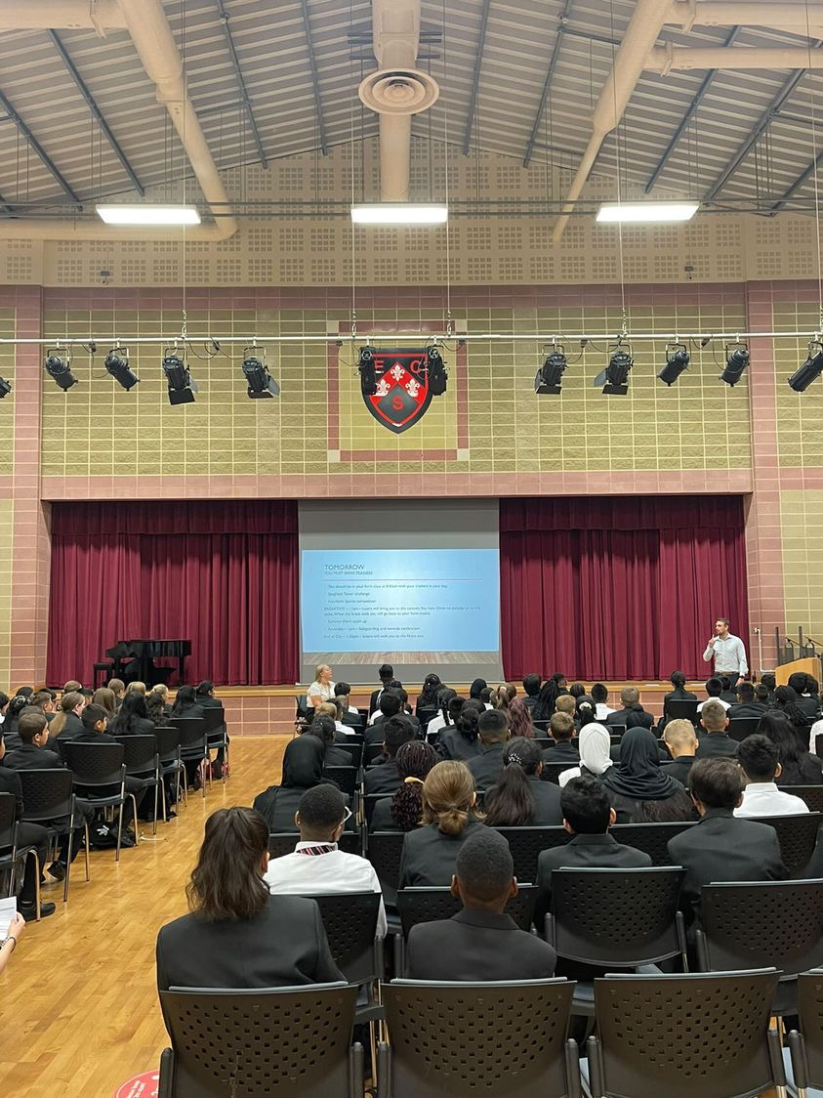

## Headteacher’s Welcome

Welcome to Eastbury Community School, and thank you for expressing an interest in applying for the position of Sports Coach/PE Cover Supervisor/PE Technician.

For me, our school is where our young people are given the opportunities to allow them to realise their potential, and that potential can and does manifest itself in a range of ways.

Our young people need to see that success comes in a range of different forms, and ECS is where they can explore where and how they can and will be successful. Our pupils get some of the best progress results in GCSEs in the local area, our 6th Form- judged outstanding (March 2024) achieves some of the best results in the Barking and Dagenham, and over half of these young people go on to attend Russell Group universities.

Our young people need to have a voice in the school, the local community and the wider world. As part of our commitment to this belief we are a Rights Respecting School – Silver award at the moment, but we are confident that within the next year we will achieve Gold – one of the only 3-19 schools in London to do so.

Sir Tim Brighouse said “If a teacher makes the weather the school creates the climate.” and I firmly believe this. It is our role as a leadership team to create the best possible learning environment so that all our staff can work with our young people to support them in reaching their potential.

We expect the best from all our staff, and will provide the training and development to ensure that this is the case throughout the school. We have created systems and structures that support high quality learning, whilst minimising workload and maximising impact.

**Our recent Ofsted report – March 2024 stated:**

“*Pupils are proud to be part of this inclusive community where people respect and care for each other. They appreciate the support they receive from staff if they have a concern” .*

*“Leaders are ambitious for all pupils to achieve well”*

*“The school takes effective steps to address behaviour that does not meet its high expectations. Pupils conduct themselves well and enjoy their time at school. Low level disruption in lessons is rare”*

*“Staff, including early career teachers, said that leaders have carefully considered their workload and well-being. They value the many opportunities to improve their professional practice.”*

If you share our ethos and values and absolutely believe in the potential of all young people then we can offer you the chance to make a difference and change our community for the better, and look forward to receiving your application form and welcoming you to our school.

 **Sharon Gladman – Executive Headteacher**

**The Recruitment Process**

The interview process will be organised to provide a range of assessment tasks and opportunities for candidates to find out more about the school and demonstrate their ability to fulfil the role.

**Key Dates**

**Closing Date for Applications: 4 October 2024**

**Interviews: 14 October 2024**

Please note all dates are subject to change.

Completed applications should be sent to: [kdunnell@eastbury.bardaglea.org.uk](mailto:kdunnell@eastbury.bardaglea.org.uk)

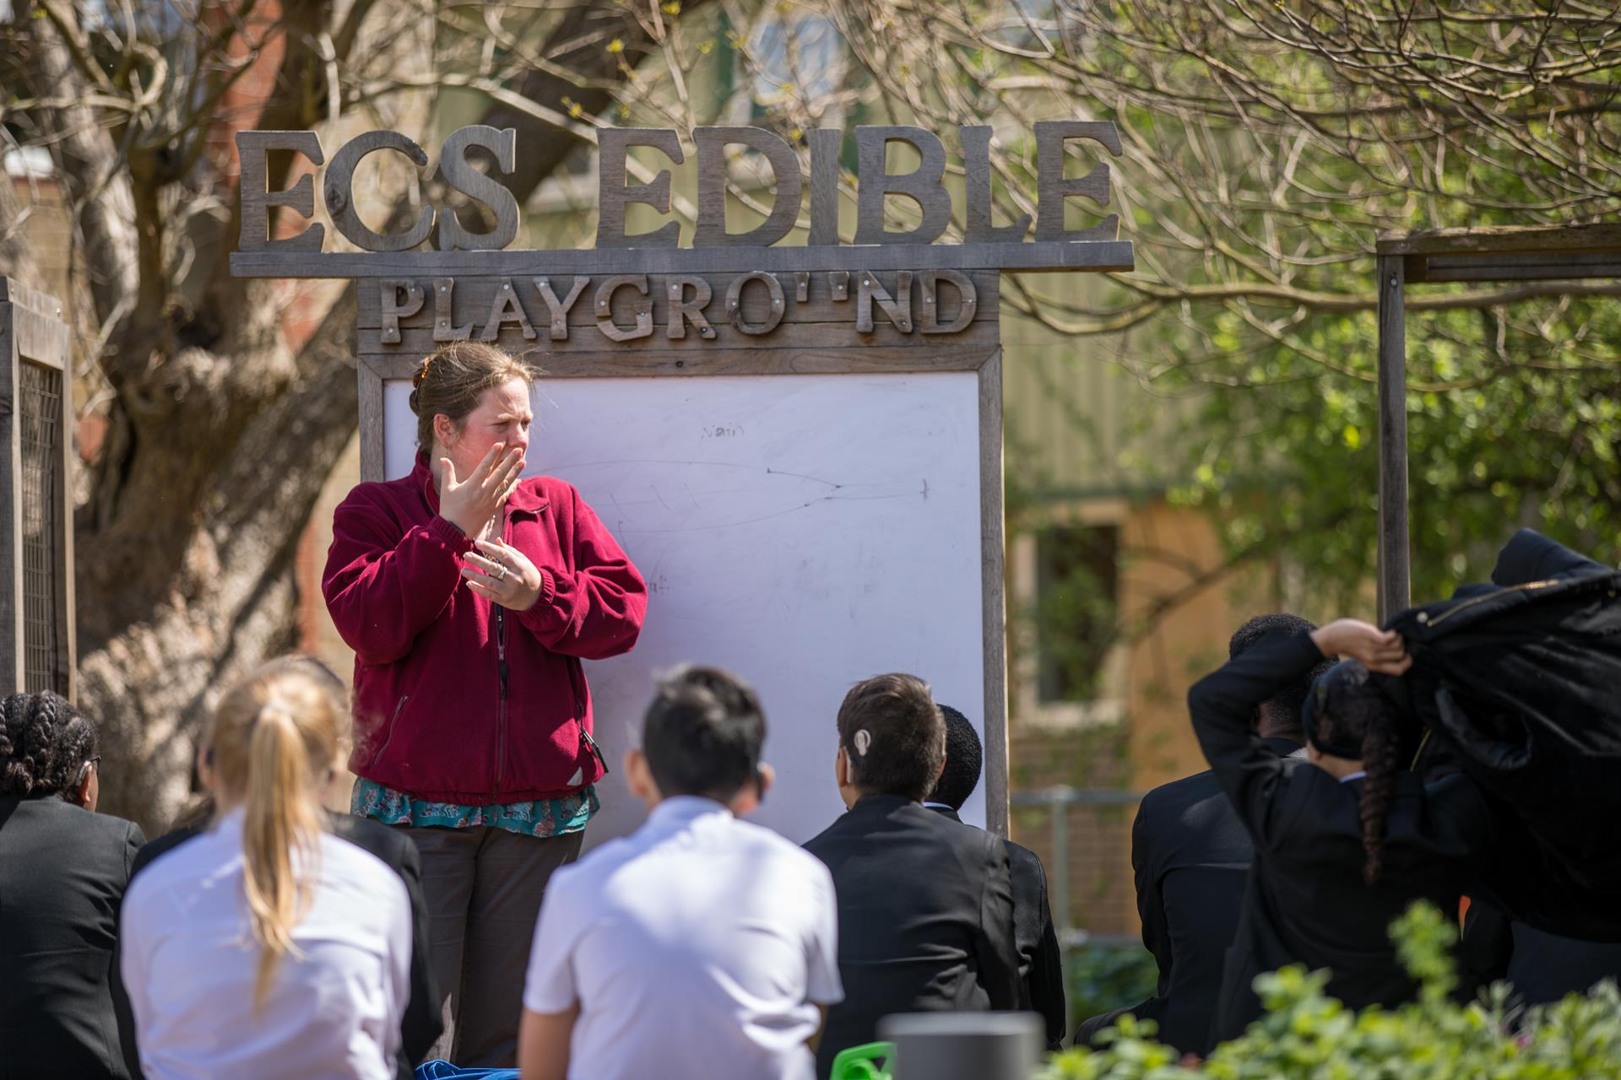

**Advertisement**

**Advertisement**

**JOB ROLE SPORTS COACH/PE COVER SUPERVISOR/PE TECHNICIAN (3-19 school)**

**CONTRACT: 35 hours per week term time only**

**CONTRACT TERM: One year fixed term in the first instance**

**START DATE: October 2024**

**SALARY SCALE: APT and C Scale 5 £25,482 - £26,676 (actual salary)**

**About Our School:**

This is an excellent opportunity for a committed and innovative individual, in a successful, well ordered, and inclusive 3-19 all through school. We are at the heart of an ethnically diverse community in London East, an area undergoing significant regeneration and building affordable homes. We are a successful school, where academic outcomes and character development are at the heart of everything we do. We believe our students can achieve and give them the opportunities to realise their potential.

We foster a collaborative culture where talented individuals are empowered to produce their best work in brand new purpose built accommodation.

**Find out more about a career at ECS here:** [**Join Our Community**](https://www.eastbury.bardaglea.org.uk/Work-for-Us/index.asp)

**About The Role:**

We are seeking a Sports Coach /PE Technician who will embed a strong culture of teaching and learning across the school. The candidate will work collaboratively with the Secondary PE Department to support and develop Eastbury’s extra-curricular sport opportunities, whilst also supporting the PE team through the following:

* Delivers extra-curricular sport and physical activity before during and after school; including fixtures and competitions
* Can plan and deliver cover lessons following the PE National Curriculum and/or set programs of study
* Supporting the department through the organisation of equipment and resources as required

ECS celebrates its diversity, and we positively welcome applications from all sections of the

community. If you are interested in making a difference in young people’s lives, whatever your background or history please apply.

In return we can offer:

* A pupil centred, progress focused ethos.
* A welcoming and supportive community.
* The opportunity to work with a passionate, hardworking and supportive staff.
* A commitment to develop your skills through continued professional development.
* A supportive and committed Leadership Team and Governing Body.
* A cohort of pupils with high aspirations and a willingness to learn.
* A school which understands the importance of staff well-being and workload management

*“Pupils value the opportunities that they have to work with leaders to further improve the*

*school, for example through the school council. Older pupils, and students in the sixth*

*form, help pupils in the primary phase with their reading. Pupils benefit from a range of*

*extra-curricular clubs, both at lunchtime and after school.” (Ofsted March 2024)*

Please click here to find out more information about what it is like to work at ECS:

<https://www.eastbury.bardaglea.org.uk/>

The school is located less than 10 minutes’ walk from Upney tube and 15 minutes from Barking mainline station.

To find out more about how teachers can secure rented accommodation at a discounted rate of 20% please contact: [**info@bdsip.co.uk**](mailto:info@bdsip.co.uk)

ECS is committed to safeguarding and promoting the welfare of children and is an Equal Opportunities Employer.

This post is exempt from the Rehabilitation of Offenders Act 1974 and a comprehensive screening process, including Disclosure check, will be undertaken on all successful applicants.

**How To Apply:**

For full details of the post and an application form, please visit the school website [www.eastbury.bardaglea.org.uk](http://www.eastbury.bardaglea.org.uk) and return the application form to the Headteacher’s PA, Karen Dunnell [kdunnell@eastbury.bardaglea.org.uk](mailto:kdunnell@eastbury.bardaglea.org.uk). The closing date for applications is 4 October 2024 and interviews will be held w/c 14 October 2024.

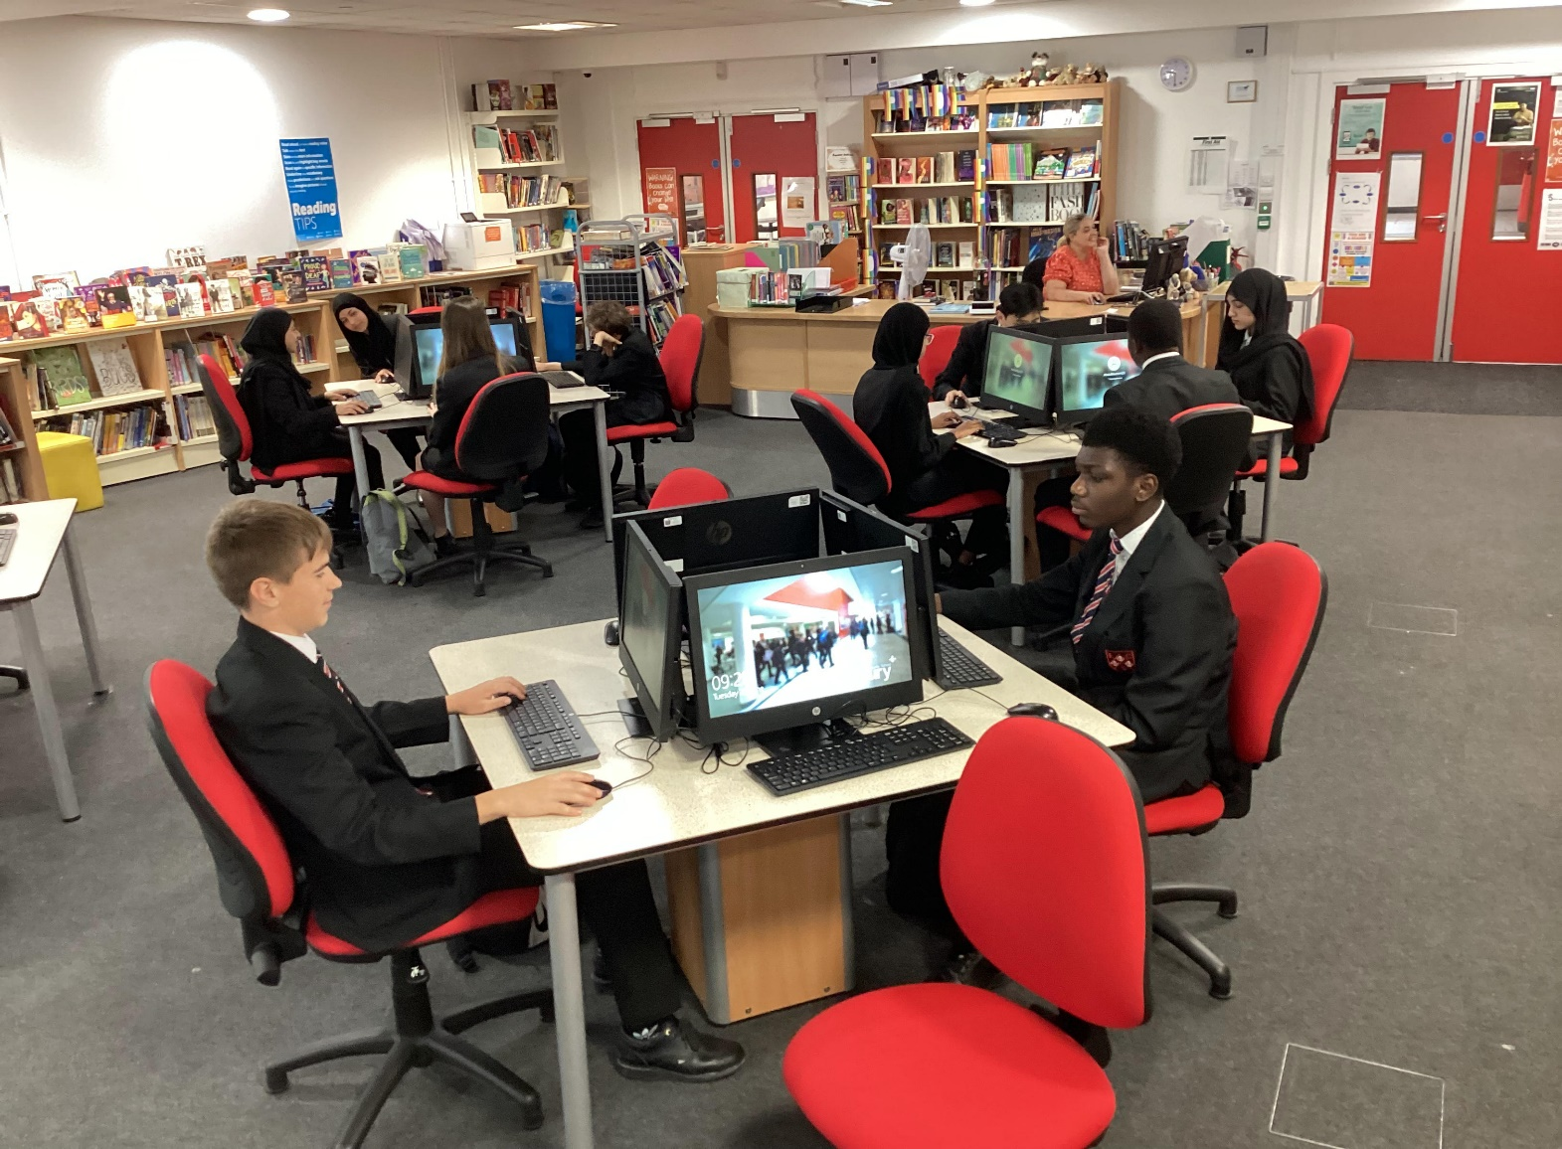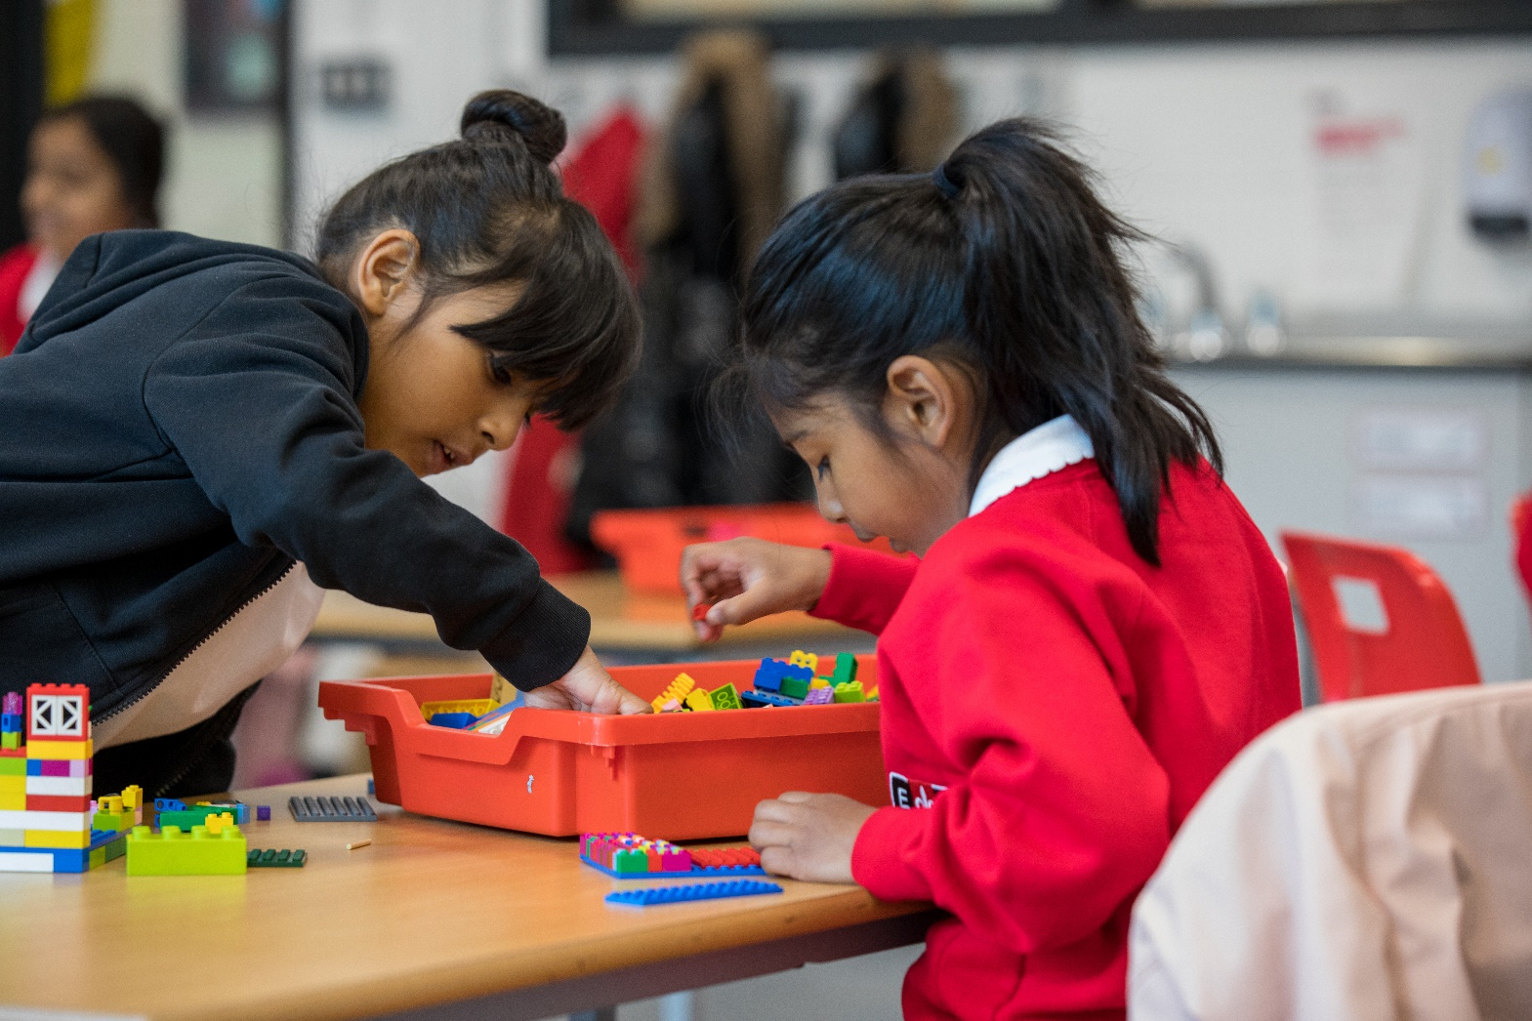



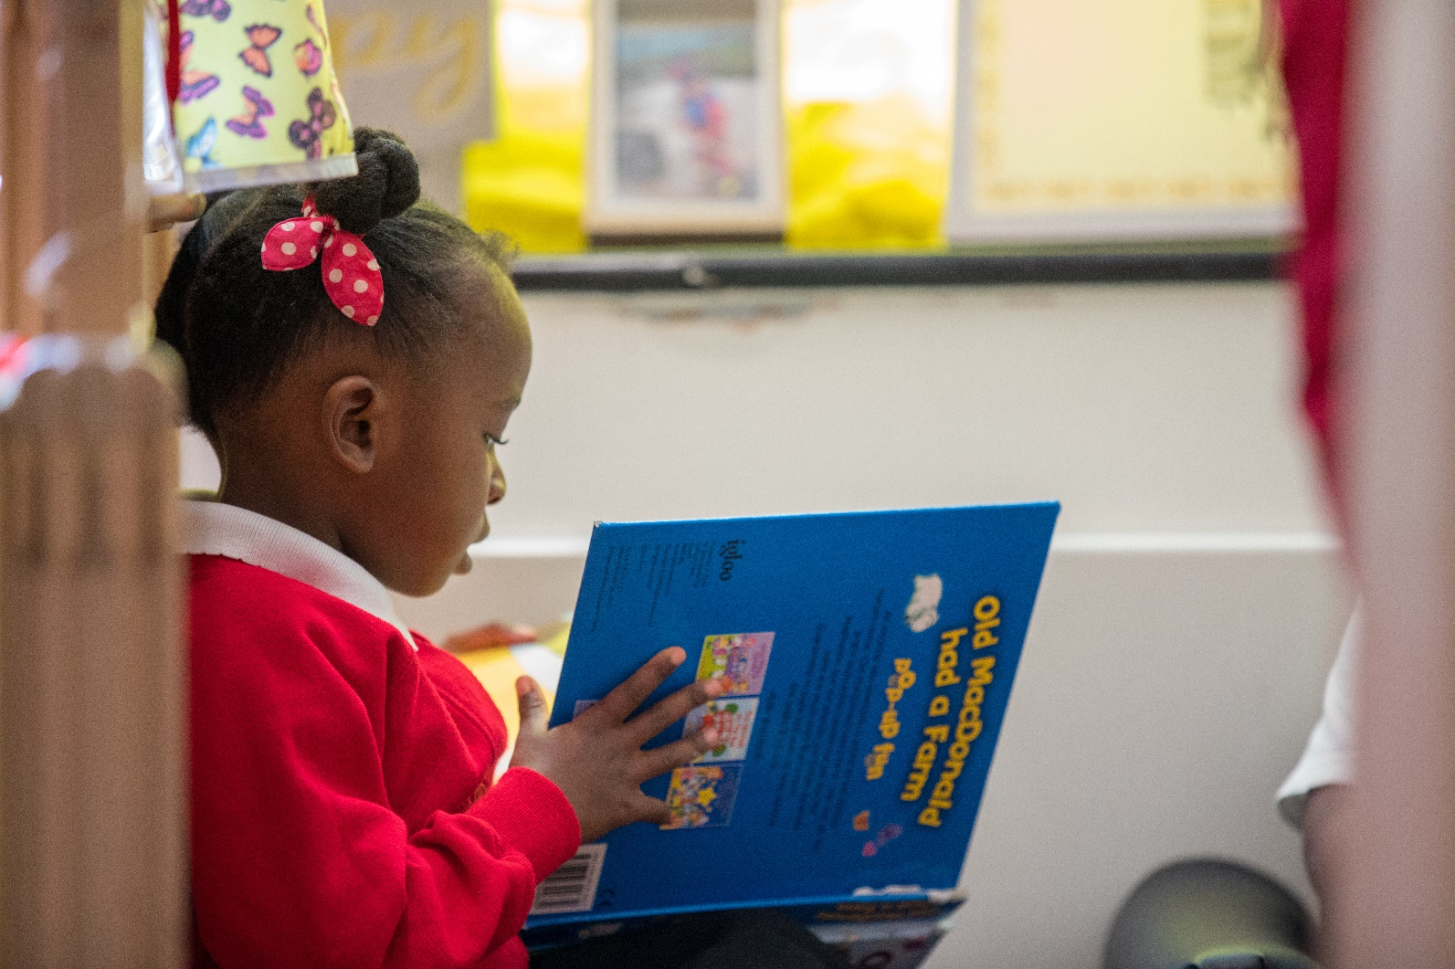

**Department Information**

**Job Description**

PE DEPARTMENT

The PE department consists of inspiring and supportive colleagues who strive for excellence through engaging and thought-provoking lessons. This is an exciting time to join the PE department and the successful candidate will be integral to us developing our curriculum offer and extra-curricular success.

The PE department believes all students should be stretched and challenged to maximise opportunities for them to make progress and that pupils fully understand the importance of leading a healthy active lifestyle to maintain and develop their physical, mental and social health and well-being. We also believe that the skills learnt and developed in PE are skills for life and that physical activity and sport is something that all pupils should enjoy.  We actively seek ways to motivate our learners and we relish the chance to help our pupils enjoy all forms physical education. We are proud to motivate pupils to want to further their knowledge in sport and physical education and we consistently have 2 to 3 groups of GCSE pupils each year. PE at Eastbury is inclusive staff prioritise supporting pupils in all key stages to make the best possible progress using a variety of teaching and learning strategies.

At Eastbury, all students in KS3 and KS4 have two hours timetabled physical education a week. Our Key Stage 3 PE curriculum is designed to develop skills and implement strategic thinking across a range of broad range of physical activities, while developing metacognition through opportunities for self and peer evaluation and feedback. Students are also provided with opportunities to increase confidence, take responsibility and develop leadership skills.

Students choosing to study PE at GCSE follow the AQA specification. Our GCSE course follows the AQA specification, which requires students to study Applied Anatomy and Physiology, Movement Analysis, Physical Training, Sports Psychology, Socio-cultural influences, Health, Fitness and Well-bring and Practical Performance.

The department also offer A level Physical Education, following the OCR Specification. Students will study Applied Anatomy and Physiology, Exercise Physiology, Biomechanics, Skill Acquisition, Sports Psychology, Sport and Society and Contemporary Issues in Physical Activity and Sport.

**Job Description**

**Job Description**

**EASTBURY COMPREHENSIVE SCHOOL**

**Job Description**

|  |  |  |
| --- | --- | --- |
| **Post Title:** |  | **Sports Coach / PE Cover supervisor / PE Technician (3-19 school)** |
|  |  |  |
| **Purpose:**  **Duties**  **And**  **Responsibilities** |  | ***Core Purpose:***  To provide a range of extra-curricular opportunities for students at Eastbury Community School, including taking responsibility for leading teams for training and fixtures. To deliver cover lessons for core and GCSE PE. Assist with the organisation and delivery of the Sports Excellence Programme.  **Sport Coach**   * **Extra-curricular clubs and fixtures** * To organise and lead sports teams, fulfilling their training and fixtures as appropriate, including supervising students outside of the school day * Running extra-curricular activities (before school, break times, after school) * Overview of fixtures diary and booking of pitches/facilities * To promote sports clubs, results and successes during registration, in assemblies, newsletters, PE Instagram, displays, etc. * To assist with running of the Sports Leaders programme under the direction of the Head of PE/Sports Excellence lead. * To assist with training and support of sports leaders * To provide provision out of school hours that that support the Sports Excellence Programmes * To arrange trips and visits as appropriate * To complete risk assessments for trips and visits * To liaise with staff to plan visits and trips * To present plans for Sports activities to the appropriate SLT link for the Bulletin meeting * To manage stock and materials for the Sports Excellence programme/PE Department * To arrange for outside providers to participate in Sports activities / /CPD. * To organise and attend events designed to support the development of sports programmes. * To contribute to the raising of standards of student attainment and achievement within sports programmes. * To develop and enhance the practices of others to make them more effective coaches. * To embody the strategic direction the school and community. * To ensure successful essential liaison and collaboration with B&D CIAS; HMI; Consultants and other inspectors. * To act as an advocate for the Sports Development groups both outside and inside school. * To make a significant contribution to the vision of the school. * To liaise with and help coordinate community partners to ensure the effective delivery of any community programme pertaining to sports development. * To ensure that student progress is effectively monitored and to monitor the quality of such monitoring within sports development in liaison with the HoDs * To ensure that student attendance and punctuality to sports activities is effectively monitored and to monitor the quality of such monitoring within sports development under the direction of school leaders. * To contribute to a distinct ethos pertaining to the sports development is apparent in the school   **Cover Supervisor**  ***Cover Supervisor - Main Tasks under the direction of a Qualified Secondary Teacher***   * To deliver ***PE*** cover lessons to KS3 and KS4 ***PE*** classes ***(core PE and GCSE PE)*** at Eastbury Community School, using cover work set by class teachers. * To use effective behaviour learning strategies within lessons and follow school behaviour policies and procedures. * To inform class teachers/HOD of any behaviour issues. * To work in close partnership with the ***PE*** Staff to ensure a strong curriculum offering has been provided. * To support the delivery of the National Curriculum for PE to specific year groups. * To contribute to and assist teachers with the lesson planning and the management/preparation of resources. * To assist teaching staff in PE in lessons when available. * To deliver intervention with groups of students within PE lessons * To attend departmental meetings as and when required.   **PE Technician**   * **Fitness Suite** * Maintenance of facility / equipment and fault reporting. Development of gym programmes / resources / ‘Wellness’ for break and after school clubs / teachers /sports team specific * Advertising and promotion of above clubs * Induction of fitness suite users - recording those induction /registers of users * Inducting staff on the safe use of the fitness suite * Health and safety monitoring reporting any issues * **Stores** * On going inventory of equipment – recording and restocking * Tidying and maintaining equipment. –Eg pumping balls etc ready for use * **Kit and Laundry Room** * Clearing changing rooms of kit * Cleaning, drying and storage of kit and team kits * Maintenance of facility / equipment and fault reporting. * **Sports Halls** * Maintenance of facility / equipment and fault reporting. * Health and safety monitoring reporting any issues * Tidying and maintaining equipment. – gym equipment away eg: bibs, cones, benches * **Administration** * Photocopying * Displays * Advertising and promotion of department and clubs * Notices and information – posters /e-mails etc * Maintenance of PE Dept printer with support from Network Team * **Lesson support** * Preparation of equipment and resources – eg: badminton nets, gym mats * Working with individual teachers as specified   W**orking with pupils across 3-19 school:**  To organise and prepare teams of pupils during inter-school and inter-Borough events. To liaise with other schools for inter-school events  Provide the pupil(s) with the level and type of individual attention specified by the teacher and strive for excellent relationships.  Encourage the pupil to take responsibility for his/her behaviour and to act independently.  Interact with the pupil in a manner appropriate to the pupil’s communication and interaction skills.  To assist in the changing process of children before and after PE. Safeguarding Responsibilities**To have a due regard for safeguarding and promoting the welfare of children and young people and to follow all associated child protection and safeguarding policies as adopted by the school and Local Authority** **Health and Safety**  Be a nominated first aider (training given if required)  Fire marshall duties if required  Follow health and safety regulations and guidelines when attending to pupils’ hygiene health and medical needs.  To attend and keep up-to-date with any mandatory training (first aid, epilepsy etc) to ensure that PE lessons are run providing a safe environment for all students and staff.  To complete risk assessments where necessary for group activities/individual pupils to minimise the risk of injury.  To be aware of school policies and procedures and follow the school’s ethos.  Be aware of and comply with policies and procedures relating to child protection, medical care, health, safety, behaviour, positive handling, security and confidentiality - reporting all concerns to an appropriate person to ensure pupils’ wellbeing. Equal Opportunities **To implement the Council’s Equal Opportunities Policy and work actively to overcome discrimination on the grounds of race, gender, disability, sexuality or status in the Council’s service.** **To take responsibility, appropriate to the post for tackling racism and promoting good race, ethnic and community relations.** |
|  |  |  |
| **Reporting to:** |  | Head of PE/Head of Primary |
|  |  |  |
| **Responsible for:** |  | No line management |
|  |  |  |
| **Liaising with:** |  | Staff and students, parents, outside agencies, local authority. |
|  |  |  |
| **Working Time:** |  | Term time only 35 Hours per week (start and finish times to be agreed with SLT or Line Manager – dependent on school needs – agreed on a monthly basis |
|  |  |  |
| **Salary/Grade:** |  | Scale 5 |
|  |  |  |
| **Disclosure level** |  | Enhanced |
|  |  |  |
| **Communications** |  |  |
|  | | |
| **Other Specific Duties**: | | |
| Please note this job description is under review and other duties may need to be added.  To provide cover for absent teachers in an emergency.  To undertake personal professional development as agreed with the Headteacher and attend nominated training courses for professional development when necessary.  Whilst every effort has been made to explain the main duties and responsibilities of the post, each individual task undertaken may not be identified.  Employees will be expected to comply with any reasonable request from a manager to undertake work of a similar level that is not specified in this job description  Employees are expected to be courteous to colleagues and provide a welcoming environment to visitors and telephone callers.  The school will endeavour to make any necessary reasonable adjustments to the job and the working environment to enable access to employment opportunities for disabled job applicants or continued employment for any employee who develops a disabling condition. | | |
|  | | |
| This job description is current at the date shown, but, in consultation with you, may be changed by the Headteacher to reflect or anticipate changes in the job commensurate with the grade and job title. | | |

Headteacher: …………………………………………………..……………………………………………….

Sports Coach/PE Technician……………………………..…………………………………

Date issued: …………………………………………………………………………………………………….

**Person Specification**

**Person Specification**

Sports Coach

Person Specification

|  | **ESSENTIAL** | **DESIRABLE** |
| --- | --- | --- |
| **A) Qualifications** | * GCSE Maths and English C or above * Coaching qualifications (level 1 and above) across a range of disciplines | * Related academic qualifications * Football / basketball coaching |
| **B) Experience** | * Recent experience working with secondary age pupils on sporting activities * Working with parents/carers and multi agencies. | * Working with learners from a variety of social and cultural backgrounds. * Supporting learners with SEN. * Working with parents/carers and multi agencies. |
| **C) Knowledge and Understanding** | * Safeguarding practices. * An understanding of the Secondary PE curriculum. | * Knowledge of organisation challenges within sports across the borough. |
| **D) Skills/ Abilities** | * Actively promote the school’s values, aims and objectives. * Develop good professional relationships within and across teams. * Establish effective relationships with pupils, parents/carers and the school community. * Effectively manage challenging behaviour. * Demonstrate good organisational skills * Effective communication with a range of stakeholders. * Good basic literacy and numeracy skills in order to fulfil administrative roles. | * High expectations * Demonstrate a passion for PE * Specialism and personal achievement in 1 or more areas. * Driving license in order to facilitate sporting events |
| **E) Personal Characteristics** | * Demonstrate a passion for PE * Professionalism. * Effective communication skills * Flexibility, enthusiasm, resilience and drive. * A commitment to further professional development and training. * Ability to inspire, engage and motivate all learners to reach their full potential. * DBS clearance before starting. | * Creative and dynamic approaches. |

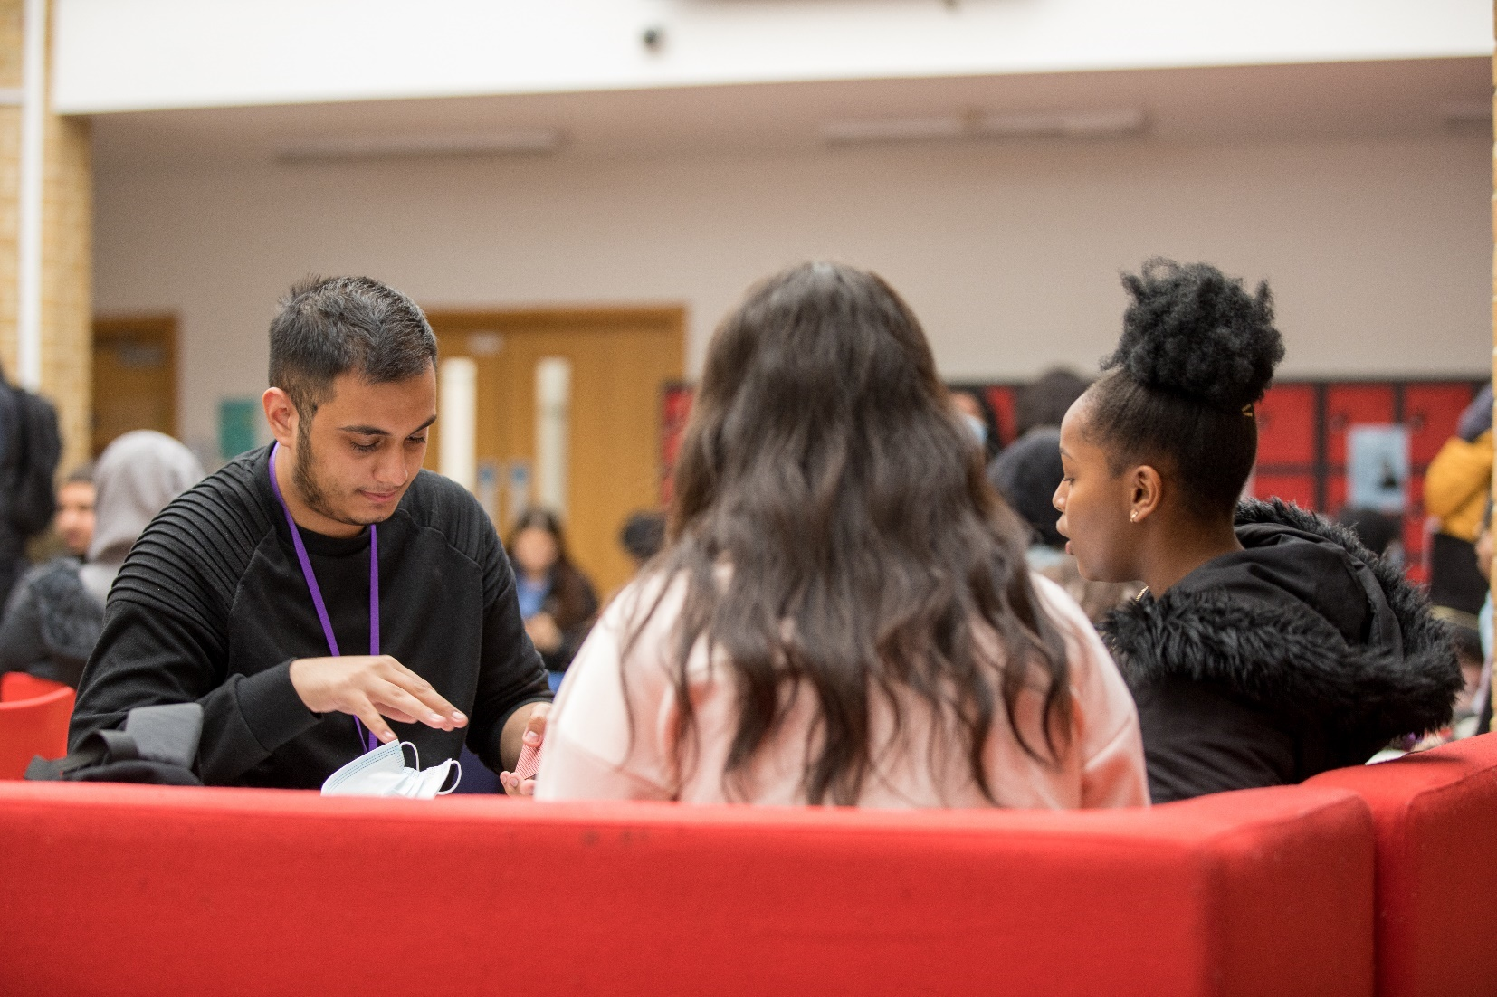

**Our Ethos and Strategic Direction**

**Our Ethos and Strategic Direction**



