


Job Description
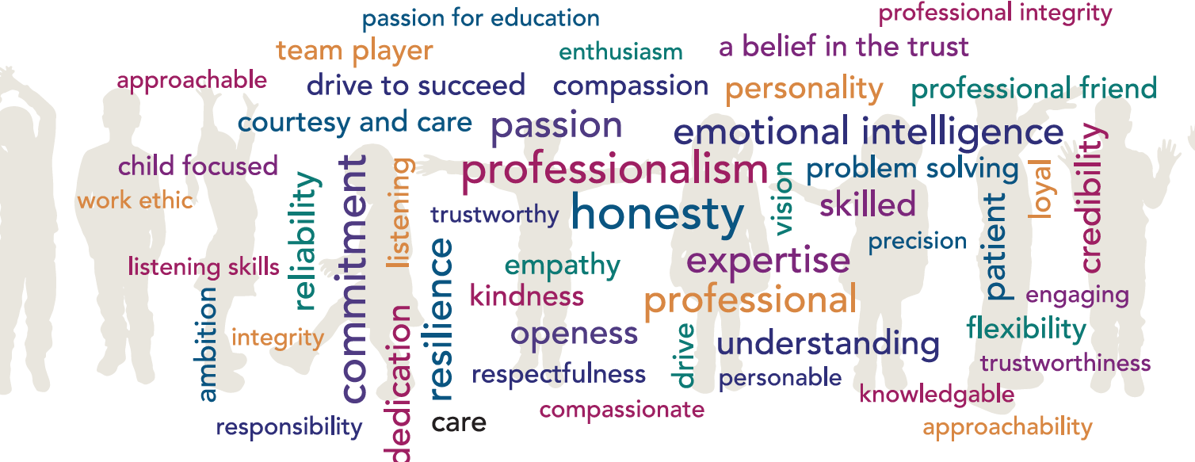

Job Title: Standards Officer

Remuneration: L16 – L21

Accountable to: Director of Education – Primary

Place of Work: Head Office and Across Hamwic Education Trust Schools

Hours: Full time – 52 weeks per year

Role Remit:
- To raise standards and improve the quality of education for pupils in the Hamwic Education Trust
- To improve the quality of leadership across the Trust, holding leaders to account for providing a high standard of education and care
- To provide leadership support and guidance for school leaders

The Postholder (through themselves and the wider team) will be accountable for outcomes and progress for all pupils within the Trust.

Key Responsibilities:
1. To raise standards and improve the quality of education for pupils in the Hamwic Education Trust
- To systematically use national data of schools and the trust as a whole, to identify priorities for improvement
- To secure improved pupil attainment and progress through effective support, monitoring and challenge
- To plan and review the work of the education team, to ensure high quality impact
- To facilitate the appropriate support packages to achieve the rapid and sustained improvement
- To develop, implement and evaluate teaching and learning related policies and practice, leading to agreed trust models of working
- To work strategically to improve the quality of education in individual schools, partnerships and across the trust
- To lead partnership forums to meet the Trust’s mission of self-improving communities

2. To improve the quality of leadership across the Trust, holding leaders to account for providing a high standard of education and care
- To set school leaders robust and precise targets, including through performance management
- To hold school leaders to account for delivering a high standard of education and care
- To coach and mentor school leaders to improve their schools, brokering effective support as required
- To work with school leaders to identify and develop their areas for improvement
- To ensure school leaders accurately evaluate the needs of schools and prioritise appropriately to bring about rapid school improvement
- To identify actions that school leaders and managed services need to take to ensure the school delivers a high standard of education and care
- To develop effective working relationships with schools, colleagues and other key partners
- To challenge school leaders with rigour and professional courtesy, to ensure the school continues to improve

3. To provide leadership support and guidance for school leaders
- To plan and deliver induction and training for new school leaders, so that they are supported to be effective in their roles
- To evaluate and provide advice and guidance to schools about their strategic documents such as development plans and post OFSTED action plans
- To consider the well-being of leaders in our schools, providing support and challenge to ensure they take care of themselves and their staff teams
- To identify and disseminate effective practice, including contributions to professional development and other training programmes
- To contribute to the recruitment and selection of senior school leaders, staff, and any other relevant personnel procedures
- To take responsibility for ensuring that preparation for and follow up to all Ofsted inspections are thorough, robust and lead to the very best possible outcomes
- To provide termly policy updates to school leaders and governors

Other Duties:
At an appropriate level, according to the job role, grade and training received, all employees in the Trust are expected to:
- Support the aims, values, mission and ethos of the Trust and participate to the one team approach, All About the Child and What About Sam?
- Attend and contribute to staff meetings and training days as required, and identify areas of personal practice and experience to develop
- Take appropriate responsibility for safeguarding and children’s welfare and be aware of confidential issues linked to home/child/teacher/academy and keep confidences appropriately
- The post holder at all times, whether or not in the employ of our schools or Trust and except where such information is in the public domain maintain the strictest secrecy with regard to the business affairs of our schools or Trust and its customers/stakeholders, products and product lists
- Be aware of health and safety issues and act in accordance with the Health and Safety Policy
- To liaise with other staff, contractors and outside agencies/organisations as appropriate

The post holder may be expected to carry out duties other than those given in the job description where the level of responsibility is similar, and he/she has appropriate qualifications or received appropriate training to carry out these duties.

Person Specification

Our Managed Service Team have identified the traits above that they feel any Hamwic employee should have, with professionalism, honesty, emotional intelligence and commitment being the top traits.

Qualifications

- A relevant degree and/or equivalent professional qualification

- Qualified teacher status

- Evidence of significant and effective teaching experience and professional development

Experience
- Substantial experience at senior leadership level

- A wide range of experience in Ofsted inspection processes

- Experience of driving rapid and sustained school improvement

Skills and Knowledge

- Make sound hypotheses using analysis and interpretation of relevant evidence

- Make objective judgements that are based securely on evidence, articulating reasons convincingly

- Analyse information, including performance data, accurately

- Accurately identify barriers and actions required to bring about rapid improvement

- Set actions and targets, holding leaders to account for improving their schools

- Produce accurate and evaluative written records that are fit for purpose within the required time scale

- Demonstrate competence in the use of IT

- Respond professionally and calmly to challenge

- Formulate and communicate critical judgements sensitively

- Establish respectful, open and professional relationships across the central team and the trust

- Manage the significant workload proactively by being efficient, organised and well prepared

- Share information efficiently and effectively to support team working and school improvement

- Lead others and manage their work effectively to achieve high quality outcomes

- Update professional knowledge continuously and as necessary

- Comply with procedures on safeguarding and protecting children, young people and learners

- Behave professionally, adapting flexibly to any roles assigned

- Plan and deliver high quality training, utilise existing materials and developing new materials as required

- Contribute to the leadership of the Trust through considered opinion and reflection

Personal Attributes

- A positive attitude, working well under pressure

- High levels of professional and personal integrity

- Enthusiasm for the role and the energy to carry it out

- Ability to self-motivate and inspire others

- A strong role model for professional practice

- High level of emotional intelligence

- A deep commitment to the vision, values and ethos of the Trust

- Excellent communication skills

- A strong team player with good interpersonal skills and the ability to work effectively as part of a growing organisation

- Ability to work well under pressure and in a calm, professional manner

