
Kirkby High School
Recruitment Pack

Student Counsellor

MAXIMISING OUR POTENTIAL


CONTENTS
Letter from Headteacher
About us
CPD
Job Description
Person Specification
How to Apply
Application Form
Welcome
Dear Applicant,
Thank you for your interest in the Student Counsellor position at Kirkby High School. Required for 5th January 2025.
We are seeking to appoint a dedicated and enthusiastic individual who is ambitious and has an excellent work ethic.
We are proud of our school’s success and are committed to providing an ambitious and inclusive environment with a strong pastoral care system that values every member of our community.
To help you decide if the job would suit you, please find enclosed some details, which we hope will give you a flavour of what Kirkby High School and The Rowan Learning Trust are about.
If your values and ambitions mirror ours and you believe you can deliver that vision, then we would be delighted to receive an application from you.
Visits to our school are welcome and can be arranged by contacting my PA, Jo Barrett on 0151 477 8710 or email j.barrett@kirkbyhighschool.net
We are committed to safeguarding all members of our community; therefore, all posts are subject to enhanced disclosure procedures and pre-employment checks.
Yours faithfully,
Mrs A Dobson
Headteacher, Kirkby High School

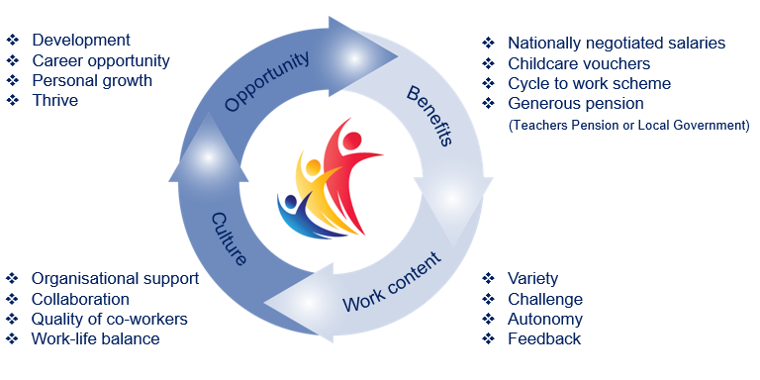
The Rowan Learning Trust
The Rowan Learning Trust (RLT) was established as a Multi-Academy Trust in 2012 to maximise potential of all children, students and adults in our schools.

We are an education charity. Our schools are working in collaboration, as one entity, to improve and maintain high educational standards across the group. We have a single legal and moral purpose: to advance education for the public benefit.

Currently the RLT family comprises 12 schools: 3 high schools, an
all-through alternative provision academy and 8 primary schools. Together we share a set of common values:

- Respect Kindness Integrity

Our strategic aim is to provide a world class education by:
- Attracting, developing and retaining people
- Embodying the values of the Trust
- Expanding our reach
- Optimising resources

The Trust in Numbers:
- 4250+ students 11 schools
- 10 sites 675+ employees
- 5 local authorities £37,000,000 annual budget

- 80+ governors

Kirkby High School
Kirkby High School is an Ofsted rated 'Good' 11-16 mixed comprehensive. All staff at Kirkby High School fully embrace our vision: “A community driven by high expectations and mutual respect providing all individuals with the belief and opportunities to succeed now and in the future”.
Kirkby High School stands at the centre of our local community and we believe that we offer our young people guidance and aspiration to be the best they can be in all aspects of life. Quality teaching and learning, supported by reliable pastoral systems, ensure that students are preparing well for later life.
We believe in building a culture of resilience and tolerance in which our students can thrive. Our aim is to increase our students’
self-belief and to show them that they can be what they want to be.
Confidence Kindness Aspiration Respect Resilience


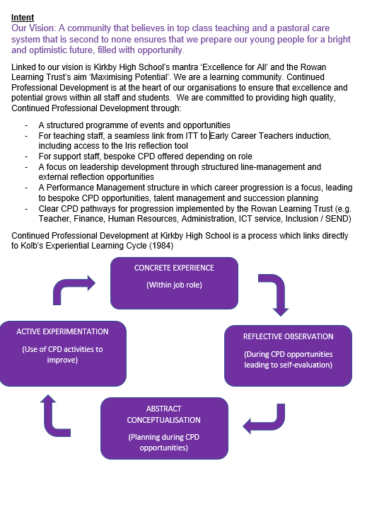
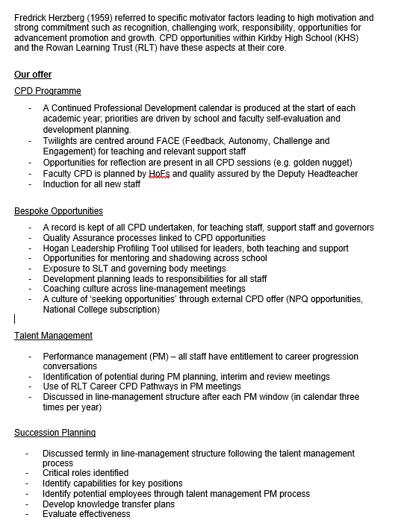
Continued Professional
Development Framework


Job Description
Student Counsellor
Reports to: Designated member of SLT
Location: Kirkby High School, Bracknell Avenue, Kirkby, L32 9PP
Salary: Grade H SCP 23-25, £34,434 - £36,363 per annum

Hours: 36 hours per week, full year

Overall Purpose of the Post
- Provide individual and group counselling to students.
- Liaise with all relevant people and agencies if the occasion arises.
- Support the aims and objectives of the school.
Main duties and Responsibilities
- To manage, co-ordinate and deliver a confidential specialist Counselling service to support Kirkby Hall students and staff.
- To work in collaboration with the Pastoral Deputy Head, Deputy Heads and Heads of Year to ensure comprehensive service.
- Ensure parental permission has been agreed.
- Carry out home visits when necessary.
- Liaise with all academic staff, parents and relevant outside agencies to ensure the support of students
- To provide written evidence of individual weekly session to students.
- To provide written evidence to outside agencies when required.
- To work pro-actively as a member of the pastoral team.
- Participate in regular meetings.
- Review students’ progress on a regular basis.
- Maintain files and records.
- Work in accordance with Counselling Practitioners Framework of Ethics and Practice for Counselling.
- Participate in training students for roles of responsibility such as peer support.

Support for the School
- Be aware of and comply with policies and procedures relating to child protection, health, safety and security, confidentiality and data protection, reporting all concerns to an appropriate person.
- Be aware of and support difference and ensure all students have equal access to opportunities to learn and develop.
- Contribute to the overall ethos/work/aims of the school.
- Establish constructive relationships and communicate with other agencies/professionals, in liaison with the teacher, to support achievement and progress of students.
- Attend and participate in regular meetings as may be reasonably directed
- Participate in training and other learning activities as may be reasonably directed.
- Recognise own strengths and areas of expertise and use these to advise and support others.

Please submit the enclosed application form and a supporting statement of no more than two sides of A4 outlining why you are interested in the opportunity and how your application addresses the requirements of the role.
Applications should be returned electronically to j.barrett@kirkbyhighschool.net
Alternatively, send a hard copy to:
Mrs A Dobson
Headteacher
Kirkby High School
Bracknell Avenue
L32 9PP

Closing date: 12 noon Friday 7th November 2025

Person Specification
The successful candidate will possess:

Essential:

- A commitment to safeguarding and equality
- An empathy with children
- The ability to maintain confidentiality.
- The ability to work independently and without direct supervision.
- An excellent attendance and punctuality record.
- Excellent communication and listening skills
- The ability to communicate and liaise with external agencies.
- A recognised Diploma in Counselling
- U.K. Counselling Practitioners Registration.
- Knowledge of the Child Protection Act.
- Commitment to attend relevant training courses for further development

Desirable:

- Previous experience of working in a school or with children.


How to Apply


The Trust will make any necessary reasonable adjustments to the job and the working environment to enable access to employment opportunities for disabled job applicants or continued employment for any employee who develops a disabling condition.
All appointments are subject to satisfactory references, proof of qualifications and eligibility to work in the UK.
The Trust is committed to safeguarding and promoting the welfare of all children and young people and expects all staff to share this commitment. An enhanced DBS check will be required.

The Trust will make any necessary reasonable adjustments to the job and the working environment to enable access to employment opportunities for disabled job applicants or continued employment for any employee who develops a disabling condition.
All appointments are subject to satisfactory references and eligibility to work in the UK.
The Trust is committed to safeguarding and promoting the welfare of all children and young people and expects all staff to share this commitment. An enhanced DBS check will be required.


The Rowan Learning Trust
Registered Office: 18 Beecham Court, Goose Green, Wigan, WN3 6PR
Company Number 8010464



KIRKBY HIGH SCHOOL

JOB APPLICATION FORM FOR SUPPORT STAFF IN SCHOOLS

The School and Governing Body are committed to equal opportunities in employment and welcome applications from all sections of the community.

BRACKNELL AVENUE,

KIRKBY, MERSEYSIDE, L32 9PP

TELEPHONE: 0151 477 8710

EMAIL: admin@kirkbyhighschool.net

- POST APPLIED FOR

Post Applied For:
School: | Kirkby High School
As advertised in: |  | On date:

2. PERSONAL DETAILS

SURNAME: |  | FORENAME:
TITLE:  (Optional) |  | Date of Birth:  (Optional)
Address:
POSTCODE: |  | Email:
Telephone No: |  | Mobile No:

3. CURRENT POST
CURRENT EMPLOYER AND JOB TITLE:
DATE OF APPOINTMENT: |  |  | SALARY:
NOTICE PERIOD:
MAIN DUTIES AND RESPONSIBILITIES
Reason for this application

4. EMPLOYMENT HISTORY
Post | Dates |  | Employer | Grade/Salary | Reason for Leaving
 | From | To

5. GENERAL EDUCATION
School | From | To | Qualifications – Grades, awarding bodies and dates

6. FURTHER AND HIGHER EDUCATION
Name of College/ University | From | To | Qualifications – Grades, awarding bodies & dates

7. ANY OTHER RELEVANT QUALIFICATIONS
Please give details of any other relevant qualifications you have for this post.

8. ADDITIONAL INFORMATION
- Are you related to, or a close friend of, any member of the Board of Trustees? If yes, please state relationship.
- Have you left any previous job for the reason of redundancy or are you in receipt of an occupational pension? YES/NO.
If yes, please give details, including dates, post held and employer.
- Have you ever been dismissed from any previous employment on the grounds of misconduct or incapability? YES/NO
If yes, please give details of dates and resources.
- Do you hold a current and valid driving licence? YES/NO
Please state category…………………………
- The Rowan Learning Trust is committed to providing equal opportunities and supporting all applicants. If you require any reasonable adjustments to allow you to participate in the application process, please let us know.
Do you require any reasonable adjustments? YES/NO
Do you have any unspent conditional cautions or convictions under the Rehabilitation of Offenders Act 1974? YES/NO

Do you have any adult cautions (simple or conditional) or spent convictions that are not protected as defined by the Rehabilitation of Offenders Act 1974 (Exceptions) Order 1975 (Amendment) (England and Wales) Order 2020? YES/NO

In line with Keeping Children Safe in Education, The Rowan Learning Trust will undertake general online searches for all shortlisted candidates which may include social media and video platforms. Online searches will only examine data which is publicly available, and the aim is to identify any incidents or issues. Any areas of concern will be discussed during the interview process.
9. STATEMENT IN SUPPORT OF APPLICATION
Please attach a supporting statement, indicating any matters which you feel may be relevant to this application. Please head additional documentation with your name and post applied for.

10. REFERENCES
Please state the names and addresses and telephone numbers of two persons from whom references may be obtained. One must be your current or most recent employer. In the absence of previous employment experience, a reference from your last place of full-time education will be a suitable alternative.
REFEREE 1 |  | REFEREE 2
TELEPHONE NO: |  | TELEPHONE NO:
EMAIL: |  | EMAIL:
Can this reference be taken up immediately  YES/NO |  | Can this reference be taken up immediately  YES/NO

11. FURTHER INFORMATION FOR CANDIDATES
- In the interests of the protection of children, all posts are subject to enhanced criminal record and other relevant disclosures through the Disclosure & Barring Service (DBS). A criminal record will not necessarily prevent you from obtaining a position.
- Please note that it is the policy of the Trust and the Governing Body to preclude employment of persons over the age of 65.
- You will receive no further communication unless selected for interview. If you have therefore not been contacted within three weeks of the closing date for applications, you should conclude that, unfortunately, you have been unsuccessful on this occasion.
- Under the Data Protection Act, the Trust and the Governing Body will use the information given for the purpose of recruitment and selection. Strict confidentiality will be observed and if you become an employee, the information will be used for personnel, pay and pensions administrative purposes only.

THANK YOU FOR YOUR INTEREST SHOWN IN THIS APPOINTMENT

13. DECLARATION
To the best of my knowledge and belief all the particulars I have given are true. I understand that any false statements may disqualify me from employment or render me liable for dismissal. I also understand that no offer of employment made to me will be binding unless confirmed in writing.
I also understand that this post is subject to a satisfactory enhanced Disclosure and Barring Service (DBS) check and to satisfactory medical clearance and the provision of documentary evidence (e.g. NI Number) that shows I am entitled to work in the U.K.

Signature:……………………………………………………………………………Date:…………………………………………………………

