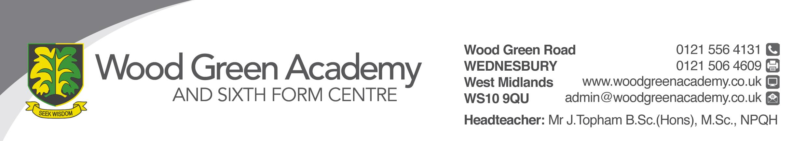
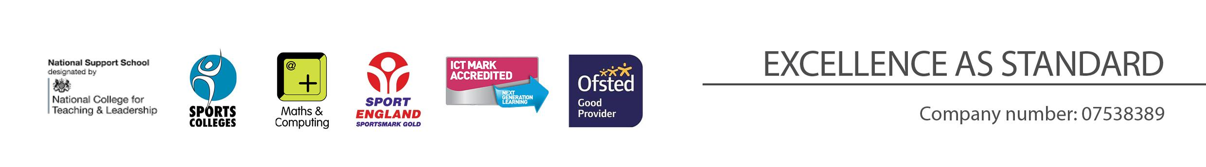
Student Support Manager
Person Specification

REQUIREMENT | ESSENTIAL | DESIRABLE
LEGAL REQUIREMENTS | Enhanced DBS Clearance
QUALIFICATIONS  Principally assessed through letter and application form | “First Aid at Work” certificate.  Secondary Education level 2  Child Protection level 2  EH Training  Counselling Level 2 | Level 3 qualifications
EXPERIENCE, KNOWLEGDE and PROFESSIONAL COMPETENCE  Principally assessed through letter, application form and lesson observation | Excellent organisational skills together with the ability to meet deadlines.  Excellent Interpersonal Skills  Experience of working with young people aged 11-18  Experience of working with confidential data.  Confident ICT skills | Ability to use Microsoft Office packages, with the ability to adapt readily to new software  Knowledge of Class charts/SIMS  Proven experience in a role which includes some of the skills outlined in this specification  Full driving license
COMMUNICATIONS  Principally assessed through letter and interview process | Have excellent written and verbal communication skills  Ability to use IT technology
PERSONAL ATTRIBUTES  Principally assessed through references, letter and interview process | To be committed to safeguarding and promoting the welfare of children and young people  Ability to motivate individuals to perform effectively  Ability to innovate and contribute to new initiatives  Commitment to working in partnership with parents  Awareness of and respect for, the needs of the individual child and their families, including multi-cultural and inclusive practices.  Ability to work when the school is open (Term Time working)  Flexibility and willingness to be involved in the school  Work effectively as a member of a team  Be an effective role model through presentation and personal conduct  Enthusiasm, energy, vigour, reliability and integrity

