FALINGE PARK HIGH SCHOOL

Subject Lead Food
Date of Taking up Post:

Organisation Chart

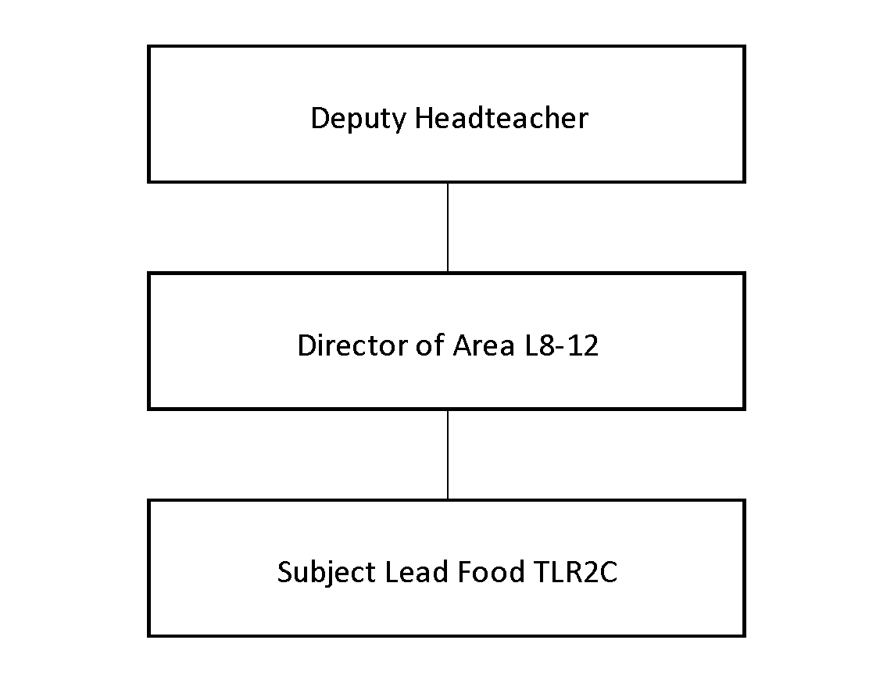

Job role and purpose

- To create a compelling learning experience

- To actively commit to the school strategy of believing in people (professional learning and research) and positive relationships

- To lead Food and Nutrition

- To demonstrate compelling leadership as part of the wider leadership team

Principal responsibilities:

The role has been developed so that subject leads can focus on two key areas:
- Curriculum and assessment design;
- Improving teaching and learning within their subject area.

Reporting to Directors of Areas

- Embody and fulfil the values of Compelling Leadership.
- Keep up to date with educational changes within their subject specialisms.
- Lead curriculum design within their teams so that:
- The big ideas of the curriculum are evident within their own curriculum areas and are met;
- The big ideas and concepts of their curriculum areas are clearly defined;
- The application of knowledge and the acquisition of subject specific skills are clearly defined;
- Curriculum constructs are clearly identified;
- Misconceptions and prior learning inform pedagogy;
- The CREATE framework is used to guide curriculum design;
- Assessments are designed to measure the constructs and that assessments have purpose, valid inferences can be made, they are reliable and have value;
- Assessment information is used to reframe teaching and learning and the curriculum;
- Lead planning meetings on a fortnightly basis to ensure that the aims of the curriculum are translated into the classroom.
- Improve teaching and learning within their subject areas through:
- Working alongside teachers within their classrooms to improve practice;
- Leading teachers through fortnightly planning meetings to ensure that the best teaching practice is being shared and acted upon;
- Identifying hinge questions and supporting teachers in ensuring they use and respond to the hinge questions;
- Providing guidance and leadership on pedagogy;
- Addressing variation within the teaching practice within their team in line with the school ethos;
- Ensuring the “nuts and bolts” of the curriculum (literacy development and Tier 2 vocabulary) are evident in teachers’ practice and within books;
- Ensuring that teachers fulfil effectively the “bread and butter” of their professional responsibility: plan, teach, mark;
- Ensuring that Learning Goals within their subject areas are meaningful and manageable;
- Ensuring that the Effective Feedback Policy is fulfilled so as to reduce variation and increase improvement.
- Meet regularly with Directors and engage in professional dialogue which will include how teachers’ reflection sheets match the quality of the work in the classroom.
- Be prepared to meet weekly after school as part of their professional development in this area.
- Undertake Performance Development reviews in line with school policy.

Additional Information
You are employed in the capacity of a teacher subject to, and with the benefits of, the conditions of employment set out, or referred to, in your letter of appointment and statement of particulars.

This Job Description identifies the responsibilities attached to your post. It is subject to the limits on working time set out in the current Teacher’s Pay and Conditions document.

This Job Description is subject to amendment from time to time within the terms of your conditions of employment, as the needs of the school/service may require, but only to an extent consistent with those conditions of employment and only after consultation with you. The agreed Grievance Procedures may be invoked in any dispute arising from this job description or subsequent amendment, in which case teachers are advised to consult their Professional Association.

The school is committed to safeguarding and promoting the welfare of children and young people and expects all staff and volunteers to share this commitment. Successful candidates will undergo an enhanced DBS check, checks of references and employment history.

Signatories:

(Both Headteacher and postholder are asked to sign and date this Job Description following consultation on its contents).

Signed: Date: __
(Post Holder)

Signed: Date: __
(Headteacher)
FALINGE PARK HIGH SCHOOL

Subject lead food
ATTRIBUTES | ESSENTIAL | DESIRABLE | HOW IDENTIFIED
WORK RELATED EXPERIENCE AND SKILLS | - Evidence of positive impact at Middle Leader Level.  - Evidence of successful teaching practice which demonstrates positive outcomes for pupils.  - Excellent relationship skills.  - Excellent knowledge of effective curriculum design. | - Knowledge and practice of alternative qualifications.  - Knowledge of evidence based interventions. | Application Form/Letter  Interview  References
QUALIFICATIONS | - Degree  - Qualified Teacher Status  - A willingness of commitment to professional development. | - Evidence of commitment to professional development i.e. NPQs | Application Form  Qualifications
SPECIALIST SKILLS AND KNOWLEDGE | - Understanding of effective curriculum and assessment design.  - Understanding of and excellent practice of teaching and learning within their subject discipline. | - Wider school experience. | Application Form/Letter  Interview  References

