Applied Learning and Employability Faculty (ALE)

Applied Learning and Employability Faculty Vision

To be a champion of academic, practical, and vocational learning; enabling students to develop their knowledge, skills and creativity, preparing them for the 21st Century.

The Faculty provides an exciting, stimulating curriculum, enabling personal success. It provides opportunities for students to take controlled risks, embrace new ideas, experience new ways of learning, developing their moral courage. A central focus of the Faculty is to provide real world context, exploiting cross curriculum opportunities, enabling our students to be outward looking and providing them with challenging leadership opportunities that will prepare them for life.

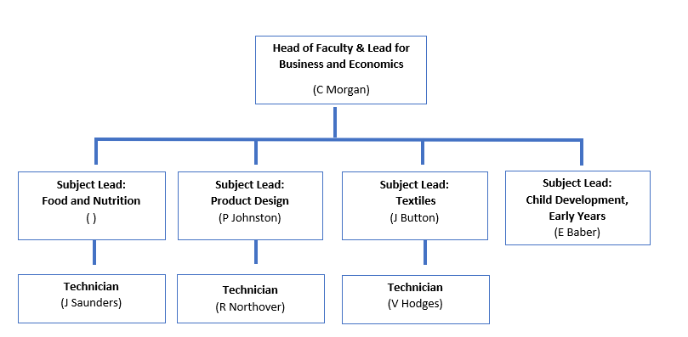
Faculty Structure
(Vacant)

For September 2021, the Faculty is undergoing a reorganisation to allow discrete curriculum pathways from Year 7 through to Sixth Form. This will allow subject specialists to grow their own subjects and embed the core skills needed to be successful at GCSE and A Level right from the start of secondary school.

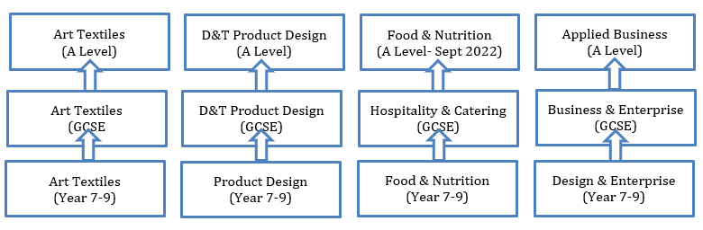

Lower School Curriculum Offer (Y7 – 9)

In Years 7 and 8, students are introduced to complete rotations complete rotations in Product Design, Fashion & Textiles, Food & Nutrition and Careers and Enterprise. Year 9 enables students to complete 4 week rotations of the different subject areas before choosing the subject they wish to study at GCSE or spend more time on. They will have 2 more longer rotations before the end of Year 9 that will include GCSE level skills.

Faculty Staff comprise:
Head of Faculty (Subject Leader for Business/Economics) Christopher Morgan
Subject Leader for Product Design Philippa Johnston
Subject Leader for Textiles Jenna Button
Subject Leader for Child Development and Early Years Emma Baber
Subject Leader for Health and Fitness Laura Jefferies
Teacher of Product Design Helen May
Teacher of Textiles Jude Lisney
Teacher of Textiles Jane Eaton
Teacher of Business and Economics Natalie Cording
Teacher of Child Development, Early Years and HSC NicolaTurner
Design and Technology Technician Victoria Hodges
Design and Technology Technician Robyn Northover
Design and Technology Technician Julie Saunders

Qualification overview and recent results:

Business  (Y10- Y13) | Our Level 2 qualification provides students with the opportunities to experience a broad range of business topic areas. We are currently following the NCFE Technical Award in Business and Enterprise. Summer 2020 results saw 100% of students achieving grades Distinction*-Pass with of these being 35% Distinction *-Distinction.  For Level 3 we follow the AQA Applied General in Applied Business, having moved over from AQA A Level in 2016. 100% of our Level 3 students achieved an equivalent A*-C grade in Summer 2020.
Child Development/  Early Years  (Y10 - Y13) | Our Level 2 qualification is the NCFE/Cache in Child Development and Care. We have been running this course for the past 4 years with fantastic results. Summer 2020 results saw 100% of students achieving grades A*-C with of these being 74% A*-A.  The Level 3 qualification has been running for the past three academic years and we are currently following the NCFE Level 3 Applied General in Early Years, Childcare and Education.
Economics  (Y12 - Y13) | Our A Level Economics students’ follow the Edexcel A Economics programme of study. We achieve good results in this A Level with a 50% grade A and above rate.
Health & Fitness  (Y10-Y11) | Our Level 2 qualification provides students with the opportunities to experience a broad range of health and fitness topic areas. We are currently following the NCFE Technical Award in Health and Fitness. Summer 2020 results saw 100% of students achieving a Level 2 Pass and above.
Health and Social Care  (Y12 - Y13) | We offer the NCFE Level 3 Applied General in Early Health & Social Care. This qualification is a popular choice at Sixth Form and has seen a strong set of results in Summer 2020.
Food and Nutrition  (Y7 - Y11) | We are currently offering the WJEC Level 2 Award in Hospitality and Catering course. Prior to this course, with a strong background in delivering the GCSE Food Technology. Summer 2020 results saw 100% of students achieving a Level 2 Pass and above (64% achieving above a Level 2 Distinction and above).
Product Design  (Y7 - Y13) | Product Design students benefit from a state-of-the-art workshop having received Dyson investment since 2012. The GCSE students follow the AQA programme of study. 2020 resulted in 89% of students achieving Grade 9-5 (72% achieving a Grade 7 and above).  The A Level programme follows the AQA exam board. 2020 results were fantastic with 100% of students achieving A*-C (75% achieving A*).
Textiles  (Y7 - Y13) | Textiles is very popular at GCSE and A Level. Since September 2019 we have followed the OCR Art & Design programme of study – Textiles Design; GCSE. Summer 2020 results saw 100% of students achieving Grade 5 and above. (42% Grade 7 and above).  AQA A Level Textiles is our flagship Textiles qualification, delivering amazing products showcased in the annual Fashion Show. Summer 2020 results saw 100% of students achieving A*-C grades.

Food and Nutrition
We have an exciting opportunity for a dynamic and committed Food and Nutrition specialist to lead the Food and Nutrition team and the Applied Learning and Employability department at Hayesfield School and Mixed Sixth Form.
We are looking for a candidate to join our dynamic Faculty who has the ability and passion to secure and sustain outstanding teaching and learning alongside promoting excellence, inclusion, and high expectations for all students in this subject area. The successful applicant will be passionate about growing the subject through to Post 16.
Curriculum Structure (September 2021)
Alongside the Lower School curriculum offer to all students in Years 7, 8 and 9 we are currently offering the WJEC Level 2 Award in Hospitality and Catering to students in Years 10 and 11.

Overview of Results for Hospitality & Catering
 | Entries | %  Distinction* - Pass | %  Distinction* - Distinction
2018 | 9 | 100 | 67
2019 | 13 | 100 | 85
2020 | 13 | 100 | 64

New staff support and development:
The Applied Learning and Employability Faculty welcomes new staff, including NQTs and those recently new to teaching. We provide all new staff with a subject specific mentor who will work closely with you to develop your knowledge of the Applied Learning and Employability Faculty policies and procedures and help develop your subject teaching skills. This mentor is also your very own point of personal contact and support. As a new subject leader

Extra-curricular provision:
There is a wide variety of extracurricular provision made available in Applied Learning and Employability at Hayesfield. This includes a trip to New York for A Level Business students’, Sewing Bee Club, Fun with Food and other opportunities that help to enrich the curriculum and show science in the ‘real world’. We have also invested significantly in ICT and specialist equipment, allowing for further extracurricular provision to be offered to students.

Wider Links

The Faculty has external links with a wide variety of employers and organizations in part because of its role in promoting employability across the school and through subject specific links. These include: RUH, QinetiQ, Buro Happold, Bath College, Rotary, Arkwright Scholarship, and the Gane Trust. The role of Hayesfield STEM Employability coordinator sits within the Faculty as part of the Head of Product Design’s job role.

