FINHAM PARK 2
SUBJECT LEADER OF ENGLISH

Full Time Permanent – Starting September 2024
Grade TMS / UPS with TLR1B

We are delighted to announce that we are recruiting an enthusiastic, innovative and highly motivated Subject Leader of English to join an experienced team with superb facilities; where teachers are committed to delivering a high quality, lively and interesting curriculum to challenge and inspire all of our students. The successful candidate will be required to teach to KS3, KS4 and potentially KS5.

Finham Park 2 is an exciting, friendly and supportive 11-19 co-educational comprehensive school based on the West side of Coventry near the border of Solihull and close to Warwick University. We opened in September 2015 with 120 students and have grown year on year, including our 6th form, which opened in 2020.

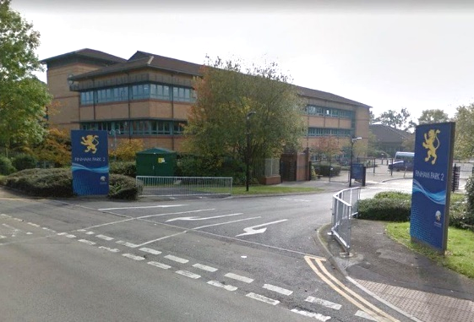
In September 2016 we moved to our new building- a light and spacious, high quality refurbishment with superb facilities including a brand-new sports hall. We are fully staffed with a positive, supportive, forward thinking team. We continue to be heavily oversubscribed each year. Our last Ofsted (November 2023) described Finham Park 2 as a good school in all areas with “a purposeful atmosphere around the school”, “a calm and orderly manner” and “a highly ambitious curriculum”, where “leaders carefully consider staff workload which staff are appreciative of.”
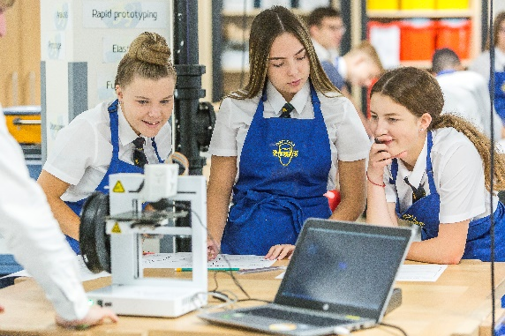
Finham Park 2 is a truly comprehensive school with almost 700 students on roll. The vast majority of our students are happy, well-behaved, friendly, inquisitive, polite and wear their uniform with pride. On entry students are broadly in line with national averages with approximately 85+% middle or higher prior attainment.

We offer an exciting curriculum that provides opportunities for all students to ensure they all achieve and make the best progress they are capable of, no matter what their starting points; a curriculum that nurtures every child’s talents and provides exceptional opportunities for students to have the ‘time of their lives’.

Finham Park 2 is supported by and proud to be part of Finham Park Multi Academy Trust. As part of the Multi Academy Trust, we enjoy working in collaboration with the other MAT schools. This provides fantastic opportunities for both our staff and students.

Successful candidates will join an established and strong team, where our teachers are committed to delivering a high quality, lively and interesting curriculum to challenge and inspire all of our students.

We are looking to appoint a charismatic, dynamic individual who naturally inspires others and is passionate about teaching and its impact on learning. The successful candidate will be driven by a commitment to create the best possible educational opportunities for our pupils, in order to raise aspirations and transform lives.

To apply, please read our pack before providing a full application form along with the equal opportunities form. Please ensure your supporting statement sets out why you feel that you are suitable for this role and includes demonstrable impact of your achievements.

Details of our interview arrangements, will be provided to the shortlisted candidates.

Closing date: Monday 8th April 2024 at 9am

Interview date: TBC

Completed application forms should be returned to apply@finhampark.co.uk or:

HR Manager
Finham Park MAT
Torrington Avenue
Coventry
CV4 9WT

Finham Park Multi Academy Trust requires all applicants to be eligible to work in the UK with no restrictions as we are unable to offer sponsorship/work visas. You will be required to provide proof of Right to Work at interview stage and if you are offered a job position with us.

Online Checks
In line with KCSIE (Keeping children Safe in Education) 2023 we will complete online searches as part of our due diligence on all shortlisted candidates. If anything is identified as part of these checks they will be discussed with you at interview. If any safeguarding concerns are identified we reserve the right to withdraw your application.

Finham Park Multi Academy Trust is committed to safeguarding and promoting the welfare of children and young people and expects all staff and volunteers to share this commitment.

