Physics at the University of Birmingham School
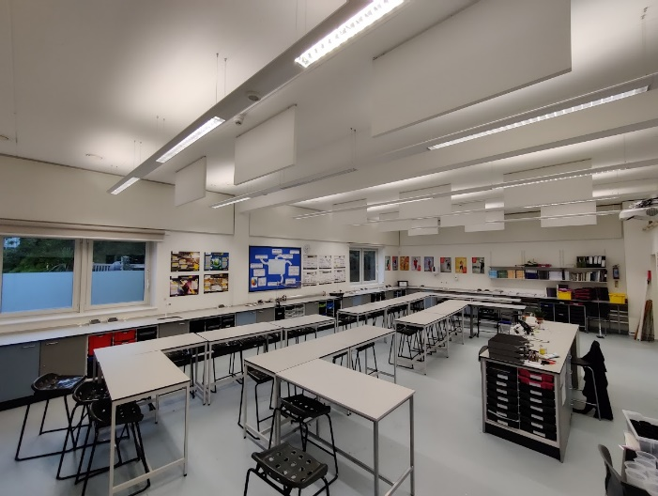
At the University of Birmingham School, Physics is a friendly, welcoming and exciting department to work in, currently staffed by four specialist physics teachers and a physics technician. Our physics lessons are taught in large, bright, modern labs. We have three physics laboratories as well as a physics prep room. All our rooms are equipped with visualizers and a range of specialist physics equipment. As a department we are exceptionally well resourced, with multiple class sets of all the usual physics equipment and a class set of IPads.
Pupils are taught physics, chemistry and biology separately from year 7 by subject-specialist teachers. Small class sizes (around 25 students) allow more individualised learning to take place. Pupils have two physics lessons per fortnight in year 7, two in year 8 and three in year 9. Students are taught in mixed ability classes. In years 7 and 8 we develop a strong foundation around the core ideas in physics while putting an emphasis on qualitative explanation of ideas over quantitate skills. In year 9, we focus on developing students’ mathematical skills in preparation for their GCSE study.
In years 10 and 11 we offer AQA GCSE combined science (trilogy) or AQA GCSE physics (along with GCSE chemistry and GCSE biology). Students have four lessons of physics a fortnight with their specialist teacher. We benefit from teaching within specialism for all our GCSE students. Our separate science students are in classes of just over 30 students, with our combined science students benefiting from smaller groups, most of which are approximately 20 students each.
Physics is a popular subject in the sixth form. We currently have around 80 students studying AQA A-level physics in year 12 and year 13. Students have ten lessons a fortnight in year 12 and year 13, with their teaching split between two teachers. In year 12, students also have one lesson a fortnight of physics skills lessons to get their numeracy and practical skills up to scratch for the demands of the course. It is often commented on how bright and conscientious our sixth form students are in the physics department and each year we have a large number of students go on to study physical sciences and engineering at university.
As a school, we have a big focus on enrichment as part of our character education program on a Friday afternoon. In the past we have run a number of physics and science themed enrichment programs, including engineering, astronomy and space, STEM club, the physics Olympiad, Oxbridge preparation and many other options. Any new members of the team would be more than welcome to contribute to our enrichment program.
The physics team is a group of enthusiastic and committed teachers with our own dedicated technician. We are always keen to discuss and develop our practice and curriculum. As physicists, we are passionate about showing our students how exciting our subject can be. As a team we look to plan collaboratively wherever possible and share resources to allow us to spend our time focusing on our practice and minimise workload.
If you are interested and have questions or would like to know more about the department, please contact the subject leader for physics Rob Campbell at r.campbell@uobschool.org.uk.

