

Targeted Mainstream Provision Teacher

Recruitment Information Pack



Contents

About the School 3
Application Process 5
Job Description and Person Specification 6



Behind the scenes of our new Targeted Mainstream Provision being built

Welcome from the Headteacher

Welcome to St. Martin’s C of E VA Primary School. Our school provides children with a happy, caring environment in which to learn and achieve. Our staff work together to offer a diverse exciting education for our children. The governors and I are very proud of the skills and dedication of the staff team and everyone works hard to create a learning environment where every child is able to reach their full potential and develop their personality.

The Christian ethos is of paramount importance at St. Martin’s and we are committed to developing ‘the whole child’, in the firm belief that each of us is created in God’s image. There are essential strong links and relationships with parents and the Church, and governance of the School is comprehensive. All of this, linked to excellent
teaching ensures our reputation as a popular school.

The school has 9 classes, with some classes working as mixed age classes. Due to our admission number of 40 per year group, mixed age classes are in operation to ensure that we keep class sizes in infants below 30 and maintain this throughout school.

Our vision encapsulates the friendly, family ethos of the school community, building secure
foundations within a nurturing Christian environment. This is vital to the well-being and personal development of every pupil in our care. A visit to the school is an ideal way to discover this for yourself. You will be most welcome!

Thank you for your interest in St. Martin’s C of E VA Primary School.

Mrs Claire Barber
Headteacher
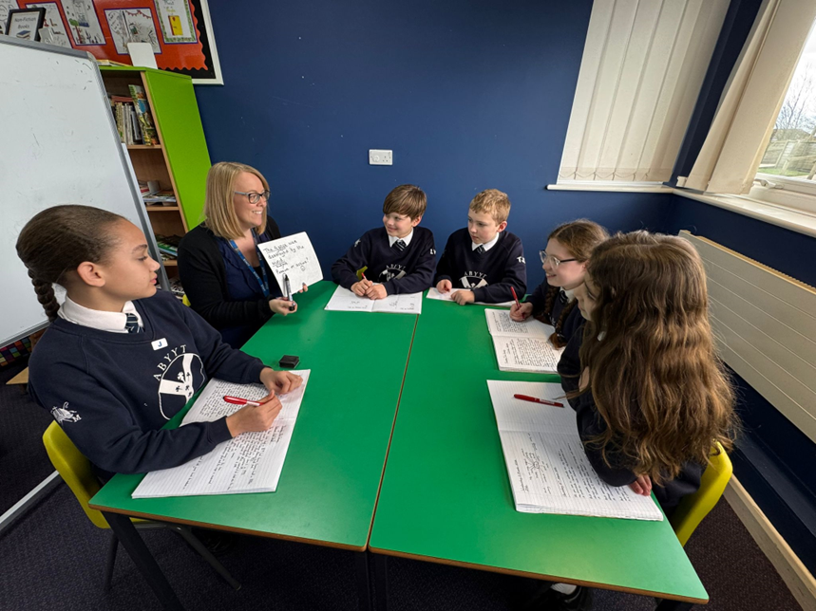

Vision & Values

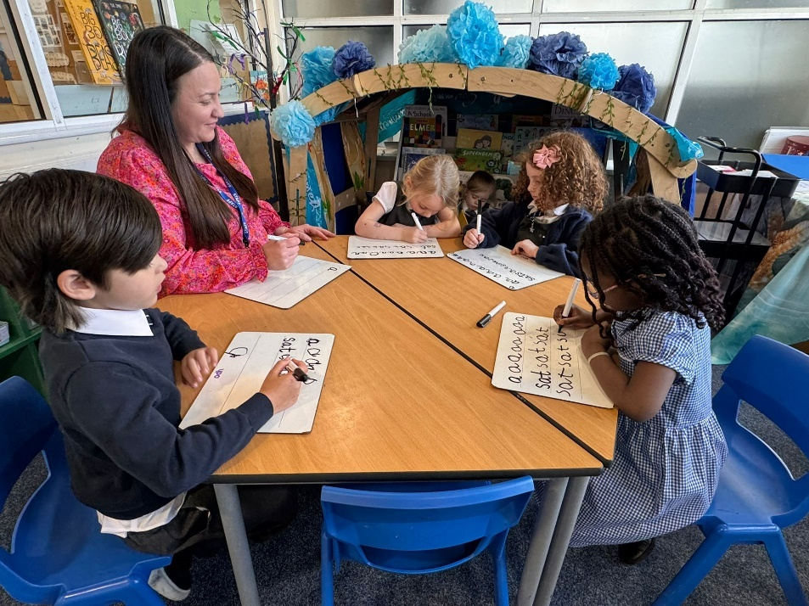
St. Martin’s C of E Primary School Vision
“Serve one another in love” – Galatians 5v13
St. Martin’s School isn’t just a school, it’s a family. Firmly rooted in the Christian faith, the St. Martin’s family will share the love of Christ with our diverse school community – all unique and special, made in God’s image, with everyone welcomed and included.

We live out our vision…
- as educators, by serving our children, teaching a rich, relevant curriculum and aspiring to the highest possible standards in our work and practice.

- sustained by the love of Jesus. Together with the education we provide and the security of a family, our children and families will flourish, widen their horizons and aspire to be the best that they can be.

- following the example of Jesus, who washed the feet of his disciples; we will all serve each other. We will also look outwards, seeking to serve our global family as we treat our environment and global neighbours with respect and understanding.

Our School Vision is underpinned by our ‘St. Martin’s 5 Ways to Flourish.







Application Process

The closing date for all applications is 11:59pm Sunday 26th April

Interviews will be held on Thursday 7th May

An email will be sent to candidates with the outcome of the shortlisting process.

Application Process
Please apply online via NYC Jobs

An email will be sent to candidates with details of the shortlisting process.
We do not accept CV’s.

Queries / Visits
Please contact Chloe Bullen at Chloe.Bullen@northyorks.gov.uk or on 01609 536 964

Visits to our setting is encouraged on the following dates and times:
● Friday 17th April: 10.00am or 4.00pm
● Monday 20th April: 1.30pm or 4.00pm
● Tuesday 21st April: 1.30pm or 4.00pm

When applying please take into account the following:

Employment History
In line with KCSIE requirements, please complete your full employment history to ensure any gaps in your education and career history are accounted for.

Suitable References
When completing your application, please provide two employment referees. Generally, this should be your current and most recent Headteacher or line manager. Please note if your former Headteacher or line manager has since left, please use an alternative current senior staff member as they need to be in post at your former location to be able to confirm your details in full.

Unfortunately, we cannot accept personal references or personal email addresses.
Please get in touch for any queries if you are unsure.

Supporting Information
The supporting information section of your application should clearly evidence your ability to meet the requirements we have outlined in the job description & person specification. This will be used to shortlist applicants for this role and therefore it is imperative that you provide evidence as requested.

Job Description

JOB TITLE: Teacher in the TMP (Targeted Mainstream Provision).
GRADE: MPS/ UPS plus SEN allowance
RESPONSIBLE TO: Headteacher and SENCo
JOB PURPOSE: The teacher of the TMP with the direction of the Headteacher and SENCo will:
- Support Cognition & Interaction and Social Emotional Mental Health practice across the TMP
- Be responsible for day-to-day operation of the SEN policy and coordination of specific provision to support individual pupils with SEN or a disability who are on the register of the TMP
- Work closely with staff, parents and other agencies
- Facilitate and encourage learning which enables pupils to achieve high standards

ACCOUNTABILITIES / MAIN RESPONSIBILITIES
Duties and Responsibilities | Teaching and Learning  - Develop and teach a differentiated curriculum to pupils assigned to the provision, according to their educational needs, including the setting and marking of work  - Plan and prepare learning programmes that meet the needs of individual learners  - Motivate pupils with enthusiastic imaginative presentation  - Plan, prepare and present lessons that cater for the needs of the whole ability range within the TMP setting  - Assess, record and report on the development, progress and attainment of pupils  - Establish good relationships and good working practices in the TMP and across the school community  - Communicate effectively and engage positively with children, staff, parents and the wider community  - Lead, support, motivate and direct HLTAS and Teaching Assistants within the TMP  - Ensure that school policies and practices are rigorously followed  - Support the ethos and values of St. Martin’s School and follow high standards of professionalism  - Ensure that the environment within the TMP is tidy, consistent with school policy, overcomes barriers to learning, and is a true reflection of the ethos of the TMP and the school as a whole  - Keep up to date with current educational practice by attending such training and CPD as may be required  - Prepare for, and participate in all staff and parental meetings relevant to the role  - Be responsible for the children in the TMP with Special Educational Needs and have a working knowledge of the SEN Code of Practice  - Take responsibility for the progress of children in your care  - Organise the TMP to create a positive and accessible learning environment  - Review and monitor EHCPS to support the SENCo  - Track pupil progress over time, and across the curriculum, for children within the TMP class. Regularly record levels of attainment and monitor the progress of pupils academically, emotionally and socially in line with school policy  - Liaise with colleagues and work flexibly  - Liaise closely with staff in the main school in order to provide the best, inclusive provision for pupils in the TMP  - Support teaching in the wider SEND provision in school  - Work with the Senior Leadership Team, SENCo and class teachers to plan and coordinate work in terms of links to pupils’ mainstream classes  - Understand broad neurodiversity and keep up to date with research developments including the use of technology  - Provide feedback to parents on a pupil’s progress at parent’s evenings and other meetings  - Act as a role model of good classroom practice for other staff, by modelling effective strategies  - Plan and implement strategies to improve teaching where needs have been identified  - To undertake other duties appropriate to the post as required by the Headteacher and/or SENCo
Systems & information | - Be aware that different types of information exist (for example, confidential information, personal data and sensitive personal data), and appreciate the implications of those differences  - Share information appropriately – in writing, by telephone, electronically and in person.  - Have an awareness and basic knowledge of the most recent legislation and the common law duty of confidentiality.  - Ensure that information systems are in place to ensure that accurate electronic and manual records are maintained and updated as required.
Safeguarding and Promoting the Welfare of Children/Young People | - Be responsible for promoting and safeguarding the welfare of pupils in line with policy and legislation, raising concerns as appropriate following policies and the staff code of conduct  - St. Martin’s C of E VA Primary School is committed to safeguarding and promoting the welfare of our pupils and young people. We have a robust Child Protection Policy and all staff will receive training relevant to their role at induction and throughout employment at the School. We expect all staff and volunteers to share this commitment. This post is subject to a satisfactory enhanced Disclosure and Barring Service criminal records check for work with children
Health & Safety | - Be aware of and implement your health and safety responsibilities as an employee and where appropriate any additional specialist or managerial health and safety responsibilities as defined in the Health and Safety policy and procedure  - To work with colleagues and others to maintain health, safety and welfare within the working environment
Data Protection | - Know about data protection issues in the context of your role  - To comply with the school’s policies and supporting documentation in relation to Information Governance this includes Data Protection, Information Security and Confidentiality
Equalities | - Within own area of responsibility work in accordance with the aims of the Equality policy, treating people with respect for their diversity, culture and values  - St. Martin’s C of E VA Primary School is committed to equality and to making fair and equitable treatment an integral part of everything we do. The School is committed to safeguarding and promoting the welfare of children and expects all staff to share this commitment. The post is subject to a successful DBS check and pre-employment checks will be undertaken before an appointment is confirmed.



Person Specification
Attributes |  | Desirable/ Essential
 | Experience of teaching in primary schools | Essential
 | Experience of supporting pupils with special educational needs | Essential
 | Able to evidence excellent pupil progress | Essential
 | Experience of working positively and closely with staff, parents and guardians | Essential
 | Effective experience in creating a positive climate and environment to secure accelerated learning | Essential
 | Recent OFSTED experience | Desirable
EDUCATION AND TRAINING | QTS | Essential
EDUCATION AND TRAINING | Thorough knowledge of teaching, learning and curriculum in primary schools | Essential
EDUCATION AND TRAINING | Commitment to continued professional development | Essential
EDUCATION AND TRAINING | Evidence of recent & relevant training | Essential
EDUCATION AND TRAINING | Safeguarding Awareness | Essential
EDUCATION AND TRAINING | Specialist qualification in the education of children with SEN | Desirable but not essential
PROFESSIONAL KNOWLEDGE AND SKILLS | An excellent classroom practitioner | Essential
PROFESSIONAL KNOWLEDGE AND SKILLS | Experience delivering phonics | Desirable
PROFESSIONAL KNOWLEDGE AND SKILLS | Effective use of assessment data to plan sequence of learning that secures accelerated progress | Essential
PROFESSIONAL KNOWLEDGE AND SKILLS | Work effectively as part of a team, relating well to colleagues, pupils and parents | Essential
PROFESSIONAL KNOWLEDGE AND SKILLS | Excellent use of ICT to support learning | Essential
PROFESSIONAL KNOWLEDGE AND SKILLS | High expectations of all pupils | Essential
PROFESSIONAL KNOWLEDGE AND SKILLS | Detailed knowledge of the National Curriculum and its planning and delivery | Essential
PROFESSIONAL KNOWLEDGE AND SKILLS | Implications of the Code of Practice for Special Educational Needs for teaching and learning | Essential
PROFESSIONAL KNOWLEDGE AND SKILLS | Evidence of ability to maintain high standards of behaviour and develop attitudes of care, control and cooperation with a range of pupils with different needs. | Essential
PROFESSIONAL KNOWLEDGE AND SKILLS | Experience of curriculum planning as part of a team | Essential
PROFESSIONAL KNOWLEDGE AND SKILLS | Ability to self-motivate and lead a team of support staff | Essential
PROFESSIONAL KNOWLEDGE AND SKILLS | High level of oral and written communication skills and ability to communicate with a wide range of audiences | Desirable
PROFESSIONAL KNOWLEDGE AND SKILLS | Able to offer subject expertise | Essential
PROFESSIONAL KNOWLEDGE AND SKILLS | High level of organisational and planning skills | Essential
PROFESSIONAL KNOWLEDGE AND SKILLS | Ability to use initiative, solve problems, make decisions and motivate others | Essential
PROFESSIONAL KNOWLEDGE AND SKILLS | Ability to relate to and empathise with pupils and to build trusting relationships with them | Essential
PROFESSIONAL KNOWLEDGE AND SKILLS | Evidence of successful multi-agency working. | Essential
PROFESSIONAL KNOWLEDGE AND SKILLS | Excellent interpersonal skills | Essential
PROFESSIONAL KNOWLEDGE AND SKILLS | Be flexible & able to respond quickly to changing needs and environment | Essential
PROFESSIONAL KNOWLEDGE AND SKILLS | Be able to work sensitively and successfully with families | Essential
ANY ADDITIONAL FACTORS | A commitment to abide by and promote equal opportunities, Health and Safety and Child Protection Policies | Essential
ANY ADDITIONAL FACTORS | Commitment to an involvement in extra-curricular activities | Essential

APPLYING FOR A JOB WITH NORTH YORKSHIRE COUNCIL

IMPORTANT ADVICE ON COMPLETING THIS APPLICATION

Your application form plays an important part in your selection. Please ensure you address all the essential requirements listed in the specifications. The following advice should help you to complete the application form as effectively as possible.
Data Protection
The information that you state on this application form will be used by the school and the Council to consider you for a job vacancy. To find out about how we use your personal data for the purposes of recruitment please see our Privacy Notice at www.northyorks.gov.uk/working-us.

Rehabilitation of Offenders
The post you are applying for requires you to have an enhanced Disclosure and Barring Service criminal records check for work with children, with a barred list check if you work in regulated activity. This check for disclosure of criminal history will include spent convictions, pending prosecutions / current court proceeding and police enquiries.

Should you be shortlisted, you will be asked to disclose full details of your criminal history prior to your interview. This includes any information deemed relevant as part of Keeping Children Safe in Education which may arise in an online search undertaken on shortlisted candidates. This information may be discussed with you at your interview in order to assess job related risks, but we emphasise that your application will be considered on merit and ability and you will not be discriminated against unfairly. Failure to disclose this information will result in any offer of employment being withdrawn.

Please also see the policy statement on the Recruitment of Ex-offenders below.

Information in Support of your Application
Every post advertised is supported by a full person specification. The specification lists all the essential skills, experience and qualifications which are necessary for the job and the criteria against which you will be assessed, both through your application form and at interview.

As part of the application process, you may have been asked to demonstrate within this application form how you meet some or all of the criteria or key competencies outlined in the person specification. Rather than simply repeating your career history, look at the skills and experience required by the job and provide evidence that you possess them by giving specific and detailed examples which include a focus on outcomes and on your own contribution to the scenario. Try to use different and varied examples wherever possible.

When completing these sections, do not forget the skills and experience you have gained outside full-time work. Outlining your previous work experience or other responsibilities may help you to uncover skills which you have taken for granted and which are clear signs of your ability to do the job.

Canvassing
You must not try to influence an elected Council Member, any council employee or a member of the school governing body, to act in your favour, as this will disqualify you. If you are related to a Councillor, a Council employee or a governor you must indicate this in the relevant section of the application form.
Policy Statement on the Recruitment of Ex-offenders (Source www.gov.uk)
- As an organisation assessing applicants’ suitability for positions which are included in the Rehabilitation of Offenders Act 1974 (Exceptions) Order using criminal record checks processed through the Disclosure and Barring Service (DBS), this school complies fully with the DBS code of practice and undertakes to treat all applicants for positions fairly.

- This school undertakes not to discriminate unfairly against any subject of a criminal record check on the basis of a conviction or other information revealed.

- This school can only ask an individual to provide details of convictions and cautions that it is legally entitled to know about. Where a DBS certificate can legally be requested (where the position is one that is included in the Rehabilitation of Offenders Act 1974 (Exceptions) order 1975 as amended, and where appropriate Policy Act Regulations as amended) this school can only ask an individual about convictions and cautions that are not protected.

- This school is committed to the fair treatment of its staff and potential staff, regardless of race, gender, religion, sexual orientation, responsibilities for dependents, age, physical/mental disability or offending background.

- This school has this written policy on the recruitment of ex-offenders, which is made available to all DBS applicants at the start of the recruitment process.

- This school actively promotes equality of opportunity for all with the right mix of talent, skills and potential and welcome applications from a wide range of candidates, including those with criminal records. Candidates are selected for interview based on their skills, qualifications and experience and criminal record information is only requested from short-listed candidates.

- A disclosure is only requested from the DBS after a thorough risk assessment has indicated that one is both proportionate and relevant to the position concerned. For those positions where a criminal record check is identified as necessary, all application forms, job adverts and recruitment briefs will contain a statement that a DBS certificate will be requested in the event of the individual being offered the position.

- This school ensures that all those who are involved in the recruitment process have been suitably trained to identify and assess the relevance and circumstances of offences.

- This school also ensures that they have received appropriate guidance and training in the relevant legislation relating to the employment of ex-offenders, e.g. the Rehabilitation of Offenders Act 1974.

- At interview, or in a separate discussion, this school ensures that an open and measured discussion takes place on the subject of any offences or other matter that might be relevant to the position. Failure to reveal information that is directly relevant to the position sought could lead to withdrawal of an offer of employment.

- This school makes every subject of a criminal record check submitted to DBS aware of the existence of the code of practice and makes a copy available on request.

- This school undertakes to discuss any matter revealed on a DBS certificate with the individual seeking the position before withdrawing a conditional offer of employment.

