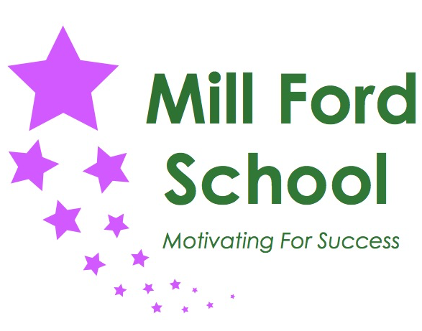

Job Title | Teacher
Band/Job Group | Teacher Pay Scale + SEN allowance
Hours/Weeks | Full Time / Permanent
Special Conditions
School | Mill Ford School
Responsible to | Head Teacher

The Post
This job description should be read alongside the range of duties of teachers set out in the annual School Teachers’ Pay and Conditions Document.
Members of staff should at all times work within the framework provided by the school’s policy statements to fulfil the general aims and objectives of the school’s improvement Plan.

To make a major contribution to the successful teaching and learning opportunities offered at Mill Ford School.

Main responsibilities

Relationships with children and young people
- Have high expectations of children and young people including a commitment to ensuring that they can achieve their full educational potential and to establishing fair, respectful, trusting, supportive and constructive relationships with them.
- Hold positive values and attitudes and adopt high standards of behaviour in their professional role.

Frameworks
- Maintain an up-to-date knowledge and understanding of the professional duties of teachers and the statutory framework within which they work, and contribute to the development, implementation and evaluation of the policies and practice of their workplace, including those designed to promote equality of opportunity.

Communicating and working with others
- Communicate effectively with children, young people and colleagues, including those from multidisciplinary teams.
- Communicate effectively with, both spoken and in writing, parents and carers, conveying timely and relevant information about attainment, objectives, progress and well-being.
- Recognise that communication is a two-way process and encourage parents and carers to participate in discussions about the progress, development and well-being of children and young people.
- Recognise and respect the contributions that colleagues, parents and carers can make to the development and well-being of children and young people and raising their levels of attainment.

Personal and professional development
- Evaluate their performance and be committed to improving their practice through appropriate professional development.
- Have a creative and constructively critical approach towards innovation; being prepared to adapt their practice where benefits and improvements are identified.
- Act upon advice and feedback and be open to coaching and mentoring.

Professional knowledge and understanding

Teaching and learning
- Have a sound, up-to-date working knowledge and understanding of a range of teaching, learning and behaviour management strategies and know how to use and adapt them, including how to personalise learning to provide opportunities for all learners to achieve their potential.
- Have a secure knowledge and understanding of the curriculum areas and related pedagogy.
- Know and understand the relevant statutory and non-statutory curricula and frameworks
- Know how to use skills in literacy, numeracy and ICT to support their teaching and wider professional activities.

Assessment and monitoring
- Know a range of approaches to assessment, including the importance of formative assessment.
- Know how to use reports and other sources of information related to assessment in order to provide learners with bespoke learning packages.

Achievement and Diversity
- Understand how children and young people develop and how the progress, rate of development and well-being of learners are affected by a range of developmental, social, religious, ethnic, cultural and linguistic factors.
- Know how to make effective personalised provision for those they teach, including those for whom English is an additional language or who have special educational needs or disabilities, and how to take practical account of diversity and promote equality and inclusion in their teaching.
- Understand the roles of colleagues with specific expertise and know when to draw on the expertise of colleagues.

Health and well-being
- Know the current legal requirements, national policies and guidance on the safeguarding and promotion of the well-being of children and young people.
- Know the local arrangements concerning the safeguarding of children and young people.
- Know how to identify potential child abuse or neglect and follow safeguarding procedures.
- Know how to identify and support children and young people whose progress, development or well-being is affected by changes or difficulties in their personal circumstances, and when to refer them to colleagues for specialist support.

Professional skills
Planning
- To take an active part in whole-school development planning.
- Plan for progression across the age and ability range they teach, designing effective and personalised learning sequences within lessons and across series of lessons informed by secure subject/curriculum knowledge and evidence of prior learning.
- Design opportunities for learners to develop their literacy, numeracy, ICT and thinking and learning skills appropriate within their phase and context.
- Plan, set, assess homework, and other out-of-class assignments where appropriate, to sustain learners' progress and to extend and consolidate their learning, working in partnership with families.

Teaching
- To have responsibility for a class group
- To be responsible for delivering on appropriate curriculum package linked to pupils EHCP and Mill Ford School curriculum guidance
- To organise the classroom, its resources, pupil groupings and displays in order to provide an appropriate stimulating learning environment.
- Teach challenging, well-organised lessons and sequences of lessons across the age and ability range in which you:
- Use an appropriate range of teaching strategies and resources, which meet learners' needs and take practical account of diversity and promote equality and inclusion
- Build on the prior knowledge and attainment of those they teach in order that learners meet learning objectives and make sustained progress
- Develop concepts and processes which enable learners to apply new knowledge, understanding and skills linked to personalised learning aims.
- Adapt their language to suit the learners they teach, introducing new ideas and concepts clearly, and using explanations, questions, discussions and plenaries effectively
- Manage the learning of individuals, groups and whole classes effectively, modifying teaching methods appropriately to suit the stage of the lesson and the needs of the learners.
- Teach engaging and motivating lessons informed by well-grounded expectations of learners and designed to raise levels of attainment.

Assessing, monitoring and giving feedback
- To become acquainted with and implement the planning and record keeping systems in operation in the school; to keep evidence efficiently and in line with school policy.
- Make effective use of an appropriate range of observation, assessment, monitoring and recording strategies as a basis for setting challenging learning objectives and monitoring learners' progress and levels of attainment and plan future teaching.
- Provide learners, colleagues, parents and carers with timely, accurate and constructive feedback on learners' attainment, progress and areas for development, including contribution to EHCP review.
- Support and guide learners so that they can reflect on their learning, identify the progress they have made, set positive targets for improvement and become successful independent learners.

Reviewing teaching and learning
- To attend EHCP reviews and Case Conferences when required, mainly during school hours, but sometimes out of school hours.
- Review the effectiveness of their teaching and its impact on learners' progress, attainment and well-being, refining their approaches where necessary.

Learning environment
- To direct and coordinate the work of Support Staff in their class team or curriculum group.
- Establish a purposeful and safe learning environment which complies with current legal requirements, national and school policies and guidance on the safeguarding and well-being of children and young people so that learners feel secure and sufficiently confident to make an active contribution to learning and to the school.
- Follow the school’s safeguarding policy and procedures
- Identify and use opportunities to personalise and extend learning through out-of-school contexts where possible making links between in-school learning and learning in out-of- school contexts.
- Manage learners' behaviour constructively by establishing and maintaining a clear and positive framework, in line with the school's behaviour policy, including management of individual behaviour support plans.
- Use a range of techniques and strategies to promote the behaviour, adapting them as necessary to promote the self-control and independence of learners.

Team Working and Collaboration
- To promote good communications with parents eg: home/school diaries, telephone calls and meetings.
- To liaise with other professions and support teachers to develop learning programmes for individual pupils and /or groups of pupils.
- Work as a team member and identify opportunities for working with colleagues, managing their work where appropriate and sharing the development of effective practice with them.
- Ensure that colleagues working with them are appropriately involved in supporting learning and understand the roles they are expected to fulfil.

Personal responsibilities
- To co-operate with the school’s Performance Management Procedures.
- To support the Head Teacher in the implementation of all school policies and procedures.
- To carry out the duties and responsibilities of the post, in accordance with the school’s Health and Safety Policy and relevant Health and Safety Guidance and Legislation.
- To take responsibility for safeguarding and promoting the welfare of children.
- To undertake training and professional development as appropriate.
- To undertake other duties appropriate to the post that may reasonably be required from time to time.
Performance standards
- To manage class and curriculum budgets (as appropriate) according to school policy and practice.
- To keep up-to-date with developments in educational thinking.

Subject Responsibility
- Ensure the subject area is taught in line with the school curriculum across the school
- Monitor planning in the subject
- Review pupil progress in the subject
- Write reviews and self evaluation on how the subject is delivered across the school to ensure weaknesses and areas for improvement are identified
- Write and deliver on action plans that show improvements in the subjects area for pupils

