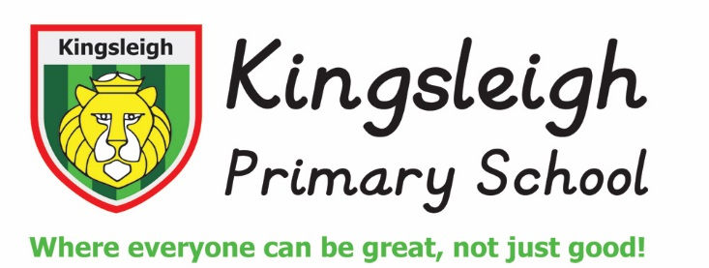

**Full-Time Class Teacher needed for September 2025 start –**

**fixed term contract to 31st August 2026**

Kingsleigh Primary School is an innovative, creative, forward-thinking place to learn and work. We believe in going the extra mile in everything that we do to ensure that our children have the very best start to their education. We are at the centre of the community we serve and see our role as more than just a school but a place where our children and families can truly thrive. We recently had our Ofsted Inspections in February this year and our school continued to be ‘good’.

Our school is a place:

***‘Where everyone can be great!’***

What we can offer:

* A large, friendly and enthusiastic staff team where everyone works together and is genuinely proud of what we’ve created.
* A forward-thinking approach to teaching and learning where risk taking is celebrated and where continuous learning is encouraged through professional development opportunities.
* A modern, spacious, purpose-built and well-resourced learning environment.
* Energetic and enthusiastic children who respond well to the creative curriculum we provide.

We are looking for someone who:

* Is enthusiastic and open-minded about teaching and learning.
* Will be proud to be a part of our school and will uphold our ethos and values.
* Is enthusiastic about working as part of a team at all levels: year group, phase and school.
* Puts children at the centre of their work.
* If this sounds like the kind of school you would like to work in, we look forward to showing you what we are all about. Please also visit our school website (www.kingsleighprimary.co.uk) which will give you a good flavour of life at Kingsleigh Primary School. Tours of the school are recommended and can be arranged by emailing kim.bainton@kingsleighprimary.co.uk.

Please complete the attached application form and email it directly to [kim.bainton@kingsleighprimary.co.uk](mailto:kim.bainton@kingsleighprimary.co.uk).

**Closing date/time for applications**: Wednesday 30th April 2025 at midday

**Interviews will be held during:** w/c 5th May 2025

Our school is committed to safeguarding and promoting the welfare of children. Rigorous checks will be made of the successful applicant’s background credentials, including enhanced DBS checks.