

**St James CE Primary School**

**Full time Teacher**

**Pay Scale Main Pay Scale T1-T3**

**Required from September 2025**

**Are you passionate about helping every child succeed and improve their life chances?**

**Are you prepared to work collaboratively for the benefit of all children?**

**Will you offer children the opportunity to flourish and shine by doing what it takes, no matter what their starting point or social challenges?**

**If so, Archbishop Temple Trust would love to hear from you!**

The Governors of St James CE Primary School invite applications for the above post from suitably experienced teachers. We are looking for someone who:

* Is an excellent practitioner with high expectations of children’s achievements and standards in all areas of school life;
* Would be able to work in either KS1 and KS2;
* Is energetic, enthusiastic and has a passion to make a difference;
* Is keen to join our hardworking, committed and friendly team;
* Would be committed to supporting and demonstrating Christian Values in our church school;
* Has the ability to form excellent partnerships within our school family and wider community groups.

To apply please complete the downloadable application form and email to office@st-james-farnworth.bolton.sch.uk or, in the event of difficulty, contact via phone on 01204 572587.

Closing date: **Monday 2nd June 2025 – 12pm (midday)**

Observations & Interviews: **Thursday 5th June 2025**

*This school is committed to safeguarding and promoting the welfare of children and young people and expects all staff and volunteers to share this commitment. Successful candidates will be subject to an Enhanced Disclosure by the Disclosure and Barring service.*

Visits to the school are welcomed. Please contact the school office on office@st-james-farnworth.bolton.sch.uk



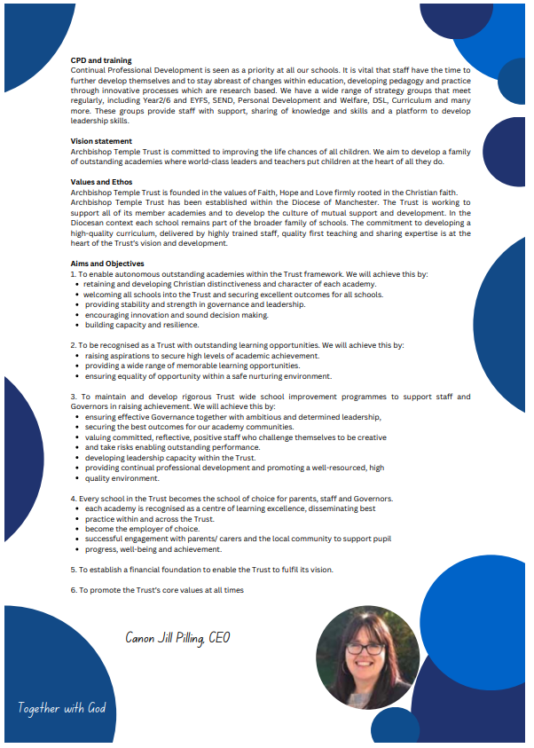

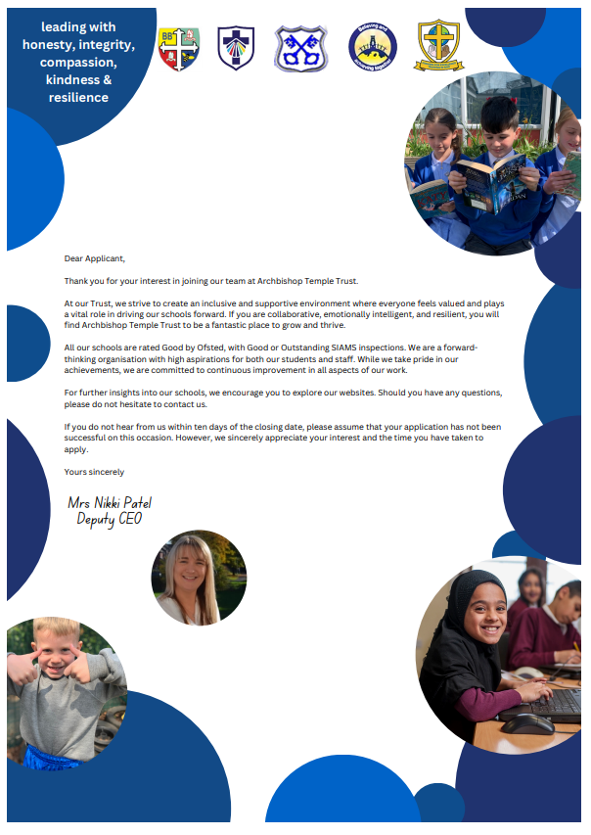



**Archbishop Temple Trust**

**Job Description**

|  |  |  |  |  |
| --- | --- | --- | --- | --- |
| **Job Title:** | **Term Teacher** | | **Department/Group:** | **KS1/KS2** |
| **Level/Salary Range:** | **M1-M3** | | **Reporting to:** | **Headteacher / Deputy Headteacher** |
| **Safer Recruitment Statement** | | | | |
| **Archbishop Temple Trust Job Description is committed to safeguarding and promoting the welfare of children and young people and expects all staff and volunteers to share this commitment.** | | | | |
| **Vision Statement** | | | | |
| **To provide our children with the opportunity to flourish and shine by doing what it takes, no matter what their starting point or social challenges:**  **by**   * Offering a high quality, inclusive and distinctive education * A caring and nurturing environment based on our Christian values * Recognising the unique nature of each child. | | | | |
| **All staff employed by Archbishop Temple Trust are required to:** | | | | |
| * uphold and promote the Trust’s vision; * uphold and promote the Christian ethos of all schools in the Trust; * As an employee within Archbishop Temple Trust, staff may be required to work at any school within the Trust. * support and contribute to the achievement of all students academically and pastorally; * support and contribute to the Trust’s responsibility for safeguarding all pupils; * undertake professional training to enhance personal development and job performance; * comply with all Trust and individual school policies and procedures including safeguarding, child protection, health, safety and security, confidentiality and GDPR, Academy Financial Handbook and Trust accounting and finance policy. * maintain high professional standards of attendance, punctuality, appearance, conduct and positive relationships with all pupils, parents/carers, colleagues, governors, trustees and members; treating everyone with dignity and respect; * share best practice, expertise and skills with others. | | | | |
| **Main Objectives of Role:** | | | | |
| The classroom teacher will be responsible for delivering learning in accordance with the curriculum, national guidelines, and the school’s strategy. The successful candidate must also carry out other duties that support pupils’ learning while operating in accordance with the school’s policies and procedures. | | | | |
| **Job Description** | | | | |
| * To undertake all duties, as required by the Teachers’ Standards. * To be committed to the ethos and success of the school. * To keep up-to-date with, and remain knowledgeable of, the requirements of the national curriculum. * To have regard for continuing professional development (CPD) and contribute to the school’s process of self-evaluation and development. * To be familiar with the school’s systems, structures, policies and procedures. * To effectively plan and deliver a varied, balanced and appropriate curriculum which emphasises raising standards and achieving excellence. * To adapt teaching styles to suit all learners and provide a supportive learning environment. * To differentiate resources and equipment so lessons may be accessed appropriately by all pupils. * To work as part of a team to evaluate and develop pupils’ learning needs. * To promote excellent behaviours for learning through effective classroom management in line with school policy * To encourage pupils to develop and use their creativity, initiative, independence and responsibilities. * To systematically assess and record pupils’ academic and social progress, and use the results to inform lesson planning decisions and drive progression in learning * To monitor both class work and homework, provide constructive feedback, and set informed targets for pupil progress. * To report on each individual pupil’s progress to the headteacher and parents as required. * To actively support school activities, on occasion, such as educational trips, extra-curricular activities and clubs, and parents’ evenings, which may require some out-of-hours availability. | | | | |
| **All staff at Archbishop Temple Trust will:** | | | | |
| * Seek to be positive and build up the common good through their own individual contribution to the life of their school; * Offer ideas and suggestions for making things better; * Engage actively in the appraisal and performance review process * Seek to develop a better work/life balance; * Appreciate that whilst every effort has been made to explain the main duties and responsibilities of the post, each individual task undertaken may not be identified in this job description; * Work within The Trust and individual school’s Health & Safety policies to ensure a safe working environment for all staff and pupils; * Follow any reasonable request from the Headteacher or SLT to undertake work of a similar level that is not specified in this job description; * Be courteous to colleagues and provide a welcoming environment to visits and telephone callers; * Promote equality and celebrate diversity, seeking to reduce disadvantage, and to encourage aspirations and participation from people who might not otherwise join in.   This job description is current at the date shown, but following consultation with you, may be changed by the Headteacher or SLT to reflect or anticipate changes in the job which are commensurate with the salary and job title. It reflects allocated duties and responsibilities but does not direct the amount of time to be spent on carrying them out. The above responsibilities are subject to the general duties and responsibilities contained in the statement of conditions of employment. | | | | |
| **Last updated:** | | **March 2023** | | |



**Archbishop Temple Trust**

**Person Specification**

|  |  |  |
| --- | --- | --- |
| **MINIMUM ESSENTIAL REQUIREMENTS** | | **METHOD OF ASSESSMENT** |
| 1. **Skills and Knowledge** | | |
| 1.1 | Excellent communication skills | Application Form/Interview |
| 1.2 | Excellent classroom practitioner | Application Form/Interview |
| 1.3 | Excellent organisational skills | Application Form/Interview |
| 1.4 | High level of behavioural management skills | Application Form/Interview |
| 1.5 | Understanding of recent Educational Legislation | Application Form/Interview |
| 1.6 | Ability to set and review targets and make decisions | Application Form/Interview |
| 1.7 | Ability to develop and review a specific curricular area and assist in its implementation | Application Form/Interview |
| 1.8 | Enthusiastic committed approach to teaching and learning | Application Form/Interview |
| 1.9 | Capable and confident with computers as a learning tool | Application Form/Interview |
| 1.10 | Smart appearance, punctual and a good attendance | Application Form/Interview |
| **Desirable Qualities** | |  |
| 1.12 | Range of out of school activities | Application Form/Interview |
| 1.13 | Willingness to work beyond the classroom with children on extra-curricular activities | Application Form/Interview |
| 1.14 | Sense of humour | Application Form/Interview |
| 1.15 | **Customer Care –** Listen and respond to customer need, seek out innovative ways of consulting service users and engaging partners. Network with others to develop services for the benefit of the service users. | Application Form/Interview |
| 1.16 | Valuing Diversity **-**  Listen, support and monitor the diverse contributions made to service development without prejudice. Challenge behaviours and processes which do not positively advance the diversity agenda whilst being prepared to accept feedback about own behaviour. Recognise people’s strengths, aspirations and abilities and help to develop their potential. Understand how Valuing Diversity can improve our ability to deliver better services and reduce disadvantage. | Application Form/Interview |
| 1.17 | **Developing Self and Others** - Ability to question, and request right training and development that links to the post, to seek opportunities that add to skills and knowledge, to respond positively to opportunities that arise. And to support others’ learning and share learning with others | Application Form/Interview |

|  |  |  |
| --- | --- | --- |
| **Experience/Qualifications/Training etc** | | |
| 2.1 | Teachers Certificate | Application Form/Interview |
| 2.2 | Evidence of recent or further studies preferably with qualifications | Application Form/Interview |
| 2.3 | Experience of teaching phonics | Application Form/Interview |
| **Work Related Circumstances – Professional Values & Practices** | | |
| 3.1 | High expectations of all pupils; respect for their social, cultural, linguistic, religious and ethnic background and a commitment to raising their educational achievements | Application Form & Interview |
| 3.2 | Ability to build and maintain successful relationships with pupils, treat them consistently, with respect and consideration and demonstrate concern for their development as learners | Application Form & Interview |
| 3.3 | Demonstrate and promote the positive values, attitudes and behaviour they expect from the pupils with whom they work | Application Form & Interview |
| 3.4 | Ability to work collaboratively with colleagues and carry out role effectively, knowing when to seek help and advice | Application Form & Interview |
| 3.5 | Able to liaise sensitively and effectively with parents and carers recognising their role in pupil learning | Application Form & Interview |
| 3.6 | Able to improve their own practice through observations, evaluations and discussion with colleagues. | Application Form & Interview |

**STAGE TWO**

Will only be used in the event of a large number of applicants meeting the minimum essential requirements

|  |  |  |
| --- | --- | --- |
| **ADDITIONAL REQUIREMENTS** | | **METHOD OF ASSESSMENT** |
| **Skills and Knowledge** | | |
| 1.1 | To have taught children from a wide socio-economic background | Application Form & Interview |
| 1.2 | Understanding of financial matters | Application Form & Interview |

**These core competencies are considered essential for all roles within Bolton Council. Please be prepared to be assessed on any of these during the interview process and, for the successful applicant, throughout the probationary period.**

**Developing Self & Others**

Promote a learning environment to embed a learning culture.  Support others to develop their skills and knowledge to fulfil their potential. Actively pursue your own development. Support and promote the principles of Investors in People.

**Civil Contingencies**

Bolton Council has a statutory duty under the Civil Contingencies Act to respond in the event of an emergency. If Bolton Council’s Emergency Management Plan is activated, you may be required to assist in maintaining key Council services and supporting the community.  This could require working outside of routine working hours and working from places other than your normal place of work.

**Equality & Diversity**

Uphold the principles of fairness and the Equality Act in all undertakings as a Bolton Council employee, including providing a fair, accessible service irrespective of customer’s race, religion, gender, sexuality, disability or age.

**Customer Care**

The ability to fully understand, assess and resolve the needs of all customers including those who present with complex situations, in a manner that respects dignity and expresses a caring & professional image.

**Health & Safety**

Take responsibility for the health and safety of yourself and others who may be affected by your acts or omissions, and comply with all health and safety legislation, policy and safe working practice, including participating in training activities necessary to your post.

**Data Protection and Confidentiality**

Ensure that any personal data or confidential data you hold is kept securely and is not disclosed, whether electronically, verbally or in writing, to any unauthorised third party. Follow Council policies and procedures on dealing with personal information and information assets, including The Code of Conduct, Data Protection, Acceptable Use and Information Security policies. Personal or confidential data should only be accessed or used for council purposes.

**Fluency Duty**

Should you be required, as a regular and intrinsic part of your role, to speak to members of the public in English, you must be able to converse at ease with customers and provide advice in accurate spoken English, as required byThe Immigration Act 2016.

**Working Hours**

The nature and demands of the role are not always predictable and there will be an expectation that work will be required outside of normal hours from time to time.

**Safeguarding**

This Council is committed to safeguarding and promoting the welfare of children, young people and vulnerable adults and expects all staff and volunteers to share this commitment. Should the role involve working with the above groups, you will be subject to an Enhanced Disclosure and Barred List check by the Disclosure & Barring Service.

**The values of an organisation are those key principles by which people are expected to work to day to day. They’re our culture and help define what is expected of each and every one of us**.







**How to apply**

We hope that you have enjoyed reading about the Archbishop Temple Trust and our school and that you will feel able to apply for this post.

Please complete the **downloadable** **application form.** Please do not send CVs or open references as part of your application as these will not be considered.

It is important that you provide a complete employment history from when you left full time education. If the application form is not fully completed or has unexplained gaps in your employment history, your application will not be considered. Copies of your qualifications will be required at the interview stage; please do not send these with your application.

Please also write **a letter of no more than two sides of A4** to explain why you want to work within our Trust, why you are the best candidate for the post and what you would contribute to our schools, with examples from your recent work if possible.

Please let us have both the supporting letter and the application form by **12pm (midday)** on **Monday 2nd June 2025** as we will not be able to consider applications received after that.

In accordance with the Data Protection Act, the details provided in the application form will be used for selection and interview procedures, and for employment records if your application is successful.

If you are disabled, please give details of how we can ensure that you are offered a fair selection and interview process.

Successful candidates will be asked to provide, prior to taking up the appointment, documentary evidence (including National Insurance number) showing their entitlement to work in the UK. We will also carry out an enhanced DBS and declaration of health check. References will also be required in line with Keeping Children Safe in Education 2019.



*"With God, there is no limit to what you can do. There is no obstacle you can't overcome. Through Him all things are possible." (Matthew 19:26)*

My name is Lisa Belfield and I am the very proud Headteacher of our special ‘St James Family’. Each day is an absolute pleasure, working with the staff and parents who are committed to make a difference to the lives of the pupils with whom we work. Our children are nurtured through the Christian values of respect, peace, love, forgiveness, honesty and hope. As a result, our pupils are kind, caring and polite; visitors always feel a warm welcome when they walk through our front door. The children of St James are utterly delightful, with exemplary behaviour and a real credit to the school and their families.

St James is situated in a very vulnerable catchment area, with above-average pupil premium and SEND figures. However, this does not stop our pupils from achieving what we set out for them, nor does it stop us as practitioners believing that our children CAN DO. I am very lucky to serve a staff who work incredibly hard to ensure the children in our care receive the very best that we can offer them. We are big advocates that ‘team work makes the dream work’ and we ensure that we are there to support, challenge and motivate each other. Staff new to school, or on supply, always comment on how helpful and friendly the staff team of St James are. We are always eager to grow our workforce with like-minded individuals, who have a passion to make a difference. Our children deserve a great education, with great professionals to ensure we achieve this.

Working within the Archbishop Temple Trust has opened many doors for school improvement and networking. Staff at St James have benefited from many CPD opportunities for training and sharing best practice. Strong and supportive relationships across staff flourish within our MAT. The impact for the children is also positive, with the opportunity to visit other schools in contrasting environments and to work on joined-up projects.



Thank you for considering our school and MAT to either start or further your career in education. I look forward to hearing from you.



Mrs Lisa Belfield

Headteacher