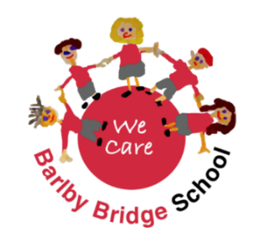**Nursery Teacher**

**Advert**

Barlby Bridge School is committed to creating a diverse workforce. We will consider all qualified applicants for employment without regard to sex, race, religion, belief, sexual orientation, gender assignment, pregnancy, maternity, age, disability, marriage or civil partnership.

**Salary:** M1 - M6

**Commencing:** January 2024

**Contract type:** Temporary

**FTE:** 0.5

**Reporting to:** Headteacher and SLT

**Welcome**

Dear

Dear Applicant,

We are delighted that you have taken the time to download this application pack and are interested in applying for the teaching position available at Barlby Bridge School.

I have also recently joined the school, starting as Headteacher in September 2023. It is an honour to have been given this opportunity and I hope you feel the same way I did when I saw the opportunity to work at this wonderful school. We have recently launched our new website on which you will find everything you need in support of this application pack when considering whether this is the right school for you. We warmly welcome visits to the school and you can arrange an appointment by phoning the school office on 01757 703650, or by emailing our School Business Manager, Mrs Webb, on [admin@barlbybridge.n-yorks.sch.uk](mailto:admin@barlbybridge.n-yorks.sch.uk).

We are seeking to recruit a highly motivated class teacher to teach our nursery class every morning. There is the potential of this job expanding into the afternoons if our nursery numbers continue to grow. Details of this role can be found in the job description which is also attached to the job advert. You will share our commitment to high standards and will have the ability and ambition to help the school in the next stage of its development. We are focused on continually developing our practice and outcomes, providing excellent pastoral care and engaging pupils in wider opportunities and experiences that help develop them into well rounded individuals.

Barlby Bridge School is a very special place to learn, where each and every one of our children feel proud to belong. We are a true community school, and view everyone associated with Barlby Bridge as part of our school family. An ethos of kindness and care touches all that we do. We have an excellent staff team who are dedicated to providing the highest standards of education for each and every child, ensuring learners achieve well and make good progress as they move through school. We are proud to share our school with you, and look forward to welcoming new families to be part of our community.

I hope you find the information provided useful and informative and that it will encourage you to apply. On behalf of the Staff and Governing Body, thank you again for your interest in the teaching position at Barlby Bridge School.

Yours sincerely,

Liam Platt

*Headteacher*

***North Yorkshire Council (NYC) are committed to directly recruiting staff and will not accept applications nor services from agency suppliers in respect of our vacancies.***

***We are committed to meeting the needs of our diverse community and aim to have a workforce reflecting this diversity. We are also committed to safeguarding and promoting the welfare of children, young people and adults. We expect all staff and volunteers to share this commitment.***

***NYC advertise vacancies on behalf of schools and external organisations (third parties) in North Yorkshire. NYC are not responsible for the recruitment/employment practices of third parties and accept no liability in relation to the vacancy and any subsequent recruitment/employment processes. Third parties are not required to follow NYC policies including the 'Positive About Disabilities- Two Ticks' Scheme. Enquiries regarding the vacancy or practices should be made directly with the third party.***