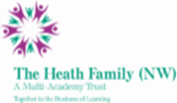
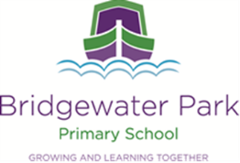

Bridgewater Park Primary School

Permanent Class Teacher – for EYFS or Key stage 1
Fixed Term for one year – for EYFS or Key stage 1

Salary: Main/Upper scale, Full Time
Permanent: 1st September 2022
Fixed term for one academic year, start date: 1st September 2022

Bridgewater Park School is a delightful Primary school nestled in the heart of Castlefields, Runcorn. We offer an exciting and enriching curriculum to ensure that all our children achieve their full potential and become life-long learners. Bridgewater Park is part of the Heath Family (NW) Multi Academy Trust which operates 8 schools across Merseyside and Cheshire.

We are looking to appoint an enthusiastic, outstanding teacher who has experience of teaching the Primary National Curriculum within Key stage 1 and/ or the EYFS curriculum. They will have an excellent and consistent approach to behaviour management and be able to use a range of behaviour management techniques. They will have the ability to build positive relationships with all children, many of whom are disadvantaged. They will be able to work well in a team with a range of staff. They will be willing to take part in a rigorous CPD programme following our ‘Core Power’ approach to the quality of education. They will be committed to all aspects of school life offering after school clubs and other enrichment opportunities.

The successful candidate will be joining a small, committed staff, in total 10 teachers and support staff and a further 7 office/ site staff. They will get the opportunity to teach and work with polite, friendly and enthusiastic children.

We very much hope, having read all the information provided, that you decide to apply to become part of the staff team at Bridgewater Park Primary School!

The Heath Family (NW) is committed to safeguarding and promoting the safety and welfare of children and young people and expects all staff and volunteers to share this commitment. This post is subject to an Enhanced DBS check and pre-employment checks.

If you would like to visit the school on 30th June at 3:30pm or 1st July at 3:30 then please email head.bridgewaterpark@halton.gov.uk

An application pack is available from Miss Karen Murphy, Principal via email.
Completed application forms and supporting letters should be emailed to head.bridgewaterpark@halton.gov.uk

Closing date for applications: Wednesday 6th July at 9am
Interview: 12th July 2022

