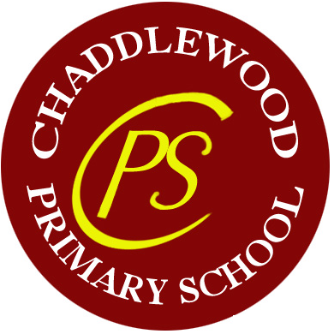

**Primary Teacher**

**Full time permanent position**

**Required from September 2021**

**Applications welcome from teachers of all experiences**

Do you have the motivation, high expectations and energy to ensure that every child achieves their full potential?

Chaddlewood Primary School would like to recruit a teacher with the drive and enthusiasm to provide the best possible learning opportunities, inside and outside of the classroom, for our children. If you can enrich our teaching team with enthusiasm, ideas and a passion for making children’s school experience exciting and challenging then we would welcome your application.

Please visit our website for further details and a downloadable application form.

Visits are by appointment and highly recommended.

Closing date for applications is Friday 30th April 2021 at 9am

Interviews will be held in the week beginning 17th May 2021

Chaddlewood is committed to safer recruitment of teachers and the welfare of our children. Any offer of a post is subject to excellent references and an enhanced DBS check.

Applicants should be aware that although this advertised post is initially based at Chaddlewood Primary School the successful candidate may be deployed to work at any of the schools that form the Westcountry Schools Trust. (WeST)

**Chaddlewood Primary School, Plympton, Plymouth PL7 2EU (Roll 401)**

01752 337450 **admin@chaddlewoodschool.org.uk**

**Website:** [**https://chaddlewoodprimary.eschools.co.uk**](https://chaddlewoodprimary.eschools.co.uk)