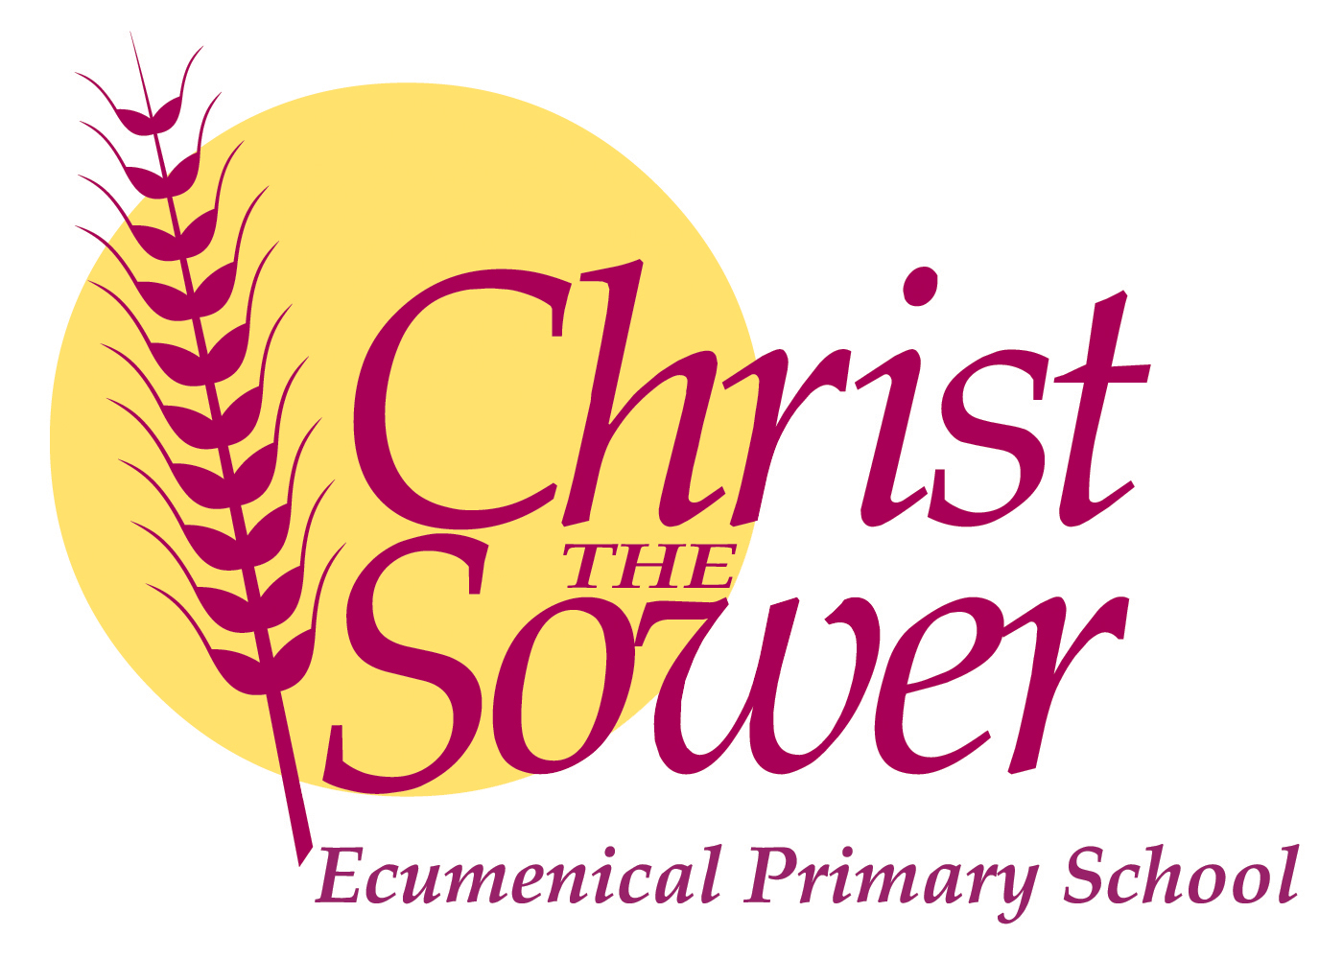

**Teacher Vacancy**

**Christ the Sower Ecumenical Primary School**

1 x MPS Full Time to start September 2021

1 x NQT Full Time with a possibility to start 12th July 2021

We are holding rolling interviews on receipt of suitable applicants. Please apply as soon as possible.

We are looking to employ a teacher to join us at our improving and growing school. If you are ambitious, hardworking, vibrant, a risk taker, brave, resilient with a passion for teaching and developing children’s characters, then we would love to hear from you.

We can offer ambitious teachers developing the early stages of their careers, amazing children, engaged parents, support and career development. We are committed to supporting you in our modern well-equipped school in developing your career and ambition. Where possible we can offer a 2-week induction period in July. We are part of the ODBST MAT that is a growing academy trust that puts its faith into and recognises the uniqueness of all its individual schools.

As a school, we are enjoying a journey to good and beyond and recognise the fantastic contributions early career stage teachers can bring to that journey.

So if you enjoy a challenge, are creative and fun, please get in touch to discuss your career opportunities here with us. Visits to the school are encouraged.

Applicants are invited from all faiths and none.

For an application pack please contact Christine Smith, [csmith@ctsmk.org.uk](mailto:csmith@ctsmk.org.uk) or on 01908 867356 or visit our website www.ctsmk.org.uk.

*Our school is committed to the safeguarding and welfare of our children. All appointments will be subject to full DBS Disclosure.*