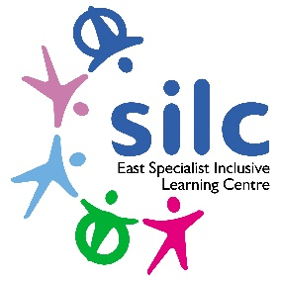 | External Job Advertisement  East SILC John Jamieson School, Hollin Hill Drive,  Leeds,  LS8 2PW  Tel: 0113 2930236  www.eastsilc.org
Teacher Complex Needs
MPS + SEN points negotiable
Full time/ Maternity Cover
The East Specialist Inclusive Learning Centre (SILC) is a 2-19 generic special school with 430+ pupils on roll. All our pupils have special learning needs and some have physical/ medical difficulties. The East SILC is a complex organisation which operates on a variety of sites to provide a range of outreach services across the city, including partnerships with primary and secondary providers, the city-wide Physical Difficulties and Medical Service including a moving and handling service, as well as the Medical Needs Teaching Service for Leeds.
An exciting opportunity has arisen to join our expanding school community. Immediate start if possible

We have an exciting opportunity for someone to join our High School Phase. Due to a maternity leave, we are seeking to recruit a teacher with a specific interest in teaching pupils with Complex Learning Difficulties. We would welcome applications from candidates with a background in SLD or an interest in this area. We are looking to recruit individuals who are:

- Talented, inspirational, motivating and enthusiastic.
- Passionate about changing young people’s lives.
- Confident working with children with complex needs.
- Committed to teaching in a supportive provision where communication is at the heart of teaching and learning.
- Passionate about integrating working practice as part of a multi-disciplinary team.
- Able to creatively differentiate the curriculum to meet a range of special needs.
- Dedicated to working with parents and carers.
- Willing to make a positive contribution to the broader life of the school.

It is illegal to apply if you are on the children’s barred list.

Closing dates for applications: Friday 7th October 2022

Interviews to take place: W/C 17th October 2022
The East SILC is committed to safeguarding and promoting the welfare of children and young people. We expect all staff and volunteers to share this commitment. The successful candidate will be subject to an enhanced Disclosure and Barring Service check and must be prepared to apply for ISA registration if required.

For further information and to request an application pack, please contact Nicola Hewitson
Tel: 0113 2930236 or e-mail: nicola.hewitson@eastsilc.org

