

**Our School**

May 2025

We are a popular, progressive and inclusive school located in Ardwick, two miles outside of Manchester City Centre. There is much redevelopment currently taking place in the local area and our school is integral to this regeneration. Many of our children come from the local area however, due to our excellent reputation, many families travel a significant distance to attend Armitage; in fact, a vast number of our school population are EAL learners, with children coming from all over the world to be part of our community! We are part of ‘The Aiming High C.E. Federation’, a newly formed group of schools which currently includes ourselves and All Saints Primary in Gorton – it’s only a short drive between the two sites!

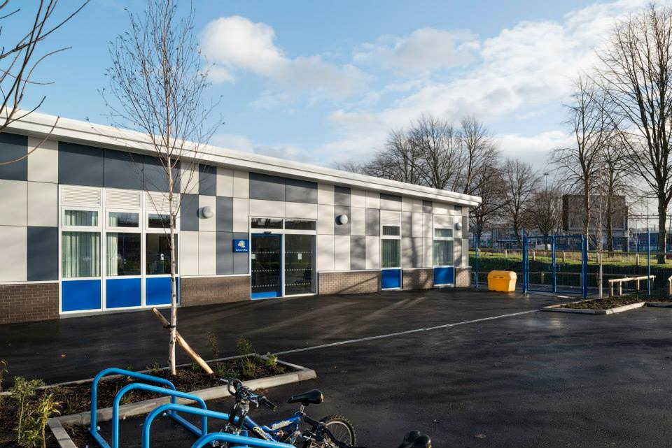**Our Environment**

Our modern Key Stage Two building provides excellent facilities for future generations of Armitage learners. Our existing building has also been renovated, providing modern facilities for children in our EYFS unit and pupils in Key Stage One classes. We are extremely proud of our environment which includes a large School Library, numerous intervention spaces, a Focused Activity base for SEN children and Calm Spaces for children with additional needs. All classrooms are equipped with up to date Computing equipment and many feature brand new Smart Boards, supporting staff in providing the best possible learning opportunities for our children. We are equally proud of our outdoor environment, which stimulates learning opportunities outside of the classroom. Our dedicated Horticultural Higher Level Teaching Assistant (HLTA) supports out children in harvesting our fruit and vegetable allotment, as well as taking care of our rare breed hens whose eggs are then sold to the school community. We are also fortunate to have a newly built building – The Link @ Armitage - which is home to our 2-year-old provision and our Community facilities.

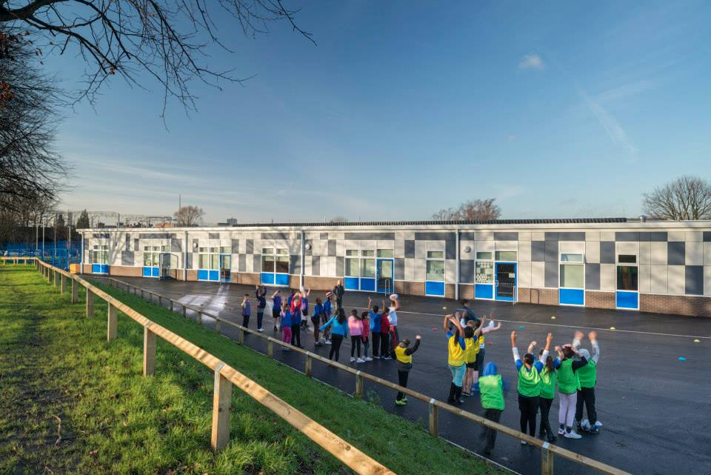

**Our Pupils**

Our children come from over 30 different countries, making Armitage a culturally diverse place to be. Difference and diversity are celebrated, with everyone’s unique identity valued and shared throughout the inclusive school community. We are particularly proud of the high praise that OFSTED gave to our pupils in October 2024, stating that they behave well, treat each other with respect and feel valued for who they are. We believe that children are the heartbeat of our school and, as such, give them opportunities to support us in continuously making Armitage a great place to be. These opportunities come in the form of our thriving school council, Ethos Group, and Junior PCSOs; all of which put children at the heart of school improvement.

**Our Staff**

Our school has a large and talented team of staff, with every individual offering something unique for the benefit of our children. Opportunities are provided for training and development, with staff being encouraged and supported to fulfil their own professional ambitions. Roles within school are flexible, allowing individual’s strengths to be best used in a forward thinking and supportive manner. We have many smaller teams of staff working together for school improvement, including an S.E.N. team, community team and various subject teams.

**Our Projects**

Armitage is a proud member of the local community and as such plays a pivotal role in ensuring that the local area continues to thrive. We are an open site, allowing access to our environment even when school is closed. Our facilities are used for adult learning courses and for our successful Parent Café project. In addition to this, we provide ‘Wrap Around Care’ to our Parents, providing a breakfast club from 7.45am and afterschool care until 6pm. Our other after school clubs provide children with exciting opportunities to participate in 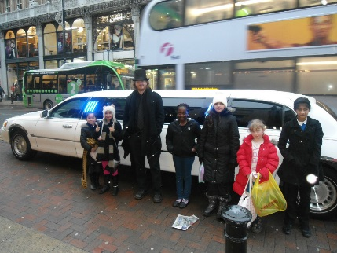activities ranging from cooking to cheerleading. Forward thinking projects such as ‘Calm Space’ are embedded in our practice, providing children with art and massage therapy to address their needs. Children are also given opportunities to learn a variety of musical instruments, participate in ‘Debate Mate’ and visit Manchester Art Gallery to take part in ‘Art of Resilience’ projects.

**Our Achievements**

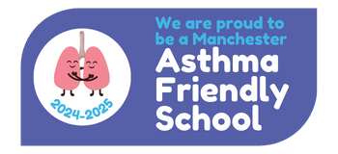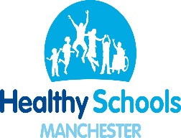Our most recent OFSTED inspection took place in October 2024, stating that our school has maintained the Outstanding standards achieved in our previous inspection in 2019. We are continually looking at ways to further develop and are currently focusing on developing ‘Golden Threads’ in History, as well as further embedding our new Writing curriculum within Literacy lessons. Our Key Stage Two SATs results are consistently in line with national levels, despite the fact that a significant number of children entering our school have not accessed pre-school education. Armitage currently holds a number of nationally recognised awards including Healthy Schools status and Asthma Friendly School accreditation.

**Our Future**

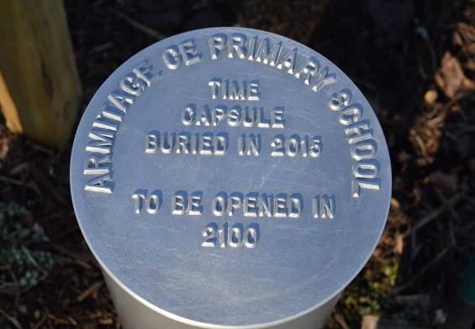Current changes in education have allowed us to adapt our practice to ensure the best possible outcomes for all members of our school community. Our bespoke assessment system allows us to recognise the fantastic achievements of pupils, as well as recognising where we can provide extra support for those who have not yet reached their full potential. The National Curriculum provides us with the opportunity to immerse children in cross-curricular learning, engaging them in a number of exciting topics brought to life by theme days and out of school visits.

As a school, regardless of changes and developments within education, we will continue to strive to provide stability and order for our children, allowing them to learn, blossom and to enjoy being children. When our buried time capsule is opened in 2100, we hope that many more generations of Armitage pupils have continued to ‘Aim High’.