




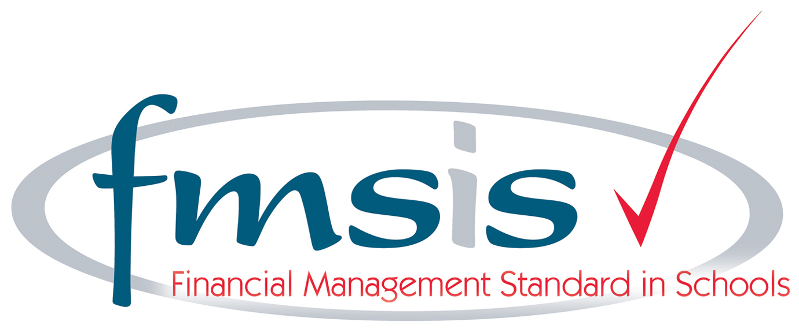
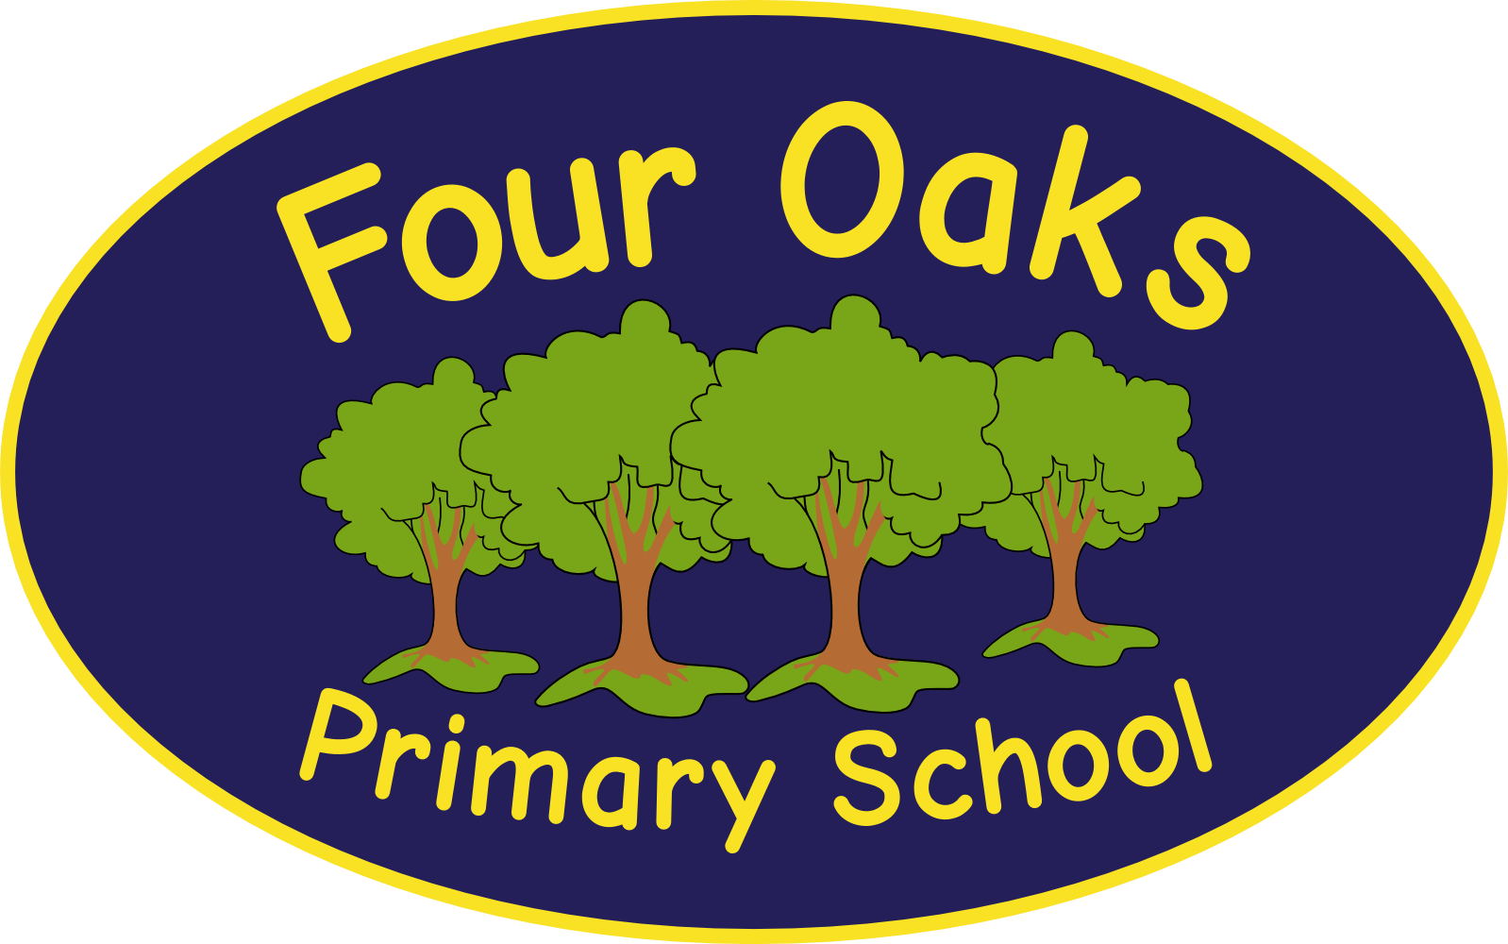

Headteacher: Mrs S Robinson B.A.(Ed) M.Ed. NPQH

39 Davy Street
Liverpool L5 1XP
Telephone: (0151) 263 4038
Fax: (0151) 260 7257
Email: office@fouroaksprimary.com
Website: www.fouroaksprimary.co.uk

25th May 2023
Teacher

Full-time, EYFS teacher.

The contract is fixed term in the first instance to support our exciting conversion to academy status. We will be joining an Academy Trust with whom we have enjoyed partnership working for over a year. This will be an exciting stage in our development with many new opportunities for our children and the wider school community.

Four Oaks is an inclusive primary school, with high aspirations for all. We have happy, extremely well behaved children and supportive, dedicated staff and governors, catering for pupils from 1 to 11 years old.

Our school has received a prestigious SCALA architects’ award. It is a modern build with beautiful, well equipped classrooms and state of the art facilities including an interactive 4D classroom. It is surrounded by landscaped grounds with many facilities for the children. Visitors to our school always comment on the happy, enthusiastic children who demonstrate exceptional behaviour.

The Governors wish to appoint a teacher to join our team. You must have consistently excellent feedback on your teaching. You will be joining an EYFS Phase team who work well together and who are dedicated to providing the very best education to our children.

Closing date: Friday 9th June 2023

Four Oaks Primary School is committed to safeguarding the welfare of young people and expects all staff and volunteers to share this commitment. All appointments are subject to enhanced DBS checks and excellent references.

Return completed application to applications@fouroaksprimary.com

