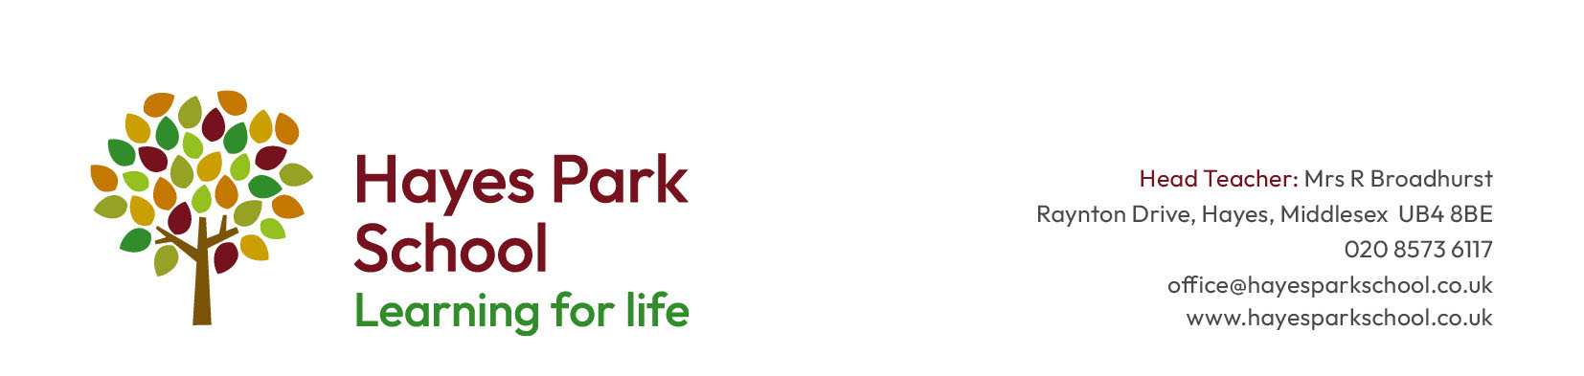

Teacher for EYFS, KS1 or KS2 – Early Career Teachers encouraged to apply

Required from September 2024

Salary: Dependent on experience

REF:………………..

Are you an inspiring graduate currently completing your Teacher Training (ITT)? Have you started to think about securing a role in Primary teaching for your ECT years? Are you a more experienced teacher looking for a new challenge?
Hayes Park School is a successful three-form entry, multi-cultural school with a Nursery and a specialist resource provision (SRP) for autism. We are wonderfully resourced, with a range of IT devices for our pupils, lovely green spaces and an eco-dome.
The School is an inclusive, friendly, caring place of learning in which all students are treated with respect and tolerance and are prepared for life-long learning. Our goal is to create an atmosphere of mutual support where we learn from each other and achieve well together. The school encourages the values of Perseverance, Respect, Excellence and Partnership (PREP).
We have a rare opportunity for the right person (professional, nurturing, friendly, with a good sense of humour) to join our vibrant team. If this is you, please see the attached job description and person specification.

What we offer our staff:
- Wonderful children and families who are engaged with learning
- Excellent behaviour
- Focused career development:
  - For ECTs - induction tailored to your needs, mentoring and coaching, professional development through UCL and Teach West London
  - For all – access to the Hillingdon Learning Partnership professional development courses and the National College
- Teaching teams who work collaboratively to share expertise and workload
- A professional environment in which to work with a focus on the wellbeing of staff and children
- A school that is innovative and continuously seeks opportunities to further improve and develop
- A forward-thinking leadership team who are research-led
- Tea and coffee!
- Outer-London pay scale

If we have not quite convinced you to apply yet, here is what our stakeholders say about us:
‘I think the school is a perfect school. I love this school.’ (Pupil questionnaire 2023)
‘I feel that I am listened to and my hard work acknowledged. I feel I am given opportunities to develop myself professionally and contribute towards the development of the school. I wouldn’t want to be anywhere else.’ (Staff questionnaire 2023)

‘Head teacher is brilliant. Teachers are as well. Excellent school and very good communication from teachers. All staff are very friendly and helpful. My children have been at the school for years and no problems. Would definitely recommend to other parents as it’s an outstanding and very friendly school. 5 stars.’ (Parent questionnaire 2023)
‘Respect is a key part of the school’s ethos and interwoven throughout the expectations for behaviour and learning...as a result, pupils behave well and show respect to both adults and peers.’ (Ofsted 2022)
We would love to welcome you for a visit to our school so that you can experience this first-hand. Please contact the school office (office@hayesparkschool.co.uk or 02085736117) to make an appointment. In the meantime, take a look at our website (www.hayesparkschool.co.uk) or follow us on X @hayesparkschool

Closing date: Thursday 16th May 2024
Interviews: w/c 20th May 2024

All applications through: https://crinklerecruitment.com/ or https://teaching-vacancies.service.gov.uk/
CVs will not be accepted

This school is committed to safeguarding and promoting the welfare of children and young people and expect all staff and volunteers to share this commitment. Shortlisted candidates will: be asked to complete a self-declaration of their criminal record or information that would make them unsuitable to work with children; be subject to online searches as part of due diligence; have two references sought pre-interview.
Appointments are subject to: an enhanced Disclosure and Barring Service (DBS) check (including a barred list check); an identity check; a fitness and right to work in the UK check; a professional qualifications check and receipt of two references.

