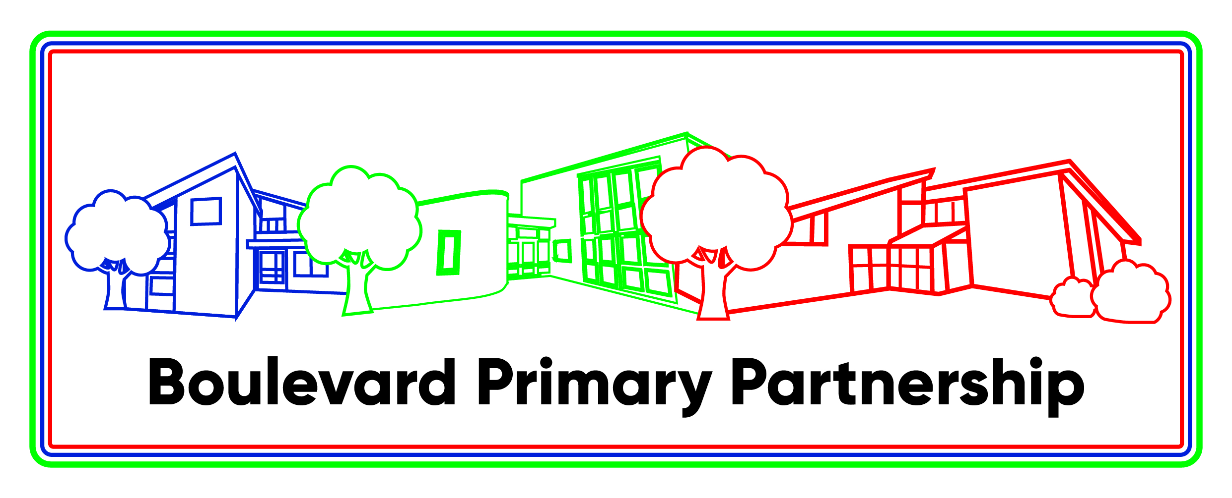

Executive Headteacher: Kate Mathews

Teaching staff vacancies in our ASC Units (M1 – M6) plus SEN allowance (£2679)
Germander Park and Southwood Schools - start date April or 1st September 2025

We have recently opened Autistic Spectrum Condition units at Germander Park and Southwood Schools, both part of the Boulevard Primary Partnership federation (along with Downs Barn School). The units currently have one class but will grow each year eventually to two classes at Germander Park and three classes at Southwood (each with 8 pupils). All children hold EHCPs.

We are in search of teachers who are motivated by the challenge of supporting pupils with ASC, who can inspire our pupils and help them to enjoy their time at school and their learning. Each teacher will lead a small team of support staff in each class of 8 pupils. This is an exciting time for the schools with this newly created provision and as such provides wonderful opportunities for a teacher to be involved in the infancy and development of the classes.

We have vibrant and inclusive schools dedicated to providing a nurturing and stimulating environment for our students.

Germander Park School
Teacher with a start date of April or 1st September 2025
Southwood School
Teacher with a start date of April or 1st September 2025

The successful candidates will be able to:
- Plan and deliver creative and engaging lessons, aligned with our curriculum
- Create a supportive and inclusive classroom environment where every student feels valued
- Differentiate to meet the diverse learning needs of our students so they can achieve their best
- Implement effective classroom management strategies promoting positive behavior

You will:
- Be sensitive to the wide range of children’s needs experienced in main stream schools
- Be an excellent communicator, able to work collaboratively with the ASC team and wider school
- Have a passion for education and a commitment for fostering a love of learning in students
- Be kind, caring and understanding and good role model for our pupils
- Hold QTS (SEND qualifications desirable)
- Have experience of working with children with ASC, this is challenging yet very rewarding role

Applications are welcomed from team players with high expectations for achievement. We can offer you good schools in a friendly and happy environment. If you would like to visit either school prior to application, please contact us and we will be more than happy to show you around. For further information contact Melanie Hornshaw on 01908 678366 or email office@southwoodschool.co.uk. The closing date for applications is 10th January 2024.

All Boulevard Primary Partnership schools are committed to safeguarding and promoting the welfare of children and expect all staff to share this commitment. We are an equal opportunities employer. The successful candidate will be required to complete an enhanced DBS check.

ASC UNITS at Southwood and Germander Park Schools
There are high expectations for behaviour, which pupils rise to.
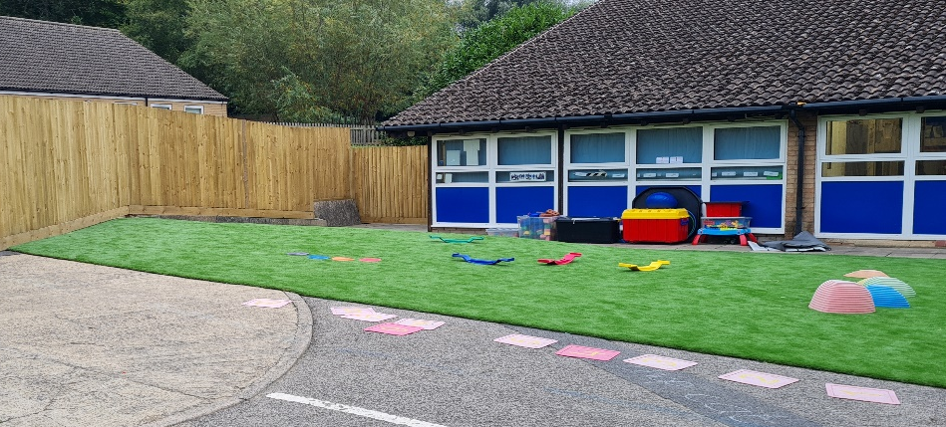
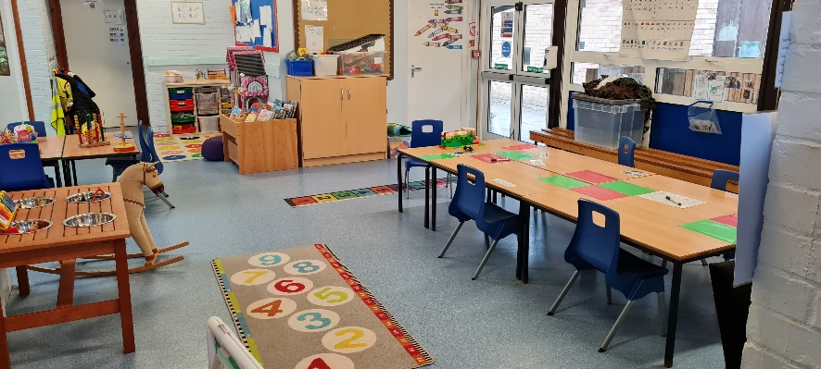
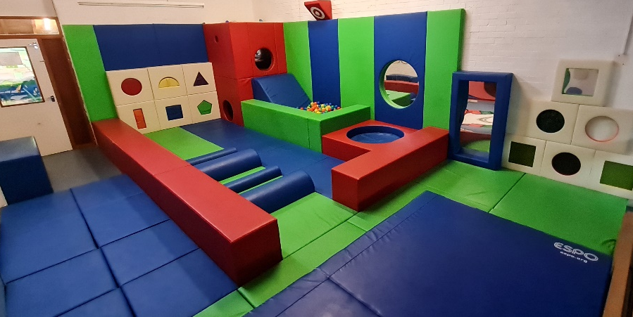
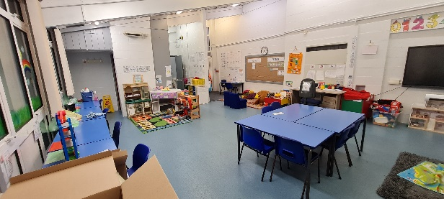
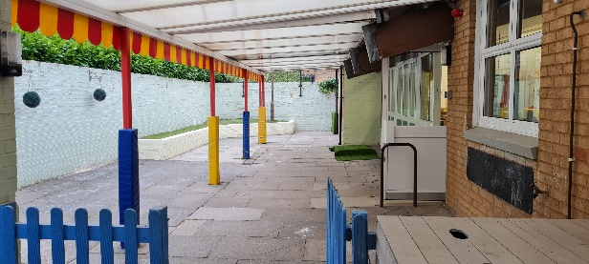
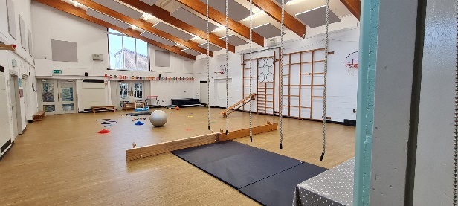
Pupils with special educational needs and/or disabilities (SEND) study an ambitious curriculum.
Leaders have high expectations for achievement and for the conduct of all pupils.
This is a welcoming and inclusive school.
Southwood School was inspected by Ofsted in May 2023 and were judged to be Good.
Germander Park School was inspected by Ofsted in June 2023 and were judged to be Good.

