




Teacher in Charge
Oakridge Community Primary School
Recruitment Information Pack

Coronation Avenue
Saltburn-by-the-Sea
North Yorkshire
TS13 5HA
www.oakridge.n-yorks.sch.uk

Contents
Our vision and values 3
YEAT Schools 4
Application process 7
Job Description and Person Specification 8

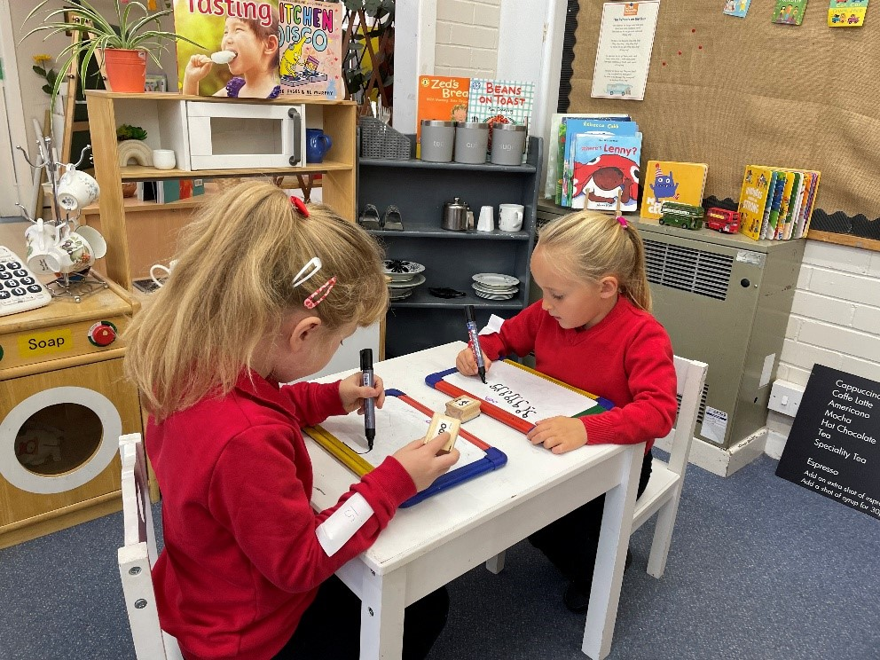

Yorkshire Endeavour Academy Trust
Our Vision and Values

Vision
- Ethical action for a world class education.
- Nurturing relationships at the heart of our communities.
- Brave leadership in a changing landscape.

Values
- Providing world-class education to all children through an ambitious curriculum.
- Encouraging curiosity and a lifelong love of learning.
- Wrapping around our community through an inclusive nurturing approach.
- Taking pride in local heritage whilst preparing our children to be global citizens.
- Collaborating with partners in education and universal services to support each child’s unique journey.
- Highlighting and sharing excellent educational practice for the benefit of all.
- Growing and developing people in all roles to be their very best.

Schools in Yorkshire Endeavour Academy Trust
Airy Hill Primary School

Pupils succeed and flourish at our school. They achieve well across the whole curriculum. Our children love the outdoor spaces at school and they say learning at Airy Hill is fun. We are a nurturing, rights-respecting and pupil centred school. Our school vision runs deeply through the life of Airy Hill and is easily identified by anyone visiting us. We ensure our pupils have broad and exciting learning experiences and this is reflected in the way our pupils talk about school. Children learn about their local heritage as well as aspects of culture from around the globe – they value and celebrate the differences in each other. We work together so every child succeeds.
For more information about Airy Hill, please visit our website.

Castleton Community Primary School

Castleton currently has 53 pupils on roll across two classes: Acorns (EYFS/KS1) and Oaks (KS2). Outdoor learning is a key feature of our provision and children have regular opportunities to participate in a range of outdoor activities. Hidden behind our historic building are extensive grounds, which include tiered gardens featuring a pond, greenhouse, adventure play area, stage, quiet zone, forest school site and an outdoor classroom. Our children are also interested in music and the arts. Our parents are very keen to be involved in the life of the school and we have an active PTFA.
For more information about Castleton, please visit our website.

Glaisdale Primary School

Glaisdale school currently has 34 pupils on roll across two classes: Explorers (EYFS/KS1) and Adventurers (KS2). We have a relatively new staff team who have worked hard in recent months to develop our curriculum, sports offer, school council and EYFS provision.
Our children love the great outdoors and our rural location provides lots of opportunities for sport and adventurous activities. We would love our new teacher in charge to share this passion, taking the lead on improving our sports and PE provision in order to achieve local, regional and national recognition.
Staff have developed excellent relationships with our parents and 100% of those completing a recent survey said they would recommend Glaisdale to other parents.
For more information about Glaisdale, please visit our website.


Lealholm Primary School
Lealholm is a very welcoming school with a friendly atmosphere. The small pupil numbers encourage a family feel, where pupils from Reception to Year 6 happily learn, play, eat and celebrate together. All pupils can identify trusted adults within school, including those in non-teaching roles, to whom they could turn to if they had any worries. Positive attitudes and kind behaviour are celebrated and awarded in weekly assemblies.
Pupils have access to a wide range of activities, as well as taking on leadership responsibilities, including being on the school council and being reading buddy. Opportunities to work collaboratively with pupils from other schools within the Trust are actively planned into the school year. This provides pupils from our small village community with useful opportunities to develop confidence and build relationships with their peers beyond Lealholm, in preparation for their eventual transition to secondary school in the nearest town, almost 10 miles away.
For more information about Lealholm, please visit our website.

Oakridge Community Primary School
Oakridge Community Primary School is situated in a most beautiful part of the country: the village of Hinderwell located between the North Yorkshire Moors and the North Sea coast.
We are a designated Community Primary School, including a nursery and cater for children between the ages of 3 and 11. The children are organised into two classes: Dolphin Class for KS2 pupils and Seahorse Class for EYFS and KS1 pupils.
We provide a rich and exciting curriculum in a safe and caring environment, where children flourish and have the opportunity to build positive relationships, make reputable choices and be inspired to become innovative life-long learners.
We recognise that parents and carers are an integral part of our family of schools, and we strive to work with them to make positive contributions to our local communities.
For more information about Oakridge, please visit our website.


West Cliff Primary School
West Cliff Primary School is a warm and friendly community school that provides education from children aged 2-11. It currently has around 200 children on roll, divided into 8 classes (one for each year group). We also have the Rockpool, which is our Targeted Mainstream Provision for children with high level social, emotional and mental health needs. The school mainly takes children from the west side and the centre of Whitby but is accessible from all parts of the town.
We pride ourselves on providing a warm and welcoming environment for children and adults alike, and we strive to provide the very best standard of education possible for our children. The six principles of nurture run through our school.
We are a Beach School as we believe that the beach is a fantastic resource that can be used, both to learn and have fun on. We are located a short walk from the beach and you can even see the sea from our upper-floor classrooms!
For more information about West Cliff, please visit our website.

Application Process

The closing date for all applications is: 9am, Thursday 19th February 2026

Interviews will be held on Thursday 26th February 2026

An email will be sent to candidates with the outcome of the shortlisting process.

Application Process
Please apply online via NYC Jobs

An email will be sent to candidates with details of the shortlisting process.
We do not accept CV’s.

Queries / School Visits
Informal chats with our Headteacher, Ben Russell, are welcomed. For queries or to arrange a call or school visit, please contact Chloe Bullen on 01609 536 964 or via chloe.bullen@northyorks.gov.uk
Chloe has been engaged to support us with recruiting to this exciting opportunity.

Visit slots:
Visits are by appointment only, please contact Chloe to book. Please note other candidates may be present.
- Tues 3rd Feb 3.30, 4.30
- Wed 4th Feb 8am, 9am
- Thursday 5th 3.30pm, 4.30pm, 5.30pm
- Tue 10th Feb 8am

Job Description
JOB TITLE: KS2 teacher-in-charge

GRADE: All grades considered + TLR2

RESPONSIBLE TO: Head teacher and Governors

RESPONSIBLE FOR: Deployment of support staff allocated (where relevant)
Operational management of the day-to-day running of the school in the absence of the Executive Headteacher.

JOB PURPOSE: Promote effective learning, appropriate achievement and educational, social and personal progress of all pupils for whom the teacher is designated as being responsible, consistent with the aims of the school and the unique needs of each individual.

KEY RESPONSIBILITIES:

1. Develop and maintain an up-to-date knowledge and understanding of the areas of teaching and pupil support for which post-holder is responsible

2. Plan work to meet the learning needs of allocated pupils in a consistent and effective way

3. Use appropriate teaching and classroom management strategies to motivate pupils and enable each to progress

4. Monitor the progress of pupils for whom the postholder is responsible to set expectations and give constructive feedback

5. Maintain appropriate records to demonstrate progress made by pupils

- Participate fully in professional development activities to develop practice further, sharing the learning from these as appropriate

- Make an active contribution to the policies and aspirations of the school

To fulfil all of the requirements and duties set out in the current Pay and Conditions Documents relating to the conditions of employment of teachers

To fulfil all of the responsibilities and duties required by the School’s policies on teaching and learning.

To achieve any performance criteria or targets arising from the School’s Performance Management arrangements

This job description will be reviewed annually.

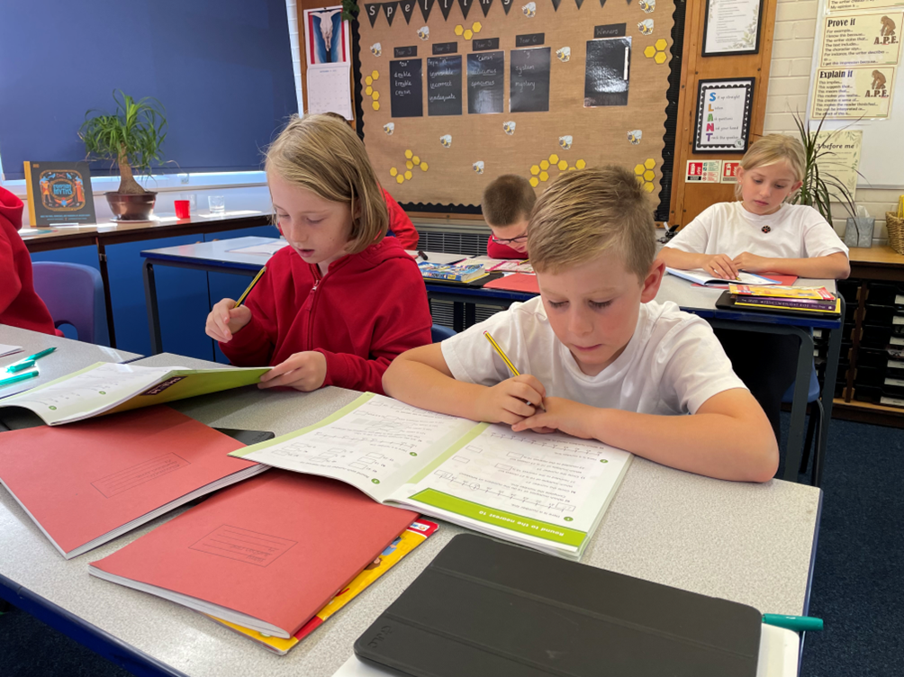

Person Specification

Attributes |  | Essential / Desirable
 | Considerable experience of teaching in primary schools  Senior leadership experience or an aspiration to become a senior leader  Able to evidence excellent pupil progress  Experience of working positively and closely with staff, parents and guardians  Effective experience in creating a positive climate and environment to secure accelerated learning  Recent OFSTED experience | Essential  Essential  Essential  Essential  Essential  Desirable
EDUCATION AND TRAINING | QTS  Thorough knowledge of teaching, learning and curriculum in primary schools  Commitment to continued professional development  Evidence of recent & relevant training  Safeguarding Awareness | Essential  Essential  Essential  Essential  Essential
PROFESSIONAL KNOWLEDGE AND SKILLS | An excellent classroom practitioner  Effective use of assessment data to plan sequence of learning that secures accelerated progress  Work effectively as part of a team, relating well to colleagues, pupils and parents  Excellent use of ICT to support learning  High expectations of all pupils  Detailed knowledge of the National Curriculum and its planning and delivery  Implications of the Code of Practice for Special Educational Needs for teaching and learning  Evidence of ability to maintain high standards of behaviour and develop attitudes of care, control and cooperation  Experience of curriculum planning as part of a team  Ability to self-motivate and lead a team of support staff  High level of oral and written communication skills and ability to communicate with a wide range of audiences  Able to offer subject expertise  High level of organisational and planning skills  Ability to use initiative, solve problems, make decisions and motivate others  Ability to relate to and empathise with pupils and to build trusting relationships with them | Essential  Essential  Essential  Essential  Essential  Essential  Desirable  Essential  Essential  Essential  Desirable  Essential  Essential  Essential  Essential
ANY ADDITIONAL FACTORS | A commitment to abide by and promote equal opportunities, Health and Safety and Child Protection Policies  Ability to manage the day-to-day operations of the school in the absence of the headteacher  Commitment to an involvement in extra-curricular activities | Essential  Essential  Essential
This post is subject to satisfactory references and enhanced Disclosure and Barring Service criminal records check for work with children. An online search may be undertaken for shortlisted candidates as part of the recruitment process on information available in the public domain. Candidates should disclose anything that may be relevant in line with Keeping Children Safe in Education.

APPLYING FOR A JOB WITH NORTH YORKSHIRE COUNCIL

IMPORTANT ADVICE ON COMPLETING THIS APPLICATION

Your application form plays an important part in your selection. Please ensure you address all the essential requirements listed in the specifications. The following advice should help you to complete the application form as effectively as possible.
Data Protection
The information that you state on this application form will be used by the school and the Council to consider you for a job vacancy. To find out about how we use your personal data for the purposes of recruitment please see our Privacy Notice at www.northyorks.gov.uk/working-us.

Rehabilitation of Offenders
The post you are applying for requires you to have an enhanced Disclosure and Barring Service criminal records check for work with children, with a barred list check if you work in regulated activity. This check for disclosure of criminal history will include spent convictions, pending prosecutions / current court proceeding and police enquiries.

Should you be shortlisted, you will be asked to disclose full details of your criminal history prior to your interview. This includes any information deemed relevant as part of Keeping Children Safe in Education which may arise in an online search undertaken on shortlisted candidates. This information may be discussed with you at your interview in order to assess job related risks, but we emphasise that your application will be considered on merit and ability and you will not be discriminated against unfairly. Failure to disclose this information will result in any offer of employment being withdrawn.

Please also see the policy statement on the Recruitment of Ex-offenders below.

Information in Support of your Application
Every post advertised is supported by a full person specification. The specification lists all the essential skills, experience and qualifications which are necessary for the job and the criteria against which you will be assessed, both through your application form and at interview.

As part of the application process, you may have been asked to demonstrate within this application form how you meet some or all of the criteria or key competencies outlined in the person specification. Rather than simply repeating your career history, look at the skills and experience required by the job and provide evidence that you possess them by giving specific and detailed examples which include a focus on outcomes and on your own contribution to the scenario. Try to use different and varied examples wherever possible.

When completing these sections, do not forget the skills and experience you have gained outside full-time work. Outlining your previous work experience or other responsibilities may help you to uncover skills which you have taken for granted and which are clear signs of your ability to do the job.

Canvassing
You must not try to influence an elected Council Member, any council employee or a member of the school governing body, to act in your favour, as this will disqualify you. If you are related to a Councillor, a Council employee or a governor you must indicate this in the relevant section of the application form.
Policy Statement on the Recruitment of Ex-offenders (Source www.gov.uk)
- As an organisation assessing applicants’ suitability for positions which are included in the Rehabilitation of Offenders Act 1974 (Exceptions) Order using criminal record checks processed through the Disclosure and Barring Service (DBS), this school complies fully with the DBS code of practice and undertakes to treat all applicants for positions fairly.

- This school undertakes not to discriminate unfairly against any subject of a criminal record check on the basis of a conviction or other information revealed.

- This school can only ask an individual to provide details of convictions and cautions that it is legally entitled to know about. Where a DBS certificate can legally be requested (where the position is one that is included in the Rehabilitation of Offenders Act 1974 (Exceptions) order 1975 as amended, and where appropriate Policy Act Regulations as amended) this school can only ask an individual about convictions and cautions that are not protected.

- This school is committed to the fair treatment of its staff and potential staff, regardless of race, gender, religion, sexual orientation, responsibilities for dependents, age, physical/mental disability or offending background.

- This school has this written policy on the recruitment of ex-offenders, which is made available to all DBS applicants at the start of the recruitment process.

- This school actively promotes equality of opportunity for all with the right mix of talent, skills and potential and welcome applications from a wide range of candidates, including those with criminal records. Candidates are selected for interview based on their skills, qualifications and experience and criminal record information is only requested from short-listed candidates.

- A disclosure is only requested from the DBS after a thorough risk assessment has indicated that one is both proportionate and relevant to the position concerned. For those positions where a criminal record check is identified as necessary, all application forms, job adverts and recruitment briefs will contain a statement that a DBS certificate will be requested in the event of the individual being offered the position.

- This school ensures that all those who are involved in the recruitment process have been suitably trained to identify and assess the relevance and circumstances of offences.

- This school also ensures that they have received appropriate guidance and training in the relevant legislation relating to the employment of ex-offenders, e.g. the Rehabilitation of Offenders Act 1974.

- At interview, or in a separate discussion, this school ensures that an open and measured discussion takes place on the subject of any offences or other matter that might be relevant to the position. Failure to reveal information that is directly relevant to the position sought could lead to withdrawal of an offer of employment.

- This school makes every subject of a criminal record check submitted to DBS aware of the existence of the code of practice and makes a copy available on request.

This school undertakes to discuss any matter revealed on a DBS certificate with the individual seeking the position before withdrawing a conditional offer.

