Our Vision:
To develop aspirational learners who strive for excellence academically, creatively and culturally, benefitting from a wide range of opportunities led by inspirational educators.

Shirley High School
Performing Arts College

Striving for Excellence

Job Description:

Post: Teacher in Charge
Line Manager: Director of Faculty

Areas of responsibility and guidance:

- To work with the DOF to ensure that learners are working through appropriate curriculum maps and medium term plans
- To lead my example to ensure the vision and values of the school are consistently met with the subject area;
- To teach all phases within the subject area;
- To develop and plan resources that can be used within the department that will challenge all students and improve academic outcomes;
- To support in the monitoring and evaluation of teaching and learning within the department with the DOF;
- To promote the ethos of inclusion and challenge within the vision and mission statement of the academy;
- To maintain the standards, expectations and polices of the school and the department at all times;
- To create a positive climate of teaching and learning in line with the vision and values of the school;
- To be responsible for the Department Improvement Plan with the DOF;
- To ensure that the environment for learning within the department is in line with the school expectations;
- To support the pastoral life of the school including behaviour within the department and across the school;
- To support and encourage school and extracurricular opportunities, especially those that enhance the cultural capital of students;
- To maintain the teacher standards assigned to this role;
- Strong knowledge of curriculum, appropriate syllabuses and national curriculum requirements;
- To be accountable with the DOF for student attainment, progress and outcomes;
- To be responsible for outcomes for personal classes in line with school expectations;
- Keep up to date on latest research and strategies that can enhance the departments teaching and learning experience
- Be responsible with DOF for the analysis of data to determine areas of strength and development within the department(s)
- To ensure with DOF that the subject curriculum is a model of progression and is sequenced to ensure all learners make progress and reflects the expectations of the school, national curriculum and specifications (where appropriate);
- To be responsible with the DOF for the medium term plans and 3i’s document within the department;
- To lead with DOF on department data input (within deadlines set) and ensure robust assessment;
- To provide cover where required for those supporting within the department
- To source other funds for investment such as external bids.
- To exhaust all strategies, styles and initiatives to help ensure all students achieve at least expected progress and the majority make more than expected.
- To challenge and support colleagues in the students’ best interest;
- To be responsible department exams including PPE with the DOF;
- To lead on department standardisations and moderation;
- To ensure with the DOF that resources
- To ensure that marking and feedback meets the expectation of the school throughout the department
- To ensure that home work is set in line with school expectations
- Contribute effectively to the work of the school and to the achievement of the school’s key priorities;
- To ensure all department displays meet the expectations of the school;
- To liaise with feeder primary schools when appropriate and requested;
- Attend all meetings linked to role;
- To identify any Gifted and Talent students and ensure opportunities are provided to engage and extend these learners;
- To promote and run CPD within the department and support where appropriate across the school.
- To promote teams work and motivate staff to ensure effective working relation.

Personal Qualities:

- Flexible, enthusiastic and innovated towards student and staff development;
- Consistently demonstrate the vision and values of the school
- Reliable, talented and conscientious teacher with high expectations in line with the school;
- Demonstrate great communication skills with all within the school community;
- Neat appearance in line with the school policy; act as a positive role model for students;
- Ability to work as part of a successful team and work effectively under pressure;
- Have the determination and resilience to ensure that all students are challenged in all aspects of school life.
- Have the potential to be a strong senior leader.

Think Green:

- Support the school in demonstrating good environmental practice (such as energy efficiency, use of sustainable materials, recycling and waste reduction) wherever possible in day-to-day work.

Safeguarding and Child Protection:

- To reinforce and enforce the school commitment to safeguarding and promoting the welfare of children and young people.
- Uphold the duty of care to ensure that if there are any concerns relating to the welfare or safety of a child they are immediately relayed to the Designated Person(s) with responsibility for safeguarding children.

Essential | Desirable
Qualified Teacher Status | Graduate status in subject area or related subject
Experience of 11-18 education | Additional teaching qualifications or training
Strong classroom management skills | Sound knowledge of current educational developments, including the use of IT
Relentless drive for improvement and success | Strong analytical skills with regards leadership and getting the best out of colleagues
Passion for learning and inspiring others | Experience of at least two school settings
Respect for all | Ability to teach Key Stage 5
Ability to lead a team and create a successful educational environment | Track record of improving student performance

We want all at SHS to believe in and maintain the values of our school:

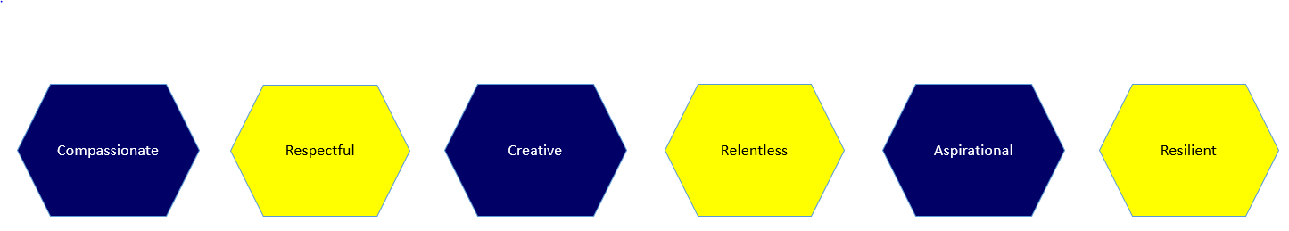

Signed: ……………………………………………………………………………………… Dated: …………………….…………………………

