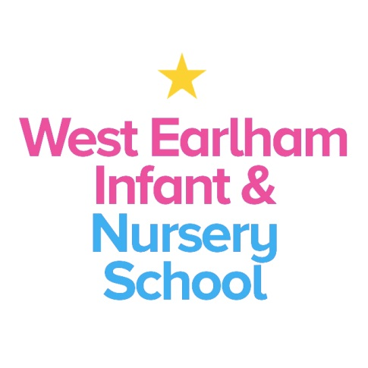
West Earlham Infant & Nursery School
Scarnell Road
Norwich
NR5 8HT
Tel 01603 451299
Email office@westearlhaminfant.norfolk.sch.uk
KS1 TEACHER –MPS Fixed term 1 Year
Required from September 2021
Governors are seeking to appoint an outstanding teacher to join our school, set in the dynamic neighbourhood of West Earlham in Norwich. The post holder will join our KS1 team. We will consider exceptional ECTs with some experience of KS1 and EYFS.
We are looking for someone who
- Understands how young children develop and learn and is able to plan and foster a developmentally sensitive pedagogy to meet all children’s needs
- is keen to use the environment and routines as learning opportunities
- has experience of using RWI to deliver phonics teaching
- Is reflective and innovative with a commitment to self-improvement
- Can use highly skilled behaviour strategies to engage and nurture children
- Has the ability to build strong and positive relationships with colleagues and families
- Has resilience and the moral drive to narrow the gap for children from disadvantaged backgrounds
- Has an enthusiasm and willingness to take part in the broader life of the school

You can expect:
- To work with a forward thinking and a highly committed outstanding team
- To be welcomed and supported by staff, governors, children and families
- To learn with us from our expert ‘resident’ speech and language therapist
- To work closely with our nursery team, EYFS colleagues, FSW and SENCo
- To develop as a teacher and receive appropriate support and opportunities to enable you to do this
- To contribute to school improvement and development
How to Apply
Applicants should access more information about our school via our website www.weins.co.uk. We actively welcome applicants from out of Norfolk. Visits to the school by appointment are warmly welcomed, although this will not prejudice those applying out of county
For further details please don’t hesitate to get in touch, our number is 01603 451299. You can find an application form by clicking on the orange “Apply for Job” button.
Please return your application to us via email to office@westearlhaminfant.norfolk.sch.uk or by post to the school address.
Closing date: 12 noon 18th June 2021
Interviews to be held on: Tuesday 22nd June 2021
Our school is committed to safeguarding and promoting the welfare of children and young people and expects all staff and volunteers to share this commitment. An Enhanced DBS check will be carried out before the post begins.
This post is likely to come under the requirements of the Childcare (Disqualification) 2009 Regulations and the successful applicant will be required to complete a declaration form to establish whether they are disqualified under these regulations

