Marston Moreteyne VC School
Marston Moreteyne
Bedford

Full Time Class Teacher(s)
Initially, Lower Key Stage 2 ~ Year 3 & 4
Based at either our Church End or Forest End Site

Salary: Main Scale (suitable for Early Career Teachers)
Starting: September 2024

The Governors of the school are seeking to appoint effective, enthusiastic and caring teachers to join our teaching team in September 2024.

Marston Moreteyne VC School is a large split site Lower School in the village of Marston Moreteyne.

The successful applicants will need to …
- demonstrate an excellent understanding of, and innovative approach to, the Early Years curriculum;
- be able to work as part of a team;
- be ICT literate and use these skills effectively throughout the curriculum;
- have a strong commitment to the school’s inclusive values and community ethos.

We offer…
- delightful, highly motivated and extremely well-behaved children;
- an outstanding working environment within a well-equipped and resourced school;
- supportive colleagues and the opportunity to develop your career as a teacher.

For the opportunity to visit the school please contact Lisa Lee in our
Church End office on 01234 768271 or email office@marstonmoreteyneschool.org

Completed applications should be sent to the Headteacher by Thursday 9th May
Interviews will take place on Tuesday 14th May
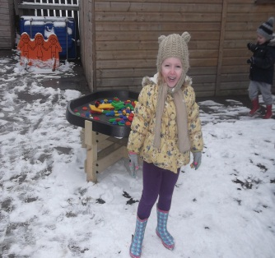
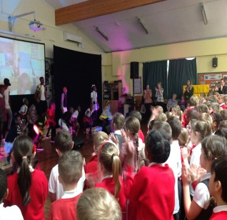
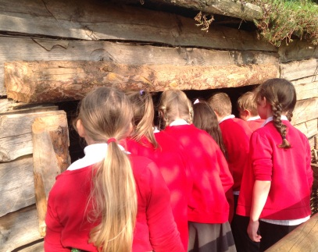

As part of our safeguarding children procedures, the successful candidates
will be required to undertake enhanced DBS checks.

