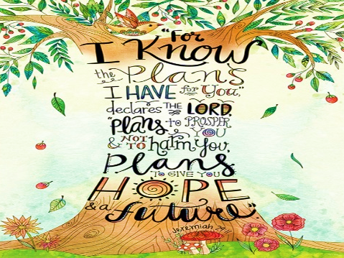
Welcome to
Marston Moreteyne VC School
April 2024

Marston Moreteyne School is a rapidly expanding four form entry, split site, lower school with 550 pupils on roll. The school receives Pupil Premium Funding for approximately 15% of our children whilst 13% are entitled to FSM.

There has been a school in the village since 1847 and lies at the heart of its community. The past ten years has seen the school grow physically and numerically as the school has been developed to meet the needs of a growing and vibrant village. In October 2014 the school assumed responsibility for a second site. Forest End is located on the Marston Park Development within the village approximately 1 km from the Church End campus.

The school is spilt across two sites and organised into three Key Stages; Early Years Foundation Stage, Key Stage One and Lower Key Stage Two. Forest End accommodates two forms of entry and is currently structured as a Pre-School, Reception, Year 1, Year 2, Year 3 and Year 4. Church End accommodates two forms of entry from Pre-School to Year 4.

We offer our staff …

- A school with high academic standards in which pupils make very good progress;
- Exceptionally hard working and well behaved children;
- Established school values which are embedded in all that we do;
- Impressive facilities which includes mature woodland areas, extensive age appropriate outside equipment, modern and reliable technology etc;
- A well-equipped and comfortable staffrooms;
- Opportunity to develop skills and knowledge by accessing high quality CPD and training;
- An inclusive, positive and professional working environment;
- A school team committed to the inclusion and well-being of all our children.

We believe that a supportive and constructive working environment, in which all are valued and make a contribution, is the most conducive in bringing out the best in our pupils. We hope that all at the school feel a tremendous sense of achievement in their contribution towards the success of the school as a whole.

Brian Storey
Headteacher

