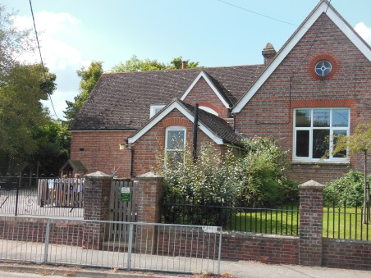
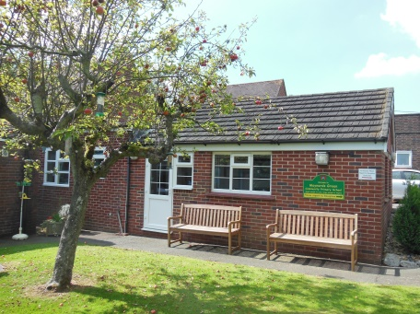
Maynards Green Community Primary School

Maynards Green, Horam, East Sussex. TN21 0DD
Tel: 01435 812622 email: office@maynardsgreen.e-sussex.sch.uk

KS2 Teacher - MPS
1 year Fixed term contract, 3 days per week, September 2021 to August 2022
Situated between Horam and Heathfield, Maynards Green is a successful and friendly community primary school. The school offers a supportive and caring environment and well behaved and highly motivated learners. The experienced and supportive staff team is friendly and committed to maintaining high standards.

We are looking to appoint an outstanding and highly motivated teacher to join our staff team who:
- is inspirational and creative
- is passionate about teaching
- is flexible and hard working
- has high expectations of children’s achievements
- can teach high quality phonics and early reading skills
- is able to work as a team member.

Visits are welcome although given the tight timescale, applicants will have ample opportunity to tour the school and spend time in classrooms if shortlisted for interview.

Application details are available from the School Office (office@maynardsgreen.e-sussex.sch.uk). You can also email the School Office to arrange an informal discussion with the headteacher.

Please be mindful that due to lockdown procedures we may need to make provision for remote interviews

Closing Date: 20th May 2021
Interview Date: Week beginning 24th May 2021

