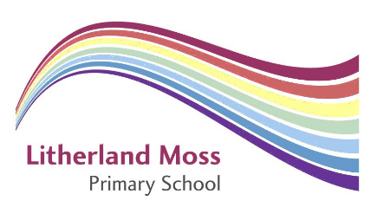

How to Apply

Thank you for your interest in this exciting opportunity at Litherland Moss Primary School.

In order to apply, please submit the following completed application forms:

- Application form

For this position you should submit a covering letter demonstrating and summarising experience and giving evidence or examples of your proven experience against the criteria listed in the person specification.

Application closing date: 15th of May 2024

Completed applications should be returned by email recruitment@theheathfamily.org.uk

We will endeavour to acknowledge receipt of all applications within 24 hrs. Should you fail to receive a confirmation, please call 01928 716521.

Please ensure that your application accounts for any gaps in employment.

Please include the names and addresses of two professional referees (one of which must be your current employer). Referees will be approached if your make the shortlisting stage of the recruitment process.

For information regarding this position please contact Ms Beth Hughes (Primary Support Officer) on 0151 928 4544 or email ehughes@LMP.theheathfamily.org.uk

